A Survival-Analysis Framework for Predicting and Explaining Time-to-Employment for Final-Year IT Undergraduates and Graduates in Sri Lanka
BSc (Hons) in Computing
Dissertation and Project Artefact
A dissertation submitted in partial fulfilment of the requirements for the degree of BSc (Hons) in Computing
Coventry Index : 16115859
NIBM Index : COBSCCOMP24.2P-019
NIBM Registered Name : M.S.F. Shazna
Faculty of Engineering, Environment and Computing
School of Computing, Electronics and Mathematics
Coventry University
School of Computing and Engineering
National Institute of Business Management
Colombo-7
October 2026

Abstract
Sri Lanka produces about 17,000 IT graduates a year, yet none can see how long their own search for a first IT job is likely to take. This study developed and evaluated an explainable survival-analysis framework that estimates time to a first IT job for Sri Lankan IT graduates and final-year undergraduates. Using Design Science Research, 1,175 graduates, 245 employers and 324 real entry-level job advertisements provided the data. Cox, Elastic Net Cox, three accelerated failure time (AFT) models and DeepSurv were fitted on training data and compared on a validation set; the selected model was tested once on a locked test set. The artifact is a web application giving an individual time range, explanations, what-if scenarios and market comparisons. The median time to a first IT job was four months, and GPA and internship experience were the factors most clearly associated with a shorter search. The AFT Log-Normal model reached a C-index of 0.69 on validation and 0.62 on the test set, ranking graduates better than chance but under-predicting employment; neural models did not perform better. Graduates rated themselves below employers' expectations on 25 of 26 skills, most in cloud computing, software testing and DevOps. Twelve users gave a mean System Usability Scale score of 76.3 (95% CI 69.5-83.0), above the benchmark of 68, and the model ranked test graduates better than ChatGPT (C-index 0.62 against 0.54). The study contributes a reproducible, explainable time-to-employment framework and a current picture of entry-level IT skill demand in Sri Lanka.
Keywords: Graduate employability; Survival analysis; Time-to-employment; Explainable AI; Decision-support system; Sri Lanka
Table of Contents
Abstract ii
List of Figures vii
List of Tables x
Chapter 1 Introduction 1
1.1 Background 1
1.2 Research Problem 2
1.3 Objectives of the Project 5
1.4 Research Questions 5
1.5 Scope of the Research 6
1.6 Justification of the Research 7
1.7 Expected Limitations 8
1.8 Chapter Summary 9
Chapter 2 Literature Review 11
2.1 Introduction 11
2.2 Theoretical Background and Conceptual Explanation of Key Concepts 11
2.3 Empirical Review of Previous Studies 14
2.4 Research Gap 19
2.5 Chapter Summary 21
Chapter 3 Methodology 22
3.1 Introduction 22
3.2 Research Philosophy 22
3.3 Research Approach 23
3.4 Design Science Research Methodology 23
3.5 Research Process 25
3.6 Requirement Gathering 27
3.7 Data Collection Methods 28
3.8 Software Development Methodology 31
3.9 Artifact Evaluation Strategy 32
3.10 Data Analysis Techniques 34
3.11 Research Validity and Reliability 40
3.12 Ethical Considerations 44
3.13 Chapter Summary 45
Chapter 4 Proposed Solution 46
4.1 Introduction 46
4.2 Requirement Analysis 46
4.3 Proposed Solution 50
4.4 System Architecture 51
4.5 System Design 53
4.6 Algorithms/Models 55
4.7 Data Sets/Data Preparation 58
4.8 Technology Selection 60
4.9 Implementation 60
4.10 Chapter Summary 62
Chapter 5 Evaluation and Results 64
5.1 Introduction 64
5.2 Evaluation Framework 64
5.3 Evaluation Criteria 64
5.4 Experimental/Test Results 65
5.5 System Performance Results 70
5.6 Accuracy/Precision/Recall or Other Technical Measures 71
5.7 User Evaluation 75
5.8 Usability Evaluation 76
5.9 Comparison with Existing Solutions 78
5.10 Results Related to Research Objectives 81
5.11 Chapter Summary 82
Chapter 6 Discussion, Conclusions and Recommendations 83
6.1 Introduction 83
6.2 Discussion of Findings 83
6.3 Achievements of Research Objectives 90
6.4 Answers to Research Questions 91
6.5 Recommendations 92
6.6 Future Research 94
6.7 Conclusion 95
6.8 Chapter Summary 96
References 97
Appendix A: Application Screenshots 103
Appendix B: Expert Review of the Questionnaires and Design 111
Appendix C: Questionnaires Used in the Main Study 112
Appendix D: Ethical Clearance Application 139
NATIONAL INSTITUTE OF BUSINESS MANAGEMENT 140
School of Computing & Engineering 140
1. Researcher Details 140
2. Programme of Study 140
3. Project Details 142
4. Ethical Considerations 142
5. Informed Consent 143
6. Data Protection and Confidentiality 143
7. Risk Assessment 143
8. Supervisor’s Approval 144
9. Student Declaration 144
Appendix E: Exploratory Data Analysis and Validity of the Skill Scores 145
Appendix F: Test Evidence and System Performance 150
Appendix G: Usability Evaluation Materials and Results 153
Appendix H: LLM Benchmark Prompt and Results 156
Appendix I: Job-Advertisement Coding Agreement 157
Appendix J: Model Development Diagnostics 158
Appendix K: Additional Evaluation Figures 165

List of Figures
Figure 3.1: Design Science Research Process Applied to This Research 24
Figure 3.2: Analysis and Modelling Pipeline 26
Figure 3.3: Project timeline, January to October 2026 27
Figure 4.1: Use-case diagram of the decision-support system 50
Figure 4.2: System architecture 51
Figure 4.3: The results dashboard of the redesigned interface (most likely time, range, confidence and chance of employment) 54
Figure 4.4: Sequence diagram of a prediction request 54
Figure 4.5: Flow chart of a prediction request 55
Figure 4.6: Processing flow of the candidate models 57
Figure 4.7: Data preparation and the fixed three-way split (graduate data) 59
Figure 5.1: Share of training graduates who had found an IT job, by GPA and internship (Kaplan-Meier) 68
Figure 5.2: Graduate self-ratings at completion vs employer importance, with the share of job advertisements naming each skill 69
Figure 5.3: Uno's C-index of the candidate models on the validation set 72
Figure 5.4: Calibration of the selected model on the test set (tertiles of predicted risk) 73
Figure 5.5: System Usability Scale score of each participant, with the mean, its 95% confidence interval and the benchmark of 68 77
Figure 6.1: Adjusted time ratios of the selected AFT model (training set); only GPA and internship months exclude 1 85
Figure 6.2: What graduates think matters most for employability vs what employers rank in their top three 87
Figure 6.3: Achievement of the research objectives and questions 90
Figure 6.4: Recommendations by stakeholder 92
Figure A.1: Home: the purpose of the application, headline figures from the real job advertisements and the steps to an estimate 103
Figure A.2: My profile, step 1 (About you): status, GPA, degree programme and institution 104
Figure A.3: My profile, step 2 (Experience): internship months, projects and certifications 104
Figure A.4: My profile, step 3 (Skills): self-ratings of the skill areas 105
Figure A.5: My profile, step 4 (Preparation): portfolio, open source, hackathons and preparation habits 105
Figure A.6: My dashboard: most likely time with its range and confidence, and the chance of a job by 3, 6, 12 and 24 months 106
Figure A.7: Improve my chances: combinations to explore and the what-if sliders 106
Figure A.8: Compare: the profile against employer importance ratings and job-advertisement demand 107
Figure A.9: Job market: headline figures, key findings and skill demand in the 324 real advertisements 107
Figure A.10: Ask: questions about the result, answered only from the system's own results 108
Figure A.11: Research lab: model comparison on the validation set (real data) 108
Figure A.12: The Spark assistant open on the dashboard 109
Figure A.13: The dark theme (My dashboard) 109
Figure A.14: The phone layout: home, dashboard and improve my chances 110
Figure E.1: Spearman correlation between the predictors (training set, n = 620) 147
Figure E.2: Distribution of the skill self-ratings at degree completion (training set, n = 620) 148
Figure E.3: Scree plots with parallel analysis for the technical and soft-skill items (training set, n = 620) 149
Figure J.1: DeepSurv training loss and early-stopping hold-out loss by epoch (training set) 160
Figure J.2: Learning curve of the selected model (validation Uno's C by size of the training set) 162
Figure J.3: Brier score over time of the selected model and the Kaplan-Meier baseline (validation set) 164
Figure K.1: Time to the first IT job with the number at risk (Kaplan-Meier, all modelling graduates, n = 885) 165
Figure K.2: Cumulative incidence of a first IT role and of another path (competing risks) 166
Figure K.3: Mean predicted share employed under each AFT distribution against the Kaplan-Meier curve (training set) 167
Figure K.4: Scaled Schoenfeld residuals of the Cox model against the rank of event time (training set) 168
Figure K.5: Uno's C and calibration at six months by gender and institution type (locked test set) 169
Figure K.6: Uno's C of the selected model across the sensitivity, temporal and institution-transfer checks (validation set) 169

List of Tables
Table 1.1: Existing approaches to estimating or supporting graduate employment, and what is missing 4
Table 2.1: Summary of Reviewed Studies and Systems 18
Table 3.1: Evidence retained for each data source 31
Table 3.2: Evaluation metrics and the reason for each 33
Table 3.3: Variables and types of data 34
Table 3.4: Data analysis techniques by research objective and question 35
Table 3.5: Candidate Survival Models and Rationale for Inclusion 38
Table 3.6: Conditions under which the model is claimed to work 40
Table 3.7: Pilot testing and instrument validation stages 41
Table 3.8: Expert reviewers (anonymised) and the main points they raised 42
Table 4.1: Inputs, processing and outputs of the system 47
Table 4.2: Functional requirements and the components that satisfy them 48
Table 4.3: Non-functional requirements and the components that satisfy them 49
Table 4.4: Candidate models and the settings tuned on the validation set 56
Table 4.5: Technology selection 60
Table 4.6: Testing plan 62
Table 4.7: Traceability of the objectives to the proposed solution and its evaluation 63
Table 5.1: Evaluation criteria (fixed before analysis) and the results against them 65
Table 5.2: Functional test scenarios (final model, real data) 66
Table 5.3: Adjusted associations with time to first IT job (training set, n = 620, 467 events) 68
Table 5.4: System performance (development laptop, 30 requests per endpoint, 14 October 2026) 71
Table 5.5: All candidate models on the validation set (133 graduates) 72
Table 5.6: Conditions under which the model is claimed to work (Table 3.6) and the evidence 73
Table 5.7: Profile of the usability participants (n = 12) 76
Table 5.8: Inspection against the non-functional requirements 76
Table 5.9: System Usability Scale results (n = 12) 77
Table 5.10: Comparison with existing solutions 78
Table 5.11: Capabilities of existing solutions and of this study 80
Table 5.12: Results by research objective 81
Table B.1: Expert recommendations and how they were addressed 111
Table E.1: Sample characteristics by split 145
Table E.2: Each predictor and the outcome (univariate Cox, training set) and variance inflation factors 145
Table E.3: Suitability for factor analysis, reliability and convergent validity of the skill blocks 146
Table E.4: Item loadings on a single factor per block (training set) 146
Table E.5: Sample compared with published Sri Lankan figures (all modelling graduates) 149
Table F.1: Requirements and the automated tests that verify them 150
Table F.2: Automated tests per module (parameterised cases counted separately) 151
Table F.3: API response times (30 requests per endpoint after one warm-up, 14 October 2026) 152
Table G.1: SUS statements and item results (n = 12) 153
Table G.2: Participants, answers to the ten SUS statements and SUS score 153
Table G.3: Usability issues and most useful parts (open comments coded with fixed keyword rules) 154
Table G.4: Open comments (verbatim) 154
Table H.1: Ranking and calibration of ChatGPT and the selected model on the same test graduates 156
Table I.1: Agreement between hand coding and the keyword rules, by skill (36 advertisements) 157
Table J.1: Prediction error by actual time to the first IT job (validation set, graduates who found work) 158
Table J.2: The worst-predicted tenth of validation graduates compared with the rest (means) 159
Table J.3: Every tuning configuration and its validation Uno's C (each fitted on the training set; AFT distribution chosen by AIC) 160
Table J.4: Time-dependent AUC, Uno's C and integrated Brier score of the candidate models (validation set) 163
Table J.5: The selected model against simpler baselines (AFT log-normal, validation set) 164

Chapter 1
Introduction

1.1 Background
The information technology (IT) and business process management (BPM) sector is one of Sri Lanka's most strategically important industries, and its continued growth depends heavily on a steady supply of technically competent, industry-ready graduates (Amarasooriya, 2024). Sri Lankan universities and higher-education institutes currently produce an estimated 17,000 IT and computing graduates annually (SLASSCOM, 2024), reflecting substantial national investment in technical education.
Despite this volume of output, industry bodies and employers continue to report a persistent mismatch between the skills held by entry-level candidates and the skills actually required in the workplace. The Sri Lanka Association of Software and Service Companies (SLASSCOM) Employability Skills Report identifies specific and recurring gaps in areas such as cloud computing, DevOps practices, cybersecurity fundamentals, and applied artificial intelligence - precisely the domains in which industry practice evolves fastest (SLASSCOM, 2024). Academic literature corroborates this: Aljohani et al. (2022) and Amarasooriya (2024) both document, through large-scale bibliometric and labour-market analyses respectively, that the gap between what university curricula teach and what employers require, particularly in fast-moving technical domains, remains substantial and persistent rather than closing over time. More recent Sri Lankan studies confirm that this mismatch is a current problem (Fernando et al., 2023; Samaradivakara et al., 2024).
This mismatch does not affect all graduates equally, and it is not explained by academic performance alone. Employability is a multidimensional outcome shaped by the interaction of academic achievement, technical skill depth, soft-skill competence, certifications, internship and project experience, and portfolio activity (Bennett & Ananthram, 2022; Tomlinson et al., 2022) - no single factor determines whether, or how quickly, a graduate secures employment. Consequently, many final-year undergraduates and recent graduates approach the job market with considerable uncertainty about where they genuinely stand, and often only discover which specific gaps are holding them back after months of unsuccessful applications, by which point the opportunity to address those gaps before graduation has already passed.
At the same time, the recent and rapid mainstream adoption of general-purpose large language models (LLMs), such as ChatGPT and comparable tools, has introduced a legitimate and increasingly common question, raised directly during this research's own proposal review: if a graduate can already submit their qualifications, skills, and experience to a freely available chatbot and receive commentary on their apparent weaknesses, what additional value can a purpose-built academic system offer? Rather than treating this as an inconvenient objection, this research adopts it as a central design constraint. It argues - and, critically, sets out to empirically demonstrate rather than merely assert - that a system built on real, local, triangulated data (final-year/graduate profiles, employer hiring criteria, and current job-market requirements, collected specifically for this study) can produce a measurable, explainable, and locally validated estimate of time-to-employment that a general-purpose LLM, which has no access to any such dataset and cannot report a verifiable accuracy figure, is structurally unable to reproduce.
It is worth noting that this uncertainty is not simply a matter of graduates lacking information about the job market in general; national labour-market statistics (Department of Census and Statistics, 2025), university career-guidance resources, and industry reports such as the SLASSCOM Employability Skills Report (SLASSCOM, 2024) are, in principle, publicly available. The specific gap this research addresses is the absence of any tool that translates this general, population-level information into an individualised, evidence-based estimate for a specific person's specific profile - telling a given final-year student not merely that "cloud skills are in demand generally" but, given their own combination of GPA, technical skills, certifications, and experience, what their own realistic timeframe looks like, and precisely which change would most improve it.

1.2 Research Problem
Graduate employability is not merely a theoretical concern in Sri Lanka: youth unemployment (ages 15-24) stood at 19.7% in the first quarter of 2025, the highest of any age group and far above the national rate of 3.8% (Department of Census and Statistics, 2025), and the SLASSCOM Employability Skills Report documents that this is compounded, specifically within the IT sector, by a persistent skills mismatch between graduate profiles and employer requirements (SLASSCOM, 2024). Although graduate employability has attracted substantial research attention internationally, and to a growing extent within Sri Lanka, three specific and interrelated problems remain unaddressed by the existing body of work, each of which this research directly targets.
First, no existing study applies survival analysis to Sri Lankan graduate populations within the IT or computing disciplines specifically. The closest Sri Lankan precedent, the ensemble-based career-path prediction model built by Rukais et al. (2025) on 820 local IT industry employee profiles, is IT-specific but produces a classification-style output rather than a time-to-event estimate. This distinction matters substantially: IT-sector skill requirements evolve rapidly (Acemoglu et al., 2022), meaning the specific factors driving time-to-employment for an IT graduate are unlikely to mirror those identified in a general-graduate population. Survival-analysis methodology itself is well established and actively evolving, including recent deep-learning extensions (Wiegrebe et al., 2024; Zhao et al., 2024), but it has not been applied to the Sri Lankan IT graduate population.
Second, existing Sri Lankan machine-learning-based employability and career-prediction systems, most notably the ensemble-based career-path prediction model developed by Rukais et al. (2025) on 820 IT industry employee profiles, rely on classification-style outputs - a predicted category or label - rather than an individualised, continuous, and explainable time-to-employment estimate. These systems also do not triangulate graduate self-report data with independent employer requirement data and real job-advertisement data within a single validated framework, which limits the extent to which their predictions can be cross-checked against actual market demand.
Third, and most directly responsive to feedback received during this research's own proposal and review stages, no reviewed study or deployed system empirically benchmarks its predictive and explanatory value against what a general-purpose large language model can already provide when given the same input. Given the increasing accessibility of such tools to the very population this research targets, this comparison is not a peripheral concern but a necessary component of establishing the system's practical justification.
This research addresses all three problems by developing and evaluating a survival-analysis-based, explainable machine-learning framework specifically for final-year IT undergraduates and entry-level IT graduates in Sri Lanka, trained on triangulated graduate, employer, and job-market data, and by directly and empirically comparing its output against a general-purpose LLM given identical profile information.
Taken together, these three problems point to a single underlying issue: existing research and existing systems each address one facet of graduate employability in isolation - either the statistical/methodological facet (survival analysis, but not for IT graduates), the systems/engineering facet (ML-based prediction, but not explainable time-to-event, and not triangulated with market data), or the practical/comparative facet (whether AI tools already solve this, which has not been tested). This research is structured specifically to close all three facets within a single, coherent framework, rather than advancing any one of them independently.
Table 1.1 summarises the existing approaches reviewed in Chapter 2 and what each leaves missing.
Table 1.1: Existing approaches to estimating or supporting graduate employment, and what is missing
Approach | Examples | What it achieves | What is missing
Tracer studies and labour-force surveys | University of Kelaniya (2022); Department of Census and Statistics (2025) | Employment rates of graduates or young people at one point in time | No time to a first job and no individual estimate
Curriculum-industry mismatch studies | Aljohani et al. (2022); Amarasooriya (2024) | Show where skills and demand diverge across the sector | Describe the gap in general; no prediction for an individual
Career-path and job-matching systems | Rukais et al. (2025); Karunanayake et al. (2023); Sribharathi et al. (2025) | Predict a career category, filter job postings or match skills to jobs | Give a label or a match, not a time to employment; do not use graduates still searching
General-purpose language models | ChatGPT and similar tools | Give advice from a typed profile | Not trained on Sri Lankan graduate outcomes; no reviewed study tests them against observed outcomes
Problem statement. There is currently no explainable, individual estimate of the time to a first IT job for Sri Lankan IT graduates that uses graduates who are still searching, is linked to employer demand, and has been tested against what a general-purpose language model can already provide.

1.3 Objectives of the Project
Aim: To develop and evaluate an explainable, survival-analysis-based framework that predicts time-to-employment for final-year IT undergraduates and entry-level IT graduates in Sri Lanka.
- O1. To identify the factors significantly associated with time-to-employment, using survival analysis of responses from approximately 400 final-year students and graduates.
- O2. To measure the alignment between graduate skill profiles and employer requirements, using responses from 30-50 IT employers and current job-advertisement data.
- O3. To compare four families of survival models (Cox Proportional Hazards, Elastic Net Cox, Accelerated Failure Time with three distributions, and DeepSurv; seven models in all) on a fixed training, validation and test split, select one by a rule set in advance, and evaluate it once on the locked test set by concordance index and calibration, with the 95% confidence interval of the test C-index above 0.5.
- O4. To develop a web-based prototype and evaluate it with 8-12 users (System Usability Scale, target mean of at least 68) and by a benchmark comparison against a general-purpose LLM given the same held-out profiles (target: a higher Uno's C-index for the model).

1.4 Research Questions
Each research question below is derived directly from, and answers, the objective of the same number above, so that every stage of the research design is traceable back to a single stated aim.
- What academic, technical, professional, and experiential factors are significantly associated with time-to-employment for final-year IT undergraduates and entry-level IT graduates in Sri Lanka?
- How well do final-year/graduate profiles align with current employer requirements and job-market demand, and what are the most significant and actionable gaps?
- How accurately and reliably can a survival-analysis-based machine learning framework predict time-to-employment for this population, and how do the linear, regularised, parametric, and nonlinear approaches compare?
- To what extent does the prototype web-based decision-support application provide accurate, explainable, and actionable guidance to final-year students and graduates, as measured through usability evaluation and a structured benchmark comparison against a general-purpose LLM given identical input?

1.5 Scope of the Research
The scope of this research has been deliberately bounded to ensure feasibility within the constraints of a single-researcher, final-year dissertation timeline, while retaining the elements necessary to address the research questions meaningfully.
In scope:
- Final-year IT/computing undergraduates within approximately six months of expected graduation, and IT/computing graduates within two years of graduation, resident in or studying within Sri Lanka.
- Primary data: collected directly from final-year/graduate respondents and from employers/recruiters via structured questionnaires (Section 3.7).
- Secondary data: Sri Lankan IT job advertisements and relevant published industry reports (Section 3.7).
- Survival-analysis and deep-learning survival modelling approaches specifically: Cox Proportional Hazards, Elastic Net (regularised) Cox, Weibull/Log-Normal/Log-Logistic Accelerated Failure Time models, and DeepSurv.
- An explainable-AI layer providing both global and individual-level (local) explanations, including hazard/time ratios and SHAP-based explanations, together with a counterfactual "what-if" guidance component.
- A working prototype web-based decision-support artifact, and a documented, structured empirical comparison between the artifact's output and that of a general-purpose LLM.
Out of scope:
- Ensemble and forest-based algorithms (e.g., Random Forest, Gradient Boosted Trees), explicitly excluded following supervisory guidance identifying such methods as common defaults that do not, by themselves, provide sufficient methodological justification for a final-year research project of this kind.
- Graduates or undergraduates outside Sri Lanka, or from disciplines outside IT/computing, for whom the identified employability factors and market conditions may not generalise.
- Replacing professional career counselling services, or informing, automating, or influencing actual employer hiring decisions in any way.
- A continuously updated, real-time job-advertisement scraping pipeline; a static or periodically refreshed dataset, collected once over a defined window, is used instead for feasibility reasons.
- Persistent user accounts, authentication, or storage of individual predictions - the artifact is intentionally designed to process each submitted profile statelessly, both to control scope and to avoid unnecessary data-protection complexity given the sensitivity of employment-related personal data.

1.6 Justification of the Research
This research is justified on four interrelated grounds. First, graduate employability remains a persistent and nationally significant concern in Sri Lanka (Department of Census and Statistics, 2025; SLASSCOM, 2024), and the specific sub-population addressed here - final-year IT undergraduates and entry-level IT graduates - has not previously been studied using an individualised, explainable, time-to-event predictive approach, despite the sector's scale and strategic economic importance.
Second, survival-analysis methodology is well established internationally and continues to be actively extended with deep-learning techniques (Wiegrebe et al., 2024), yet remains meaningfully under-utilised specifically within the Sri Lankan IT sector, where the closest local precedent (Rukais et al., 2025) instead relies on classification-style outputs. Applying survival analysis here therefore extends an established and credible methodology into a context where it offers genuine additional value, rather than introducing an untested approach. Feasibility is further supported by the fact that Cox and accelerated-failure-time models are routinely fitted to datasets of a few hundred observations, provided the number of events per model parameter is adequate (Zhao et al., 2024), which this study's planned sample and reduced set of composite predictors are designed to achieve.
Third, the deliberate exclusion of ensemble and forest-based methods, and the resulting requirement to justify a progression across linear (Cox), regularised (Elastic Net), parametric (AFT), and nonlinear (DeepSurv) survival models on the basis of the data's own properties rather than convenience or popularity, constitutes a genuine and defensible methodological contribution appropriate to final-year research. It requires every modelling decision in this study to be argued for explicitly, a standard that a default ensemble-classifier pipeline would not have imposed.
Fourth, and most directly responsive to critique received during this research's development, this study provides documented, empirical evidence - obtained through a structured, repeatable comparison against a general-purpose LLM given identical profile input - of precisely what a locally validated, triangulated-data system can offer that a general-purpose AI tool cannot. This evidence, rather than argument alone, forms the practical justification for the system's existence and directly addresses the most commonly raised objection to research of this kind.

1.7 Expected Limitations
As with any empirical study conducted within the constraints of a single academic year, this research is subject to a number of limitations, which are stated explicitly here so that findings can be interpreted appropriately and their generalisability is not overstated.
- Self-reported data and recall. Skills, certifications, outcomes and the months of degree completion and first IT job are self-reported and may be inaccurate, which adds noise to the outcome.
- Sample size and censoring. The target of about 400 graduates, of which 70% is used for fitting, limits the number of predictors (especially for DeepSurv), and respondents still searching are censored.
- Job-advertisement snapshot. The advertisements cover a fixed window and describe advertised vacancies only, not all hiring.
- Association, not causation. Findings describe statistical association; the Cox and AFT assumptions are tested but may limit the reading of single coefficients.
- Unmeasured factors. Personal networks, interview performance and job-search effort are not measured, which limits the accuracy that can be reached.
- Non-probability sampling. Purposive, convenience and snowball sampling, self-selection and an employer frame drawn from SLASSCOM members limit generalisation.
- Sri Lanka, IT and time. Findings are specific to Sri Lankan IT graduates and the period of data collection, and may not transfer to other countries, disciplines or later conditions.
- Small usability sample and decision support only. Eight to twelve participants can reveal major usability problems but not support statistical claims, and the artifact does not guarantee any individual outcome.
- Single researcher, one academic year. The scope of data collection and evaluation reflects these resource and time constraints.

1.8 Chapter Summary
This chapter has introduced the employability challenge facing final-year IT undergraduates and entry-level IT graduates in Sri Lanka, situating it within the wider context of the country's growing but skills-mismatched IT/BPM sector. It has defined the specific research problem this study addresses: the absence of an IT-specific, explainable, survival-analysis-based prediction framework that triangulates graduate, employer, and job-market data, and the absence of any empirical comparison demonstrating what such a system offers beyond what a general-purpose LLM can already provide. One aim, four concise and measurable objectives, and four corresponding research questions were presented, followed by an explicit statement of the research's scope, its four-part justification, and its data-related, methodological, sampling, geographical, and practical limitations. Chapter 2 now turns to a detailed review of the relevant literature, situating this research against prior empirical work and formally establishing the research gap introduced here.

Chapter 2
Literature Review

2.1 Introduction
This chapter reviews the literature relevant to graduate employability, university-industry alignment, survival analysis as applied to employment outcomes, machine learning and deep learning approaches to survival prediction, and explainable AI, before reviewing empirical studies and deployed systems addressing employability prediction, career guidance, job matching, and skill-gap analysis. The chapter closes by formally identifying the specific research gap that Chapters 3 and 4 of this dissertation address.

2.2 Theoretical Background and Conceptual Explanation of Key Concepts
Employability is widely understood in the literature as a multidimensional construct rather than a single measurable trait, encompassing academic achievement, technical competence, professional and interpersonal (soft) skills, certifications, and practical industry exposure such as internships, projects, and portfolio work (Bennett & Ananthram, 2022; Tomlinson et al., 2022). This multidimensional framing is significant for the present research because it rules out any single-variable proxy for employability (such as GPA alone) as an adequate basis for prediction. This research adopts this multidimensional framing and extends it temporally: rather than treating employability as a static, binary state ("employable" versus "not employable"), it is treated as a determinant of time-to-employment, consistent with the survival-analysis framing formally adopted in Chapter 3.
The literature distinguishes between technical skills - programming languages, cloud platforms, database technologies, DevOps tooling, and similar hard competencies - and soft skills, including communication, teamwork, problem-solving, and adaptability. Both categories are consistently identified as necessary but individually insufficient for employability; it is typically the combination and balance between the two, rather than strength in either alone, that employers report valuing most (SLASSCOM, 2024; Tomlinson et al., 2022).
A substantial body of literature documents misalignment between university curricula and industry skill requirements, particularly in fast-evolving technical domains such as cloud computing and DevOps (Aljohani et al., 2022; Amarasooriya, 2024). This misalignment is not merely an assertion but is evidenced through both bibliometric analysis of the wider academic literature and direct labour-market and curriculum-mapping analysis specific to the Sri Lankan context, and forms part of the theoretical basis for this research's decision to include both graduate self-report and independent employer-requirement data within its design, rather than relying on graduate self-report alone.
Survival analysis models the time until a defined event occurs - in this research, the event is obtaining first employment - and explicitly accounts for censored observations, meaning cases where the event has not yet occurred by the time of data collection (i.e., respondents who are still seeking employment) (Zhao et al., 2024). This is a critical advantage over standard classification methods, which would otherwise require such respondents to be either discarded or forced into an artificial binary category. The Kaplan-Meier estimator describes the proportion of a group that has experienced the event by each point in time while accounting for censoring (Zhao et al., 2024). The Cox Proportional Hazards model estimates the effect of covariates on the hazard, or instantaneous risk, of the event occurring, without requiring an assumption about the specific statistical distribution of survival time, and it remains the most widely used and continually refined approach for this purpose (Tarkhan & Simon, 2024). Accelerated Failure Time (AFT) models, including the Weibull, Log-Normal, and Log-Logistic variants, instead model survival time directly under a specified distributional assumption, which can provide more directly interpretable time-based estimates - for example, stating that a given factor multiplies expected time-to-employment by a given ratio. Regularised Cox models, such as Elastic Net Cox, apply statistical penalisation to handle a high ratio of predictor variables to observations (Zhao et al., 2024), which is directly relevant to this study given its expected sample size.
DeepSurv extends the standard Cox model by replacing its linear risk function with a neural network, allowing potentially complex, nonlinear interactions between covariates to be captured that a linear model could not represent (Wiegrebe et al., 2024). This research includes DeepSurv specifically as a means of empirically testing, rather than simply assuming, whether the relationship between employability factors and time-to-employment in this population is genuinely linear or nonlinear - a real, open empirical question given the exploratory nature of this specific application, rather than a default methodological choice adopted for its own sake.
Because the outcome of censored respondents is unknown, classification metrics such as accuracy, precision, and recall are not appropriate for time-to-event prediction. Discrimination is instead measured with the concordance index (C-index): the probability that, of two individuals, the one who experienced the event sooner was assigned the higher predicted risk. Uno's C-index corrects for censoring, and the way a C-index is calculated must be reported to avoid misleading comparisons between models (Sonabend et al., 2022). Calibration compares predicted and observed proportions experiencing the event at fixed time points, and the integrated Brier score summarises prediction error over time (Zhao et al., 2024). When models are tuned and compared, the data used for tuning must be kept separate from the data used for the final performance estimate - either by nested cross-validation or by separate validation and test sets - to obtain an unbiased estimate of performance (Bates et al., 2024).
Explainable AI seeks to make model predictions interpretable to end users, either globally (identifying which factors matter most across the population overall) or locally (explaining why a specific individual received a specific prediction) (Hoffman et al., 2023). For the Cox and AFT models used in this research, hazard ratios and time ratios provide direct, human-readable explanations without requiring additional tooling. For the DeepSurv model, SHAP (SHapley Additive exPlanations) values provide a comparable form of local, individual-level explanation (Mosca et al., 2022). This research deliberately extends explanation beyond static feature importance into counterfactual guidance: quantifying how a specific, realistically achievable change in an individual's profile - for example, completing one additional relevant certification - would be expected to change their predicted time-to-employment, thereby converting a diagnostic output into an actionable one.
Behavioural intention to use a new technology, as conceptualised in the Technology Acceptance Model and its later extensions (Lee et al., 2025), informs the design of this study's technology-acceptance and XAI-preference questionnaire items, which measure final-year students' and graduates' anticipated willingness to trust and use an AI-based employability support tool of the kind developed in this research.

2.3 Empirical Review of Previous Studies
This section critically reviews studies and systems relevant to the research area, organised into eight topics corresponding to the concepts introduced in Section 2.2. Within each topic, studies are evaluated in terms of their contribution, strength, and limitation, rather than simply summarised, and a consolidated summary table is provided at the end of the section.
Aljohani et al. (2022) conducted a large-scale bibliometric analysis of over 10,000 Scopus-indexed publications spanning 2010 to 2021, identifying a persistent and non-narrowing mismatch between university curricula and job-market requirements across the wider computing education literature. Its key strength is the scale and rigour of aggregating evidence across a decade of literature rather than a single dataset; its limitation is that, as a bibliometric review, it provides no individual-level predictive tool of the kind this research develops.
Amarasooriya (2024), working specifically within the Sri Lankan context, mapped ACM/IEEE computing degree classifications against emerging technology demand using national IT-BPM workforce survey data, identifying cloud computing as the single most in-demand skill area and cataloguing fourteen distinct in-demand ICT job categories. Its strength is direct Sri Lankan labour-market grounding, providing a locally specific evidence base this research draws on directly; its limitation is that the analysis is macro-level and descriptive, offering no individual-level or predictive capability.
Samaradivakara et al. (2024) examined how higher-education administrators in Sri Lanka conceptualise employability within a turbulent labour market, providing an up-to-date, institution-facing account of how employability is understood and supported administratively. Its strength is its currency and its focus on the administrator perspective, which complements this research's graduate- and employer-facing data; its limitation is that it is qualitative and perception-based, with no predictive or individual-level component. Fernando et al. (2023) examined employability and skills mismatch among recent Sri Lankan state university graduates, assessing the gap between graduate skills and employer expectations through alumni experience and perception data. Its strength is its direct, recent evidence of a persisting graduate-employer skills mismatch in Sri Lanka; its limitation is that it is confined to management graduates and does not extend to prediction or time-to-employment estimation. Together, these two recent studies confirm that the curriculum-industry and skills-mismatch problem identified by other sources (Aljohani et al., 2022; Amarasooriya, 2024) remains current, while neither offers the individual-level, predictive capability this research develops.
Gangoda et al. (2024) developed Resume Ranker, an NLP-based resume parsing and skill-matching system evaluated on Japanese candidate and job-posting data. Its strength is a demonstrated reduction in recruitment time and the provision of skill-enhancement suggestions; its limitation is that it does not integrate degree, GPA, or certification data and is not designed for undergraduates.
Atanacio et al. (2025) developed JobFinder, a resume-parsing job-matching platform specifically for persons with disabilities in the Philippines. Its strength is demonstrating the value of AI-based matching for a specific, underserved population; its limitation is a narrow focus that does not extend to skill-gap analysis or career-switching guidance.
Karunanayake et al. (2023) developed ITConnect, a Sri Lankan platform combining fake-job detection (using DistilBERT), content-based job-posting filtering, and resume evaluation for IT professionals. Its strength is high reported accuracy in both fake-job detection and resume evaluation within a Sri Lankan IT context; its limitation is that it targets working IT professionals rather than undergraduates or entry-level graduates, and provides no predictive time-to-employment or skill-gap forecasting capability.
Parimi et al. (2025) developed a multi-modal, AI-assisted job recommendation platform combining text, categorical, skills, and graph-based features with learning-to-rank techniques (BPR and LambdaMART) and XGBoost-based salary prediction, evaluated on 50,000 candidate-job entries. Its strength is methodological sophistication and effectiveness at job recommendation and salary prediction at scale; its limitation is that it is not focused on undergraduates, is not localised to Sri Lanka, does not integrate degree, GPA, or certification-level academic data, and does not predict a time-to-employment outcome.
Roy and Sharma (2026) proposed a scalable career-guidance framework combining Decision Trees, XGBoost, and Support Vector Machines with RIASEC vocational-interest theory. Its strength is improved accuracy and personalisation of career recommendations; its limitation is reliance on a single-institution dataset and RIASEC interest data alone, without skills, labour-market alignment, or country-specific localisation.
Nandi et al. (2025) developed a hybrid multi-entity reinforcement-learning system for career-path recommendation within alumni networks, using SentenceTransformer embeddings and continuous feedback. Its strength is adaptive, scalable recommendation generation; its limitation is dependence on strong institutional alumni networks, excluding early-career graduates who lack such access, with no skill-gap prediction or labour-market alignment.
Sribharathi et al. (2025) developed Scopira, combining TF-IDF and BERT-based resume parsing with supervised skill-gap detection and job matching, reportedly outperforming conventional approaches. Its strength is the integration of resume parsing with skill-gap detection in one pipeline; its limitation is an apparently general/global dataset rather than a Sri Lanka-specific one, limited career-switching guidance, and no integration of degree, GPA, or certification data for undergraduates.
Ning (2025) applied predictive analytics, correlation, and regression analysis to responses from 100 undergraduate students. Its strength is demonstrating that predictive analytics can meaningfully identify skill gaps and that engagement enhances skill acquisition; its limitation is a small sample, a focus on soft skills only, and no job-matching, career-path, or Sri Lanka-specific component.
Lai et al. (2025) applied hierarchical clustering, k-nearest-neighbour classification, and non-parametric statistical testing to undergraduate perception-survey data. Its strength is demonstrating the value of learning analytics for identifying gaps between career aspirations and perceived skill readiness; its limitation is reliance entirely on self-reported perception data, with no industry-data-based predictive modelling and no IT-specific or Sri Lanka-specific focus.
Wang et al. (2025), studying 886 vocational students, used mediation analysis to show that stronger alignment between a student's academic programme, intended occupation, and acquired skills improves professional identity formation, with learning experience mediating this effect. Its strength is a valuable theoretical link between programme-occupation-skill alignment and a student's own sense of professional readiness, a construct closely related to this research's self-perceived-employability questionnaire items; its limitation is that the study is perception-based rather than predictive, employs no machine learning, is not IT-specific, and is not situated within the Sri Lankan context.
Rukais et al. (2025) developed an ensemble machine-learning model, comparing eight algorithms across 31 attributes including skills, education, and internship experience, to predict career paths from 820 Sri Lankan IT industry employee profiles, achieving high precision, recall, and F1-scores. Its strength is that it remains the strongest existing local precedent for ML-based employability-related prediction identified in this review; its limitation, from the perspective of the present research, is twofold: its explicit use of ensemble methods is directly representative of the common, non-differentiated methodological approach this research deliberately departs from (Section 1.5), and it predicts career-path category rather than a time-to-employment outcome, without incorporating employer-side or job-advertisement data.
Amarasena et al. (2024) developed an AI-driven mock-interview platform for fresh IT graduates, combining LLM-generated interview questions with convolutional neural network-based non-verbal behaviour analysis. Its strength is measurable improvement in interview readiness; its limitation is a narrow focus on interview preparation only, with no degree-to-job alignment analysis or predictive skill-gap component.
Weraduwa et al. (2025) developed an agent-based simulation, using NetLogo, of student-university-company interactions to address internship allocation gaps for Sri Lankan IT undergraduates. Its strength is useful, practically grounded curriculum and policy recommendations; its limitation is that it is simulation-based rather than predictive, excludes early-career (post-graduation) outcomes, and does not incorporate AI-driven individual-level career guidance.
Among deployed commercial products more broadly, Workera provides AI-driven skill-gap assessment dashboards, SkillWaze offers skills verification and micro-internship matching, CareerBuilder (with Textkernel) and Gigged.AI provide recruiter-facing candidate-job matching, and Big Interview provides AI-assisted interview coaching. Their collective strength is mature, deployed functionality across specific employability sub-tasks; their shared limitation, relative to this research, is that none output a survival-analysis-based time-to-employment range, none triangulate graduate, employer, and job-advertisement data within a single framework, and none are built for the Sri Lankan IT graduate or final-year undergraduate population.
Several validated psychometric instruments inform this study's questionnaire design, including the EmployABILITY Scale (Bennett & Ananthram, 2022; n = 10,193 across more than fifteen Australian universities), the Graduate Capital Scale (Tomlinson et al., 2022; n = 1,501), and the Perceived University Employment Support Scale (Ye et al., 2025). Their strength is established, large-sample validation of the underlying constructs; their limitation, for this research's purposes, is that reliability figures reported for these original, multi-item instruments do not automatically transfer to a single item extracted for use in this study's questionnaire, which is addressed directly through this study's own pilot testing and reliability analysis (Section 3.11). Individual items adapted from these and other instruments are documented in full, on a per-item basis, in this study's Evidence and Justification Matrix (Appendix).
Table 2.1 consolidates the studies and systems reviewed above, summarising each contribution and its principal limitation relative to the present research.
Table 2.1: Summary of Reviewed Studies and Systems
Study / System | Key Contribution | Key Limitation
Aljohani et al. (2022) | Bibliometric evidence of curriculum-industry mismatch | No individual-level or predictive capability
Amarasooriya (2024) | Sri Lanka-specific ICT demand mapping | Macro-level, descriptive only
Samaradivakara et al. (2024) | Recent SL administrator perspective on employability | Qualitative, no prediction
Fernando et al. (2023) | Recent SL graduate-employer skills-mismatch evidence | Management graduates only
Gangoda et al. (2024) | Resume/skill matching, reduces recruitment time | No degree/GPA/certification integration
Atanacio et al. (2025) | AI matching for an underserved population | Narrow focus, no skill-gap analysis
Karunanayake et al. (2023) | High-accuracy SL IT resume/fake-job system | Targets professionals, not graduates; no prediction
Parimi et al. (2025) | Large-scale, multi-modal job recommendation | Not localised, no time-to-employment prediction
Roy and Sharma (2026) | RIASEC-based personalised career guidance | Single institution, no market alignment
Nandi et al. (2025) | Adaptive alumni-network career recommendation | Excludes graduates without alumni access
Sribharathi et al. (2025) | Combined resume parsing and skill-gap detection | Not Sri Lanka-specific, no undergraduate integration
Ning (2025) | Predictive analytics on skill gaps | Small sample, soft skills only
Lai et al. (2025) | Learning analytics on aspiration-skill gaps | Perception-based only, not IT-specific
Wang et al. (2025) | Programme-occupation-identity alignment theory | Perception-based, no ML, not IT-specific
Rukais et al. (2025) | Strongest local ML career-prediction precedent | Ensemble-based; predicts category, not time-to-event
Amarasena et al. (2024) | AI mock-interview readiness improvement | Interview-preparation only
Weraduwa et al. (2025) | Internship-allocation policy simulation | Simulation-based, not predictive
Deployed tools (Workera, SkillWaze, etc.) | Mature, specific employability sub-tasks | No triangulated, survival-analysis-based prediction
Considered together, the studies and systems reviewed above illustrate a clear pattern: research and system development in this space has advanced substantially along several separate tracks - job matching and resume analysis, career-path and career-interest recommendation, skill-gap analytics, curriculum-industry alignment research, and, separately, survival-analysis-based employment-duration modelling - without any single study or system bringing these tracks together for the specific population, and using the specific non-ensemble, explainable, triangulated-data methodology, that this research adopts. This pattern of parallel but disconnected progress across related sub-fields is itself part of the justification for the integrative approach taken here.

2.4 Research Gap
Drawing together the theoretical background and empirical review presented above, this research identifies five specific, interrelated gaps in the existing literature and deployed systems, each of which this study is designed to address.
- Population gap: no reviewed study or deployed system addresses final-year IT undergraduates and entry-level IT graduates in Sri Lanka specifically, and in combination, as a single predictive population.
- Methodological gap: no reviewed study applies a non-ensemble survival-analysis framework - spanning linear (Cox), regularised (Elastic Net), parametric (AFT), and deep-learning (DeepSurv) approaches - to this population, nor empirically tests which of these approaches is actually justified by the data rather than assumed by default.
- Data-integration gap: no reviewed system combines graduate/final-year, employer, and real job-advertisement data within a single triangulated predictive framework; each reviewed study or system draws on, at most, one or two of these three data sources.
- Explainability and actionability gap: existing predictive systems, where explainable at all, rarely provide individual-level, quantified, counterfactual guidance (for example, quantifying how a specific change would alter a specific predicted outcome) rather than a static, one-time feature-importance output.
- Evidence gap regarding general-purpose AI: no reviewed study empirically documents, through a structured and repeatable comparison, what a locally validated predictive system offers beyond what a general-purpose LLM, given the same input, can already provide - despite this being an increasingly necessary and directly relevant comparison for any applied AI decision-support research conducted in the current technological environment.
This research does not claim to close the entirety of this gap. Instead, it addresses a specific, bounded part of it, directly aligned with its stated objectives: it identifies the factors associated with time-to-employment for this specific population (O1); compares graduate/final-year profiles against employer and job-market data (O2); develops and empirically compares a non-ensemble survival-analysis framework spanning linear, regularised, parametric, and deep-learning approaches (O3); and deploys the best-supported approach into a web-based decision-support application providing explainable, counterfactual guidance, benchmarked directly against a general-purpose LLM (O4). This positions the research as a direct, context-specific extension of the existing Sri Lankan employability and career-prediction literature (Aljohani et al., 2022; Amarasooriya, 2024; Rukais et al., 2025), informed methodologically by the explainability and deep-learning-survival literature reviewed above (Wiegrebe et al., 2024), rather than as an attempt to replicate the full scale of the international studies it draws on.

2.5 Chapter Summary
This chapter has reviewed the theoretical foundations of graduate employability, university-industry alignment, survival analysis and its evaluation, deep learning for survival prediction, and explainable AI, before examining closely related empirical studies and several deployed commercial systems spanning job matching, career guidance, skill-gap analytics, and Sri Lankan-specific employability research. Across this body of work, five specific gaps were identified: a population gap, a methodological gap, a data-integration gap, an explainability/actionability gap, and an evidence gap regarding general-purpose AI tools. Chapter 3 now presents the methodology developed to address these gaps and the research questions set out in Chapter 1.

Chapter 3
Methodology

3.1 Introduction
This chapter presents the methodology used to address the research questions and objectives set out in Chapter 1, in light of the research gap formally established in Chapter 2. It covers the research philosophy, approach, and process; requirement gathering; data collection methods, sampling and the justification for each data source; the evidence retained for each claim; software development methodology; artifact and model evaluation strategy; data analysis techniques, each linked explicitly to a research objective and question; pilot testing and validation of the instruments; validity and reliability considerations; data-leakage safeguards; the conditions under which the model is claimed to work; and ethical and reproducibility considerations. Each section states not only the chosen approach but the specific justification for that choice, given this research's particular constraints (single researcher, one academic year, an expected small-to-moderate sample size, and a supervisory requirement to avoid ensemble/forest-based modelling methods).

3.2 Research Philosophy
This research adopts a pragmatist philosophy. Pragmatism does not commit the researcher to a single, fixed ontological or epistemological position; instead, it permits the selection of whichever methods are most appropriate to the specific research questions at hand, judged by their practical adequacy for generating useful knowledge and a usable artifact (Saunders et al., 2023). This is considered appropriate here given the research's genuinely dual aim: to generate empirical knowledge (the factors associated with time-to-employment, and the comparative performance of different survival-analysis approaches) and, simultaneously, to design, build, and evaluate a practical, usable decision-support artifact. A purely interpretivist or purely positivist stance would each capture only one half of this dual aim.

3.3 Research Approach
A deductive, quantitative approach is combined with applied artifact development, consistent with the pragmatist philosophy above (Saunders et al., 2023). Variables and hypotheses are derived from the literature reviewed in Chapter 2 (for example, the expectation that internship experience, certifications, and specific in-demand technical skills will be associated with shorter time-to-employment), tested through statistical and machine-learning analysis of primary and secondary data collected specifically for this study, and the resulting findings are then used directly to inform the design and behaviour of the prototype artifact, closing the loop between empirical finding and practical output.
The study tests four expectations, stated before the analysis and derived from the literature in Chapter 2 and from the pre-set conditions in Table 3.6. Chapter 5 reports the evidence for each, and Section 6.2 discusses how far each was supported.
H1: Higher GPA, more internship experience, more certifications and stronger in-demand technical skills are associated with a shorter time to the first IT job (O1, RQ1).
H2: Graduates rate their own skills below the importance that employers give them on most skills, most of all in fast-changing technical areas such as cloud computing and DevOps (O2, RQ2).
H3: The selected survival model ranks graduates on the locked test set better than chance (the 95% confidence interval of Uno's C is above 0.5), and the neural model DeepSurv does not clearly outperform the simpler Cox and AFT models at this sample size (Wiegrebe et al., 2024) (O3, RQ3).
H4: Users rate the prototype above the usability benchmark (a mean System Usability Scale score of at least 68; Hyzy et al., 2022), and the model ranks held-out graduates better than a general-purpose LLM given the same profiles (O4, RQ4).

3.4 Design Science Research Methodology
Design Science Research Methodology (Haryanti et al., 2024) is adopted because this research both investigates a real-world problem empirically and produces and evaluates a practical artifact intended to address that problem directly - a dual requirement that a purely empirical or purely engineering methodology would not, on its own, adequately capture. The DSRM stages applied in this research are as follows.
- Problem identification and motivation: established in Chapter 1, and grounded in the research gap formally identified in Chapter 2.
- Definition of objectives for a solution: the four specific objectives set out in Section 1.3.
- Design and development: the data collection instruments, the survival-analysis modelling pipeline, and the prototype artifact itself, detailed in the remainder of this chapter.
- Demonstration: a working prototype capable of accepting a user profile and returning a predicted time-to-employment range, explanation, market-alignment comparison, and prioritised guidance.
- Evaluation: quantitative model-performance metrics (Section 3.9), prototype usability testing, and the structured LLM-comparison benchmark (also Section 3.9).
- Communication: this dissertation, together with any associated viva presentation or demonstration.
Figure 3.1 illustrates how these stages map onto the activities of this research.
Figure 3.1: Design Science Research Process Applied to This Research

3.5 Research Process
The overall research process follows twelve sequential stages, several of which proceed in parallel where feasible to manage the project timeline efficiently.
- Literature review and identification of candidate employability and time-to-employment factors.
- Design of the graduate/final-year and employer/recruiter questionnaires, with a per-item justification recorded in the Evidence and Justification Matrix.
- Pilot testing of both questionnaires with a small sample outside the main study, and revision based on the feedback received.
- Institutional ethics application and approval, conducted in parallel with instrument finalisation.
- Primary data collection (graduate/final-year and employer questionnaires) and secondary data collection (job advertisements and relevant industry reports).
- Data cleaning, validation, and construction of the duration and event (censoring) variables required for survival analysis.
- Descriptive and exploratory data analysis, including graduate-employer-job-advertisement comparison.
- Survival-analysis model development: Cox Proportional Hazards, Elastic Net Cox, the AFT model family, and DeepSurv.
- Model evaluation and comparison (concordance index and calibration) and explainability analysis (hazard/time ratios and SHAP).
- Design and development of the counterfactual guidance layer and the prototype artifact's interface and backend.
- Artifact usability evaluation and the structured LLM-comparison benchmark test.
- Analysis, discussion, and write-up of findings against the research questions set out in Chapter 1.
Figure 3.2 illustrates the analysis pipeline that forms the technical core of these stages.
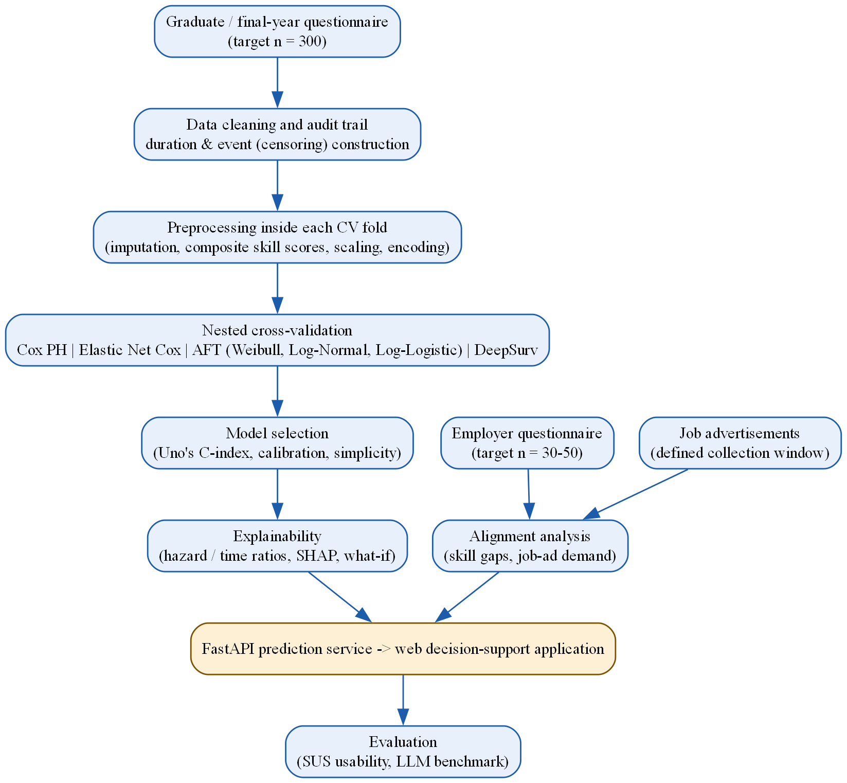
Figure 3.2: Analysis and Modelling Pipeline
Figure 3.3 shows how these stages were scheduled between January and October 2026, using the dates of the project documents and the development log. The title clearance, proposal and ethics application ran from February to May; Chapters 1-3 were written from May and revised in October; questionnaire design, job-advertisement collection and system development overlapped from June to October. Because the main survey closed on 6 October, the analysis of the real data, the usability study, the LLM benchmark and Chapters 4-6 were completed in the final week, the main schedule risk of the project.
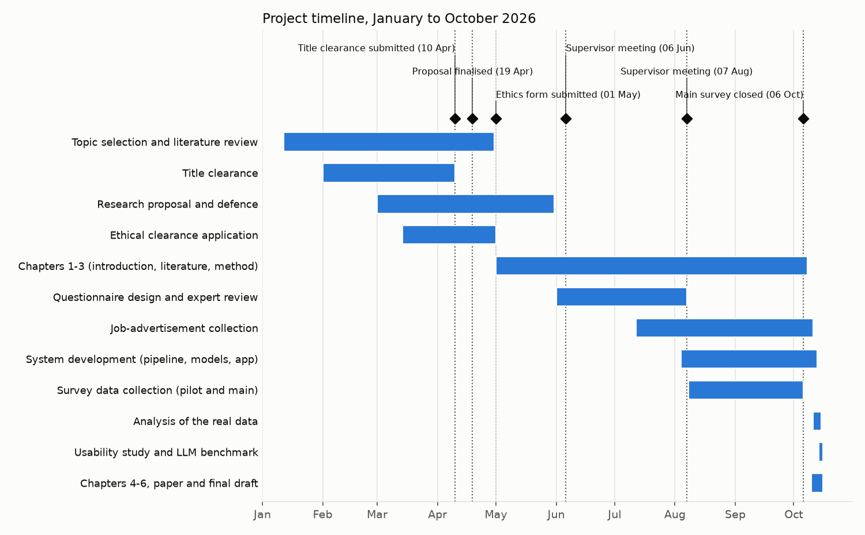
Figure 3.3: Project timeline, January to October 2026

3.6 Requirement Gathering
In practical terms, the artifact works as a simple, guided sequence rather than a black box. A final-year student or recent graduate enters a short profile covering their academic record, technical and soft skills, certifications, and internship or project experience. The trained survival-analysis model converts this profile into a predicted time-to-employment range together with an explicit confidence level. The explanation layer then states, in plain language, which specific factors in the profile are helping or holding back that estimate. The market-alignment view shows how the same profile compares against real employer requirements and current job-advertisement data. Finally, a ranked, prioritised suggestion tells the user the one change most likely to improve their outlook, with its predicted effect shown as a counterfactual - for example, how completing one additional relevant certification would be expected to shift the estimated range. This sequence, profile in and prediction, explanation, and guidance out, is presented together as a single results dashboard, whose individual components are specified as functional requirements below.
Functional and non-functional requirements for the artifact were derived from three sources: the literature review presented in Chapter 2, the specific data needs identified for model training (Section 3.7), and the intended end-user interaction - a final-year student or graduate entering a profile and receiving a prediction, explanation, and actionable guidance in return.
Functional requirements:
- Profile input (academic, technical, professional, and experiential data).
- Time-to-employment prediction generation, expressed as a range with an associated confidence level.
- Explanation display, at both global and individual (local) level.
- Employer and job-market alignment comparison.
- Counterfactual "what-if" simulation.
- A consolidated results dashboard combining the above.
Non-functional requirements:
- Usability appropriate for a non-technical end user.
- Reasonable response time for prediction generation.
- Robust input validation on all submitted profile data.
- Data privacy: no persistent storage of individual user profiles, as established in the scope statement in Section 1.5.

3.7 Data Collection Methods
Primary data:
- Graduate/Final-Year Employability Questionnaire (47 items) - the main source of profile and outcome (time-to-employment) data used to train the survival models, including the duration and censoring (event) variables central to the survival-analysis approach.
- Employer/Recruiter Questionnaire (21 items) - hiring-criteria and skill-importance data used for the market-alignment comparison component of the artifact.
Secondary data:
- Sri Lankan IT job advertisements, collected over a defined period, used to extract current skill-demand frequencies for the market-alignment feature.
- Industry reports, notably the SLASSCOM Employability Skills Report (SLASSCOM, 2024), used to contextualise and corroborate primary findings.
Population and sampling. The accessible population for the graduate/final-year questionnaire is estimated at approximately 17,000 IT/computing graduates produced annually in Sri Lanka (SLASSCOM, 2024). Given a population of this size, the required sample size is determined using Cochran's formula, n = Z²p(1-p)/e², as presented and applied in recent research-methodology literature (Abdallah, 2024), with a standard normal value of Z = 1.96 (corresponding to a 95% confidence level), a conservative proportion estimate of p = 0.5 (maximising required sample size under uncertainty about the true population proportion), and a margin of error of e = 0.05. This calculation yields a required sample of 384, so a target of approximately 400 responses is set. This target is also required by the modelling design described below, in which the sample is divided into separate training, validation and test sets. If fewer responses are obtained, the margin of error widens (for example, to about 5.6% at 300 responses), and this will be reported so that the precision of the findings can be interpreted appropriately.
For the employer questionnaire, the accessible sampling frame is SLASSCOM's membership base of over 200 companies; a target of 30 to 50 employer responses is set for this study, justified by proportion of the accessible frame (approximately 15% to 25%) rather than by a formal statistical calculation, given the smaller and less homogeneous nature of the employer population relative to the graduate population. It is acknowledged as a limitation (Section 1.7) that SLASSCOM's membership, while a reasonable and citable accessible frame, may not fully represent smaller or informally organised IT employers operating outside that industry association.
Given the practical recruitment approach available for this study - personal and university networks, social media, and referral-based outreach - a non-probability sampling strategy is used, specifically purposive sampling (respondents are screened against the eligibility criteria stated in Section 1.5 before participating) combined with convenience and snowball sampling. This is stated explicitly here as a limitation on the statistical generalisability of findings, rather than being presented, implicitly or otherwise, as probability-based random sampling.
Sample size for modelling. Beyond the descriptive precision above, the sample must support the models. A widely used guideline for survival models is at least 10 events (respondents who found a job) per estimated model parameter. Because the models are fitted on the training set only (70% of the modelling sample; Section 3.10), the guideline applies to the training set: with 16 model parameters, about 160 training events are needed. If approximately two-thirds of about 350 eligible graduates have found an IT job, about 230 events are expected, of which about 160 fall in the training set. Elastic Net Cox is included specifically to remain stable if fewer events are obtained than expected (Zhao et al., 2024). The number of events actually obtained will be reported and, if it falls below this level, the number of predictors will be reduced before modelling rather than after results are seen.
No existing public dataset records the time Sri Lankan IT graduates took to find their first IT job together with their skills, internships and certifications. National labour-force statistics report unemployment rates but not individual time-to-employment (Department of Census and Statistics, 2025), and university tracer reports give the proportion employed at one point in time rather than how long it took (University of Kelaniya, 2022). Survival analysis requires, for each person, a duration and an indicator of whether the event has occurred, so the data has to be collected directly. Each source is chosen because it answers a different part of the research questions:
- Graduate questionnaire: the only source that links an individual's profile to their own time-to-employment, including those still searching (censored), which is required for RQ1 and RQ3.
- Employer questionnaire: gives the demand side in employers' own words (what they say they value), required for the alignment comparison in RQ2.
- Job advertisements: show what employers actually ask for in public, independent of survey responses, and so act as a check on the employer questionnaire (RQ2).
- Industry reports: corroborate the primary findings against published national evidence (SLASSCOM, 2024).
Using three independent sources for the demand side (employers, advertisements and reports) allows findings to be triangulated rather than resting on a single, self-reported source.
Because this is a scientific study, every claim made in later chapters must be supported by recorded evidence. Table 3.1 states, before data collection, what evidence will be kept for each source and the minimum standard it must meet before it is used.
Table 3.1: Evidence retained for each data source
Data source | Evidence retained | Minimum standard before use
Graduate questionnaire | Anonymised raw export; consent record; cleaning audit trail (raw count, each exclusion and its reason, final count) | Valid consent; dates consistent (job date not before completion date); target of 300 complete responses
Employer questionnaire | Anonymised raw export; organisation size and sector only | Respondent involved in hiring decisions; target of 30 to 50 responses
Job advertisements | Source website, date collected and a saved copy of each advertisement; coding sheet | Collected within the defined window; duplicates removed; coding agreement (Cohen's kappa) of at least 0.6
Pilot study | Pilot responses, completion times, feedback and the list of changes made to the questionnaires | All changes documented before main data collection begins
Models | Code version, random seeds, settings and results of every experiment | Every reported number can be regenerated from the stored code and data

3.8 Software Development Methodology
The artifact is developed using an iterative methodology comprising planning, design, development, integration, testing, and refinement, repeated across the three main components of the system: the data pipeline, the modelling layer, and the user interface. The modelling and prediction-service layer is developed in Python, using the lifelines and scikit-survival libraries for the Cox, Elastic Net Cox, and AFT models, the pycox library (built on PyTorch) for DeepSurv, the SHAP library for explainability, and FastAPI to expose the prediction and explanation functionality as a lightweight web service. The user-facing interface is developed using Next.js, selected over Streamlit for its greater control over the layered, multi-panel dashboard the artifact requires (prediction, explanation, market-alignment comparison, and counterfactual guidance presented together), its more production-representative front-end/back-end separation from the FastAPI prediction service, and its closer alignment with the responsive, mobile-accessible web platform justified below. Reference data used by the artifact - job advertisements and aggregated, anonymised employer requirement data - is stored in a PostgreSQL database, while individual user input submitted to the prototype is processed statelessly and is not persisted, consistent with the scope and data-privacy requirements established in Sections 1.5 and 3.6.
A responsive web-based platform, rather than a native mobile application, was selected for the artifact. This choice is justified on three grounds. First, the artifact functions as a research demonstration and evaluation tool rather than a consumer product requiring app-store distribution, so a single, universally accessible link is more appropriate than an installable application. Second, none of the artifact's required functions - profile input, prediction display, explanation, and market-alignment comparison - depend on device-specific capabilities such as camera access, push notifications, or offline operation, which are the principal justifications for native mobile development. Third, a web-based platform is directly consistent with the technology stack described above and with the comparable systems reviewed in Section 2.3, avoiding the additional development effort a separate native codebase would require within the available project timeline. A native mobile application was therefore considered and not adopted; the resulting web platform remains fully accessible from a mobile browser, so this decision does not restrict the artifact's availability to end users.

3.9 Artifact Evaluation Strategy
Predictive model evaluation uses Uno's concordance index (C-index) as the primary metric (Sonabend et al., 2022), together with calibration analysis comparing the model's predicted survival curves against observed outcomes, and the integrated Brier score as a supplementary measure of overall prediction error (Zhao et al., 2024). The data are divided once into separate training, validation and test sets, so that models are fitted, tuned and finally evaluated on different respondents and no respondent is used more than once (Section 3.10). The time-to-employment range and confidence level presented to end users (Section 3.6) is derived from the predicted individual survival curve for each profile: the range is read off as the interval between specified lower and upper survival-probability quantiles (for example, the time points at which predicted survival probability falls to 75% and 25%), with the associated confidence level reported alongside it and validated against observed outcomes during calibration analysis. Plain classification metrics - accuracy, precision, recall, and standard (non-time-dependent) ROC-AUC - are deliberately not used as headline evaluation metrics in this study, since they are not statistically appropriate for censored, time-to-event data of the kind used here, and their use would directly undermine the methodological justification, established in Chapter 2, for adopting survival analysis in the first place.
Each metric answers a different question about whether the model works, and no single metric is sufficient on its own. Table 3.2 gives the reason for each choice.
Table 3.2: Evaluation metrics and the reason for each
Metric | Question it answers | Why it was chosen over alternatives
Uno's C-index (primary) | Does the model rank people correctly, so that those predicted to find work sooner actually do? | Designed for censored data; less biased than Harrell's C-index when many respondents are censored (Sonabend et al., 2022). Harrell's C-index is reported alongside for comparison with earlier studies
Calibration at 3, 6 and 12 months | Are the predicted probabilities correct (for example, of those given a 60% chance of a job within 6 months, did about 60% find one)? | A model can rank well but give wrong probabilities; the artifact shows probabilities to users, so these must be accurate (Zhao et al., 2024)
Integrated Brier score | How large is the overall prediction error over time? | Combines ranking and calibration into one error measure for censored data, and allows comparison with a no-information baseline (Zhao et al., 2024)
Kaplan-Meier baseline | Is the model better than predicting the same curve for everyone? | A model is only useful if it improves on this baseline; reporting it prevents a weak model from appearing strong
95% confidence intervals (bootstrap) | How certain is each result? | The validation and test sets are small (about 15% of the sample each), so a single number without its uncertainty could be misleading; the bootstrap resamples the evaluation set only and refits no model
To avoid choosing the metric that makes results look best after seeing them, the primary metric, the baseline and the model-selection rule are all fixed in advance in this chapter (Sonabend et al., 2022).
Prototype evaluation uses the System Usability Scale (SUS), a widely used and validated ten-item usability instrument whose benchmark mean of 68 has been confirmed for digital applications (Hyzy et al., 2022), administered to a target sample of 8 to 12 representative end users (final-year students and recent graduates, recruited via the same channels described in Section 3.7) following a hands-on interaction with the working prototype. In addition to model and usability evaluation, a structured benchmark test compares the artifact's output against a general-purpose LLM (such as ChatGPT), given identical profile input for a matched set of test cases. This comparison specifically and explicitly documents whether the LLM is able to produce a validated, locally grounded, and independently measurable prediction under the same conditions, providing the direct empirical evidence underpinning the justification set out in Section 1.6.

3.10 Data Analysis Techniques
This section explains which analysis technique is used for each research objective and question, why each technique is appropriate for the variables and type of data involved, and how the collected data will be analysed step by step to answer each question.
The choice of technique follows from the type of data collected. Table 3.3 summarises the main variables.
Table 3.3: Variables and types of data
Variable | Source | Type of data | Used for
Time to first IT job (months from degree completion) | Graduate questionnaire | Continuous duration, right-censored | Outcome (RQ1, RQ3)
Employment event (found an IT job: yes/no) | Graduate questionnaire | Binary (1 = event, 0 = censored) | Outcome (RQ1, RQ3)
GPA, internship months, certifications, projects | Graduate questionnaire | Numeric (continuous / count) | Predictors (RQ1, RQ3)
Degree programme, institution type | Graduate questionnaire | Categorical (nominal) | Predictors (RQ1, RQ3)
17 technical and 9 soft-skill self-ratings | Graduate questionnaire | Ordinal (1-5 Likert) | Composite predictors (RQ1, RQ3); alignment (RQ2)
Skill importance ratings (same 26 skills) | Employer questionnaire | Ordinal (1-5 Likert) | Alignment (RQ2)
Skills mentioned in each advertisement | Job advertisements | Binary per skill (mentioned / not) | Market demand (RQ2)
SUS responses (10 items) | Usability test | Ordinal (1-5), converted to a 0-100 score | Usability (RQ4)
LLM and model time estimates for the same profiles | Benchmark test | Continuous (months) | Benchmark (RQ4)
Table 3.4 links each objective and research question to the analysis technique, the reason it is appropriate, and the output it produces.
Table 3.4: Data analysis techniques by research objective and question
Objective / RQ | Technique | Why this technique is appropriate | Output
O1 / RQ1: factors associated with time-to-employment | Descriptive statistics; Kaplan-Meier curves with log-rank tests; multivariable Cox Proportional Hazards regression; Schoenfeld-residual test | The outcome is time-to-event with censored respondents still searching, which survival methods handle correctly; Kaplan-Meier describes time-to-employment by group, and Cox estimates each factor's association while adjusting for the others without assuming a time distribution (Zhao et al., 2024) | Employment curves by group; hazard ratios with 95% confidence intervals
O2 / RQ2: graduate-employer alignment | Gap score per skill (employer importance minus graduate rating); Mann-Whitney U test per skill with false-discovery-rate correction; Spearman rank correlation | Ratings are ordinal Likert data from two independent groups (graduates and employers), so a non-parametric test is appropriate; correction is needed because 26 skills are tested | Ranked list of the largest, statistically supported skill gaps
O2 / RQ2: job-market demand | Share of advertisements mentioning each skill with Wilson 95% confidence intervals; inter-coder agreement (Cohen's kappa) on a sample of advertisements | Skill mentions are binary, so proportions with intervals suited to small and extreme proportions describe demand (Hofer & Held, 2022); kappa checks that skills are coded consistently (Li et al., 2023) | Ranked skill demand with uncertainty; coding reliability
O3 / RQ3: predictive accuracy and model comparison | Fixed training / validation / test split: Cox, Elastic Net Cox, AFT (Weibull, Log-Normal, Log-Logistic) and DeepSurv fitted on training, compared on validation; the selected model evaluated once on test; Uno's C-index, calibration, integrated Brier score | Keeping fitting, tuning and final evaluation on different respondents gives an honest estimate with no data reused; these metrics are designed for censored data (Sonabend et al., 2022) | Validation comparison table; best-supported model selected by a pre-defined rule; final test-set result
O3 / RQ3: explanations | Hazard and time ratios (Cox, AFT); SHAP values (DeepSurv) | Ratios are directly interpretable for linear models; SHAP provides comparable individual-level explanations for neural networks (Mosca et al., 2022) | Global and individual explanations for the artifact
O4 / RQ4: usability | System Usability Scale: mean score with 95% confidence interval, compared with the benchmark of 68 | SUS is a validated, widely used usability measure with an established benchmark (Hyzy et al., 2022) | Usability score and identified usability issues
O4 / RQ4: comparison with a general-purpose LLM | Same held-out profiles given to the model and to the LLM; Uno's C-index for both; paired bootstrap of the difference; consistency of repeated LLM answers | Using identical profiles and the same metric makes the comparison fair; the paired bootstrap gives a confidence interval for the difference | Evidence of whether the model outperforms the LLM
Step 1 - Data preparation. Raw questionnaire exports are cleaned using documented rules: duplicate submissions are removed, out-of-range values are set to missing, and every exclusion is recorded in an audit trail. For each graduate, the duration is calculated as the months from degree completion to the first IT job (event = 1) or, for those still searching, to the survey date (event = 0, censored). Final-year students, who have no outcome yet, are used only to receive predictions. The graduates are then divided once into training, validation and test sets (Step 4). Missing values are imputed using rules learned from the training set only, so that no information from the validation or test data leaks into model training.
Step 2 - Answering RQ1 (factors). Descriptive statistics summarise the sample. Kaplan-Meier curves show how quickly graduates found work overall and by group (for example, with versus without an internship), and log-rank tests check whether group differences are statistically significant. A multivariable Cox model then estimates the association of each factor with the hazard of finding work while holding the others constant; a hazard ratio above 1 indicates a shorter time to employment. To keep the model stable with the expected sample size, the 17 technical and 9 soft-skill items are averaged into composite scores once their internal consistency is confirmed (Section 3.11), keeping the number of events per model parameter above the commonly used minimum of 10. The proportional-hazards assumption is tested with scaled Schoenfeld residuals; where it is violated, greater weight is given to the AFT models, which do not require it.
Step 3 - Answering RQ2 (alignment). For each of the 26 skills, the gap between employers' average importance rating and graduates' average self-rating is calculated. Because both are ordinal ratings from two independent groups, a Mann-Whitney U test assesses whether each gap is statistically significant, with a false-discovery-rate correction for testing 26 skills. Separately, the share of job advertisements mentioning each skill is calculated with a Wilson confidence interval, and a Spearman rank correlation tests whether employers' stated priorities agree with what they actually advertise. Skills with large, significant gaps and high advertised demand are identified as the most actionable.
Step 4 - Answering RQ3 (accuracy). Before any modelling, the graduates are divided once into a training set (70%), a validation set (15%) and a test set (15%), stratified by event status and institution type so that each set has a similar share of censored respondents. Each respondent belongs to exactly one set and is never reused in another role. Every model is fitted only on the training set; its settings are tuned and the candidate models are compared on the validation set; and the selected model is evaluated once on the locked test set, which is not used for any decision. The final model used by the artifact is the one fitted on the training set. Uno's C-index measures how well each model ranks respondents by time to employment (0.5 = chance, 1.0 = perfect), calibration checks whether predicted proportions employed at 3, 6 and 12 months match observed proportions, and the integrated Brier score summarises overall error. The best-supported model is selected by a rule fixed before results are seen (highest C-index; if models are within 0.02, the simpler and better-calibrated model is preferred), and is then used to generate explanations.
Step 5 - Answering RQ4 (artifact). After a hands-on session with the prototype, participants complete the SUS; the mean score and its confidence interval are compared with the benchmark of 68, and usability issues are summarised. For the LLM benchmark, held-out profiles are given to both the selected model and a general-purpose LLM using a standard prompt; both sets of estimates are scored with Uno's C-index against the observed outcomes, the difference is tested with a paired bootstrap, and the consistency of the LLM's answers across repeated runs is reported.
Step 6 - Fairness check. Model performance is compared across gender and institution type to identify any unintended differences before the artifact is presented as a finished contribution. Gender is used only for this check and is never a model input.
Table 3.5 summarises the rationale for including each of the candidate survival models compared in Step 4.
Table 3.5: Candidate Survival Models and Rationale for Inclusion
Candidate Model | Rationale for Inclusion
Cox Proportional Hazards | Linear baseline; estimates the effect of covariates on the hazard of the event occurring without requiring an assumption about the distribution of survival time, and remains the most widely used approach for this purpose (Tarkhan & Simon, 2024).
Elastic Net Cox | Regularised Cox model applying statistical penalisation to handle a high ratio of predictor variables to observations, which is directly relevant given this study's expected sample size (Zhao et al., 2024).
Accelerated Failure Time models (Weibull, Log-Normal, Log-Logistic) | Model survival time directly under a specified distributional assumption, providing more directly interpretable time-based estimates, and do not require the proportional-hazards assumption.
DeepSurv | Replaces the Cox model's linear risk function with a neural network, included specifically to test empirically, rather than assume, whether the relationship between employability factors and time-to-employment is linear or nonlinear (Wiegrebe et al., 2024).
The algorithms were chosen from the properties of the data and the research questions, not from popularity:
- The outcome is censored. Many respondents will still be searching for work when surveyed. Ordinary regression or classification would either discard these respondents or treat them as failures, both of which bias the results. Survival models use the information that a person has not yet found work by a given time (Zhao et al., 2024).
- The results must be explainable. RQ1 asks which factors matter, and the artifact must explain its predictions to users. Cox and AFT models give a hazard ratio or time ratio for each factor that can be stated in plain language.
- The sample is moderate. With about 250 respondents in the training set, simple models are less likely to overfit; Elastic Net Cox adds penalisation for further protection (Zhao et al., 2024).
- Linearity should be tested, not assumed. DeepSurv is included as the neural-network comparison so that the study can show whether a more flexible model actually improves prediction on this data (Wiegrebe et al., 2024). If it does not clearly improve on the simpler models, the simpler model is preferred.
- Ensemble and forest-based methods are excluded in line with the supervisory requirement stated in Section 3.1, and because their individual explanations are harder to present to non-technical users.
Data leakage occurs when information that would not be available at prediction time, or information from the test data, enters model training, producing results that look better than the model would perform in practice (Kapoor & Narayanan, 2023). The following safeguards are applied:
- No post-outcome features. Information known only after a person is employed (current salary, job title, employer, time in current job) is never used as a predictor. The final list of predictors is fixed and documented before any model is trained.
- No respondent is used in more than one role. The data are split once into training, validation and test sets before any modelling; models are fitted only on training, tuned and compared only on validation, and the test set is used once for the final evaluation (Kapoor & Narayanan, 2023).
- All preprocessing is learned from the training set only. Imputation of missing values, scaling, encoding and composite-score calculation are learned from the training set and then applied to the validation and test sets, never to the whole dataset at once (Sisk et al., 2023).
- Tuning never sees the test set. Hyperparameters and the final model are chosen on the validation set; nothing is changed after the test result is seen.
- No person appears in both training and test data. Duplicate submissions are removed before splitting, and each respondent is one row.
- Final-year students are never used for training. They have no outcome yet and only receive predictions.
- Job-advertisement data is not a model input. It is used for the alignment analysis only, so it cannot leak market information into the prediction.
This study does not ask only whether the model works, but under what conditions it works and what evidence shows this. Table 3.6 sets out each condition, how it is tested, and what happens if it is not met. These criteria are fixed before the data is analysed.
Table 3.6: Conditions under which the model is claimed to work
Condition | How it is tested | Evidence that it holds | If it does not hold
Better than no model | Compare with the Kaplan-Meier baseline | 95% confidence interval of the C-index above 0.5; integrated Brier score lower than the baseline | Report that the profile does not predict time-to-employment; the artifact shows market alignment only
Probabilities are correct | Calibration at 3, 6 and 12 months | Predicted and observed proportions within each other's confidence intervals | Recalibrate, or show only ranges and not probabilities
Results are stable | Bootstrap intervals on the validation and test sets; agreement between validation and test C-index | Similar validation and test C-index; intervals not excessively wide | Report the uncertainty and prefer the simpler model
Works across institutions | Train on some institution types and test on another | C-index on the held-out institution type close to the overall result | State that predictions apply only to the institution types represented
Fair across groups | Performance by gender and institution type | No large difference in C-index or calibration between groups | Report the difference and warn users in the artifact
Model assumptions hold | Schoenfeld residuals (Cox); fit of the AFT distribution | No significant violation | Give greater weight to the AFT models
Within the data | Compare each new profile with the range of the training data; limit predictions to the follow-up period observed | Profile within the observed ranges | Show a warning that the estimate is less reliable
Not overfitted | Difference between training and test C-index | Small gap between training and test performance | Increase penalisation or reduce the number of predictors
The model will therefore be described as working only for the population, time period and range of profiles represented in the data, and only to the extent shown by this evidence.

3.11 Research Validity and Reliability
Questionnaire validity. Content validity for both questionnaires is evidenced through a per-item Evidence and Justification Matrix, mapping each of the sixty-eight combined questionnaire items to published evidence from 2022 onwards - peer-reviewed studies of graduate employment, large published surveys and datasets that ask the same question (for example, employer and developer surveys and the national Labour Force Survey), and Sri Lankan studies - or, where no such evidence was found, to an explicit stated design rationale. Each item is graded A (direct evidence), B (indirect evidence) or C (design reason only), and grade C items that are candidate predictors are reviewed in the pilot test. Face validity is established through review conducted prior to piloting by a small validation panel comprising the research supervisor and two subject-matter experts - one academic with a background in graduate employability research, and one industry practitioner with IT recruitment experience - each asked to independently assess item clarity, relevance, and coverage before the questionnaire is finalised for piloting. Where a questionnaire item is adapted from an established multi-item psychometric scale - for example, the Graduate Capital Scale (Tomlinson et al., 2022) or the EmployABILITY Scale (Bennett & Ananthram, 2022) - this is stated explicitly in the Justification Matrix, and it is not assumed that the original instrument's published reliability figures transfer automatically to a single item extracted for use in this study.
Pilot testing and validation procedure. Both questionnaires pass through four validation stages before main data collection begins, summarised in Table 3.7. Each stage has a pre-set criterion, and every change made is recorded so that the final instruments can be traced back to the evidence that shaped them (Saunders et al., 2023).
Table 3.7: Pilot testing and instrument validation stages
Stage | Participants | What is checked | Criterion / output
1. Expert review | Six experts: three academics (research methodology, software engineering, survival analysis) and three industry practitioners | Written comments on the relevance and clarity of the questionnaire items, missing topics and the research design | Every recommendation addressed, or the reason for not acting on it recorded (Table 3.8; Appendix B)
2. Cognitive pre-test | 3 to 5 graduates, thinking aloud while answering | Whether questions are understood as intended, especially dates of completion and first job | Ambiguous wording rewritten
3. Pilot test | 10 to 15 graduates/final-year students and 5 to 8 employers, excluded from the main sample | Completion time; items skipped by more than 10% of respondents; platform and skip-logic errors; Cronbach's alpha for the skill blocks; whether duration and event can be calculated for every respondent | Alpha of at least 0.7 per block; all technical errors fixed; changes documented
4. Test-retest check | 5 to 8 pilot graduates who answer the date questions again after two weeks | Consistency of the recalled job-start and completion dates | Recalled durations differ by no more than one month for most respondents; otherwise date questions are reworded
During main data collection, each response is also validated automatically: required fields must be complete, numeric values must be within plausible ranges (for example, GPA between 0 and 4), the first-job date cannot be earlier than the completion date, and an attention-check item identifies careless responses. Responses that fail these checks are excluded and recorded in the audit trail.
Expert review. Six experts reviewed the questionnaires and the research design before the main data collection (Table 3.8). They are identified only by their background. Their full recommendations and how each was addressed are in Appendix B.
Table 3.8: Expert reviewers (anonymised) and the main points they raised
Expert | Background | Main points raised
Expert 1 | Academic, research methodology | Define the constructs; collect completion and job dates consistently; explain censoring; justify the model; ensure an adequate sample
Expert 2 | Industry, recruitment | Distinguish essential from desirable skills; employers differ in their criteria; present the output as guidance, not judgement
Expert 3 | Academic, software engineering | Separate theory from applied ability; use clear skill wording and the same terms for graduates and employers; requirements vary by role
Expert 4 | Industry, software company leadership | Recommendations should be actionable: name the competency and a practical activity
Expert 5 | Academic researcher, survival analysis | Handle right-censoring; set the selection criteria in advance; avoid leakage; use the test set once; keep claims proportionate
Expert 6 | Industry, talent acquisition | Capture experience from several activities; do not rely on one skill rating; outcomes also depend on market conditions
Reliability. The pilot test described above, involving ten to fifteen graduate/final-year respondents and five to eight employer respondents, none of whom are included in the final study sample, is conducted prior to full-scale data collection. This pilot serves to check question clarity, completion timing, and any technical issues with the data-collection platform, and to compute a preliminary Cronbach's alpha for the two genuine multi-item scale blocks contained within the questionnaire - the seventeen-item technical-skills matrix and the nine-item soft-skills matrix - with a target alpha of at least 0.7 for each, consistent with conventional reliability thresholds in the social-science and employability literature. All other questionnaire items are demographic, categorical, checklist-style, or outcome-variable items, for which Cronbach's alpha is not a statistically applicable measure, and this distinction is made explicit rather than applying a reliability statistic indiscriminately across the entire instrument. For the job advertisements, coding reliability is checked with Cohen's kappa on a random sample of advertisements coded independently (Li et al., 2023).
Model and data validity:
- A documented data-cleaning audit trail is maintained and reported in Chapter 4, recording the raw number of responses collected, every exclusion applied together with its stated reason, and the final sample size used in modelling - providing direct, reproducible evidence of how the collected data was actually used.
- The proportional-hazards assumption underlying the Cox model is explicitly tested using standard diagnostic procedures; any violation identified is reported transparently and used to justify placing greater analytical weight on the AFT model family, which does not require this assumption.
- All models are developed and evaluated on a fixed three-way split (training, validation, locked test) so that no respondent is reused across roles. A single split gives noisier estimates than repeated resampling (Bates et al., 2024), so every estimate is reported with a bootstrap confidence interval and the sample target is set at about 400 to keep the validation and test sets usable.
- Data-leakage checks are applied throughout to ensure that no feature which is only knowable after employment has already occurred (for example, current salary or job title) is inadvertently used as a predictor variable.

3.12 Ethical Considerations
Ethics and privacy:
- Personal data is collected, stored and processed in accordance with Sri Lanka's Personal Data Protection Act, No. 9 of 2022 (Parliament of the Democratic Socialist Republic of Sri Lanka, 2022): only data needed for the research questions is collected, its purpose is stated in the consent form, and participants may withdraw before analysis.
- Voluntary participation with informed consent, obtained in accordance with the eligibility criteria and consent statement included at the start of both questionnaires.
- Anonymisation and, where appropriate, pseudonymisation of all collected data; no personally identifying information is disclosed in this dissertation or in any associated publication or presentation arising from this research.
- Secure, access-restricted storage of all raw data, with at least one secure secondary backup maintained throughout the research period.
- The artifact is explicitly presented, both within its own user interface and throughout this dissertation, as a decision-support tool rather than a hiring system or an employment guarantee of any kind, consistent with the limitation stated in Section 1.7.
- A subgroup and fairness check, described in Section 3.10, is conducted specifically to identify any unintended disparities in model predictions across demographic groups before the artifact is presented as a finished contribution.
- Institutional ethical approval is sought and obtained prior to the commencement of any primary data collection activity.
Reproducibility:
- All code, the software environment (exact library versions) and the analysis scripts are kept under version control (Git), so that every reported result can be linked to the exact code that produced it. The code is available at https://github.com/ShaznaSalman/final-research-employability-survival_COBSCCOMP24.2P019.
- Random seeds are fixed for data splitting and model training, and every experiment, including unsuccessful ones, is logged with its settings and results.
- A data card describes each dataset (source, collection dates, variables, exclusions and known limitations); the anonymised data and code are shared with examiners where ethics approval permits.
- The development and reporting of the prediction models follow the TRIPOD+AI reporting guideline (Collins et al., 2024).
- The analysis plan in this chapter, including the predictors, primary metric, baseline and model-selection rule, is recorded before the data is analysed, and any later deviation is reported with its reason.

3.13 Chapter Summary
This chapter has presented the pragmatist philosophy and deductive, quantitative research approach adopted for this study, together with the Design Science Research Methodology used to guide both the empirical investigation and the development of the prototype artifact. It has detailed the twelve-stage research process; the functional and non-functional requirements informing the artifact's design; the primary and secondary data collection methods, including an explicit, formula-justified sample-size target and an honest statement of the non-probability sampling strategy used; the iterative software development methodology and technology stack; and the evaluation strategy for both the predictive models and the prototype, with the reason for each metric. It has set out the variables and types of data, linked each data analysis technique explicitly to a research objective and question with a justification for its use, and explained step by step how the collected data will be analysed to answer each question, why each algorithm was chosen, how data leakage is prevented, and the pre-set conditions and evidence under which the model will be claimed to work, followed by the four-stage pilot and validation procedure, the evidence retained for every data source, and the ethical, privacy and reproducibility safeguards governing the research. Chapter 4 presents the design and implementation of the proposed solution.

Chapter 4
Proposed Solution

4.1 Introduction
This chapter describes the solution built to meet the objectives set out in Section 1.3: the requirements it satisfies, the proposed system, its architecture and design, the survival models and algorithms it uses, how the real survey and job-advertisement data were prepared, the technologies selected, and how the system was implemented, corresponding to the design and development and the demonstration stages of the Design Science Research Methodology (Section 3.4). Where the implementation differs from the plan in Chapter 3, the difference and its reason are stated.

4.2 Requirement Analysis
The functional and non-functional requirements gathered in Section 3.6 were analysed into components (Tables 4.2 and 4.3). For each requirement, these tables state its purpose, the behaviour expected of the system, the objective or concern it serves and the component that satisfies it. FR7, answering a user's questions about their result, was added during development because explanation was the output graduates most wanted. The main study itself provided further evidence for them: 83.5% of the graduates (Q44) and 93.9% of the employers (E17) rated an explanation of a prediction as important or very important, and the explanation most wanted by graduates was the skills they need to improve (80.4%, Q45).
Two design principles shaped the analysis. First, the offline pipeline is separated from the runtime service: all data cleaning, model fitting, selection and evaluation run once, offline, and the deployed service only loads the saved results, which keeps responses fast and makes every result reproducible. Second, communication is honest: every sentence shown to a user is written in one wording module, uses associational language ("graduates with profiles like yours tended to..."), and states the limits of the estimate.
This section first follows the data through the system (Section 4.2.1), then lists the functional requirements (Section 4.2.2) and the non-functional requirements (Section 4.2.3).

4.2.1 Inputs, Processing and Outputs
Table 4.1 follows the data through the system in two parts: the offline pipeline, which is run once to produce the results, and the runtime service that a graduate uses.
Table 4.1: Inputs, processing and outputs of the system
Stage | Input | Processing | Output
Offline 1: Import and cleaning | Google Forms response workbooks (1,175 graduate and 245 employer responses) and 324 job advertisements | Convert to CSV, apply the documented cleaning rules and log every exclusion | 885 modelling graduates, 239 employers, cleaning log
Offline 2: Outcome | Month of degree completion, month of the first IT job, survey date | Duration in months; event if an IT job was found, censored if still searching | Duration and event for each graduate
Offline 3: Split | 885 modelling graduates | One stratified assignment (70/15/15), saved to a file | Training 620, validation 133, test 132
Offline 4: Preprocessing | Training set | Imputation, scaling and encoding learned from the training set only | Model-ready predictors
Offline 5: Fit, select and test | Training, validation and test sets | Fit seven models; choose by the pre-set rule on validation; evaluate the selected model once on the test set | Selected AFT Log-Normal model; test Uno's C 0.619
Offline 6: Artifacts | Final model and results | Save the final model, 200 bootstrap models, reference database, reports and figures | Files that the runtime service loads
Runtime 1: Profile entry | Academic record, institution type, internship months, projects, certifications, skill ratings and preparation items | The web page collects the profile; no name or contact detail is asked | Profile sent to the API
Runtime 2: Validation | Profile | The API checks every field against typed schemas | Valid profile, or a clear error message
Runtime 3: Prediction | Valid profile | The selected model builds the survival curve; the 200 bootstrap models give the uncertainty | Most likely time, typical range, confidence label, chance of a job by 3, 6, 12 and 24 months
Runtime 4: Explanation | Profile and model coefficients | Contribution of each factor against the average training graduate | Up to three factors helping and three holding back
Runtime 5: What-if and suggestions | Profile and changed factors | Re-predict after changing actionable factors within realistic ranges; search small combinations | New range; up to three combinations to explore
Runtime 6: Market alignment and peers | Skill ratings, employer ratings, advertisement demand, peer-group summaries | Compare each of the 26 skills, rank the largest gaps, summarise peer groups | Skill-gap chart, free learning resources, peer medians
Runtime 7: Questions about the result | A typed question and the profile | Fixed keyword rules choose a question type; the answer comes from the system's own results | A grounded reply; nothing is stored

4.2.2 Functional Requirements
Table 4.2 lists the seven functional requirements.
Table 4.2: Functional requirements and the components that satisfy them
ID | Requirement | Purpose | Expected behaviour | Relevance | Satisfied by
FR1 | Profile input | Capture the graduate's academic, experience and skill profile in the questionnaire's terms | Accepts the core inputs (GPA or degree class, institution type, degree programme, internship, certifications, projects) and optional skill ratings; rejects missing or out-of-range values with a plain message | O4, RQ4; inputs match the model predictors (O1) | Typed API request schema generated from the questionnaire definition; input form on the My prediction page
FR2 | Prediction as a range with a confidence level | Give an individual estimate with honest uncertainty | Returns the most likely month, a typical range, the chance of work by 3, 6, 12 and 24 months and a High, Medium or Low label; reports "more than 24 months" instead of extrapolating | O3, RQ3, RQ4 | Prediction module: individual survival curve, typical range, 200 bootstrap refits
FR3 | Global and individual explanation | Show why the estimate is what it is | Lists up to three factors helping and three holding back, only factors a graduate can change, in associational wording; global effects on the Research lab page | O1, RQ1, RQ4 | Explanation module: time-ratio contributions per factor (SHAP for neural models); Research lab page
FR4 | Employer and job-market alignment | Compare the profile with what employers value and advertise | Shows each skill's gap against employer importance and advertised demand, the largest gaps with free learning resources, and peer benchmarks with groups under 10 suppressed | O2, RQ2 | Reference database of employer ratings and job-advertisement demand; alignment module
FR5 | Counterfactual what-if simulation | Let the user explore realistic changes | Re-predicts after changes to actionable factors within valid ranges, warns outside the training range, and suggests up to three combinations linked with work at least one month sooner | O4, RQ4 (actionable guidance) | What-if module with range checks; suggestion search over small, realistic changes
FR6 | Consolidated results dashboard | Present every result in one place for a non-technical user | One page with headline cards, charts and sections, each labelled with its data source | O4, RQ4 | "My prediction" page combining all of the above
FR7 | Questions about the result | Let the user ask about their result in their own words | Recognises fixed question types and answers only from the system's own outputs; declines off-topic questions; stores nothing | O4, RQ4 (explainability) | Grounded chat assistant (/chat) on the My prediction page

4.2.3 Non-Functional Requirements
Table 4.3 lists the four non-functional requirements.
Table 4.3: Non-functional requirements and the components that satisfy them
ID | Requirement | Purpose | Expected behaviour | Relevance | Satisfied by
NFR1 | Usability for non-technical users | Be usable without statistical training | Plain language, ranges rather than single numbers, four pages; target mean SUS of at least 68 | O4 (Section 5.8) | Plain-language wording module; four-page navigation; headline-number cards
NFR2 | Reasonable response time | Keep the application interactive | Every request answered in under one second | O4 (Section 5.5) | Pre-computed artifacts loaded once at start-up
NFR3 | Robust input validation | Stop invalid or unintended inputs, such as gender, reaching the model | Rejects out-of-range values, unexpected fields and missing core inputs with an explanatory error | Correctness and fairness | Request schemas that reject out-of-range values and unexpected fields
NFR4 | No storage of individual profiles | Protect users' privacy | No profile or question is written to a database, file or log | Ethics (Section 3.12); PDPA | Stateless API; no database writes, files or logs of profiles
Figure 4.1 shows the resulting use cases. The graduate or final-year student uses all user-facing functions; the researcher also maintains the system by re-running the pipeline when new data arrive.
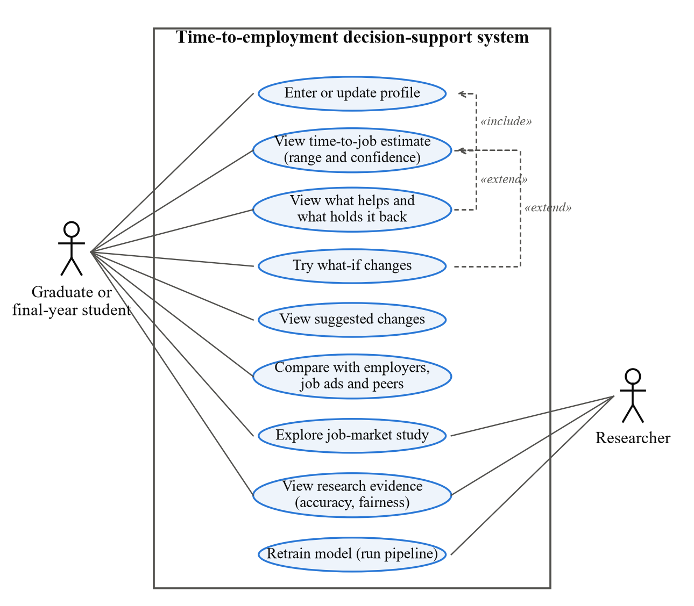
Figure 4.1: Use-case diagram of the decision-support system

4.3 Proposed Solution
The proposed solution is a web-based decision-support system that estimates how long graduates with a given profile took to find their first IT job, explains which parts of the profile were associated with a shorter or longer search, and compares the profile with what employers and job advertisements ask for. It has four pages:
- Home - the purpose of the system, headline figures and the source of each dataset.
- My prediction - a graduate or final-year student enters a profile and receives the most likely time to a first IT job with a typical range and a confidence label, the factors helping and holding back the estimate, the chance of having found work by 3, 6, 12 and 24 months, suggested combinations of realistic changes, what-if sliders, and comparisons with employers, job advertisements and similar graduates (Figure 4.3). Graduates who are still searching can enter how long they have searched; the estimate is then conditioned on that. An "Ask about your result" panel answers questions about the estimate in the user's own words (Section 4.6).
- Job market - an interactive study of the 324 real job advertisements: skill demand with confidence intervals, role profiles, skill bundles, intern-versus-junior differences and named technologies.
- Research lab - the evidence behind the estimates: model comparison, calibration, effects, fairness and robustness.
It is decision support only, not a hiring or screening tool.

4.4 System Architecture
The system has three layers (Figure 4.2). The data layer holds the survey responses and the job advertisements. The offline pipeline, run with a single command, cleans the data, constructs the survival outcome, makes the fixed training, validation and test split, fits and compares the candidate models, evaluates the selected model once on the test set, fits 200 bootstrap models, runs the fairness and robustness analyses, builds an aggregated reference database and writes every result as an artifact. The runtime layer loads these artifacts into a core library, exposes it through a FastAPI REST service with thirteen endpoints, and presents it through a Streamlit web application that calls the service over HTTP.
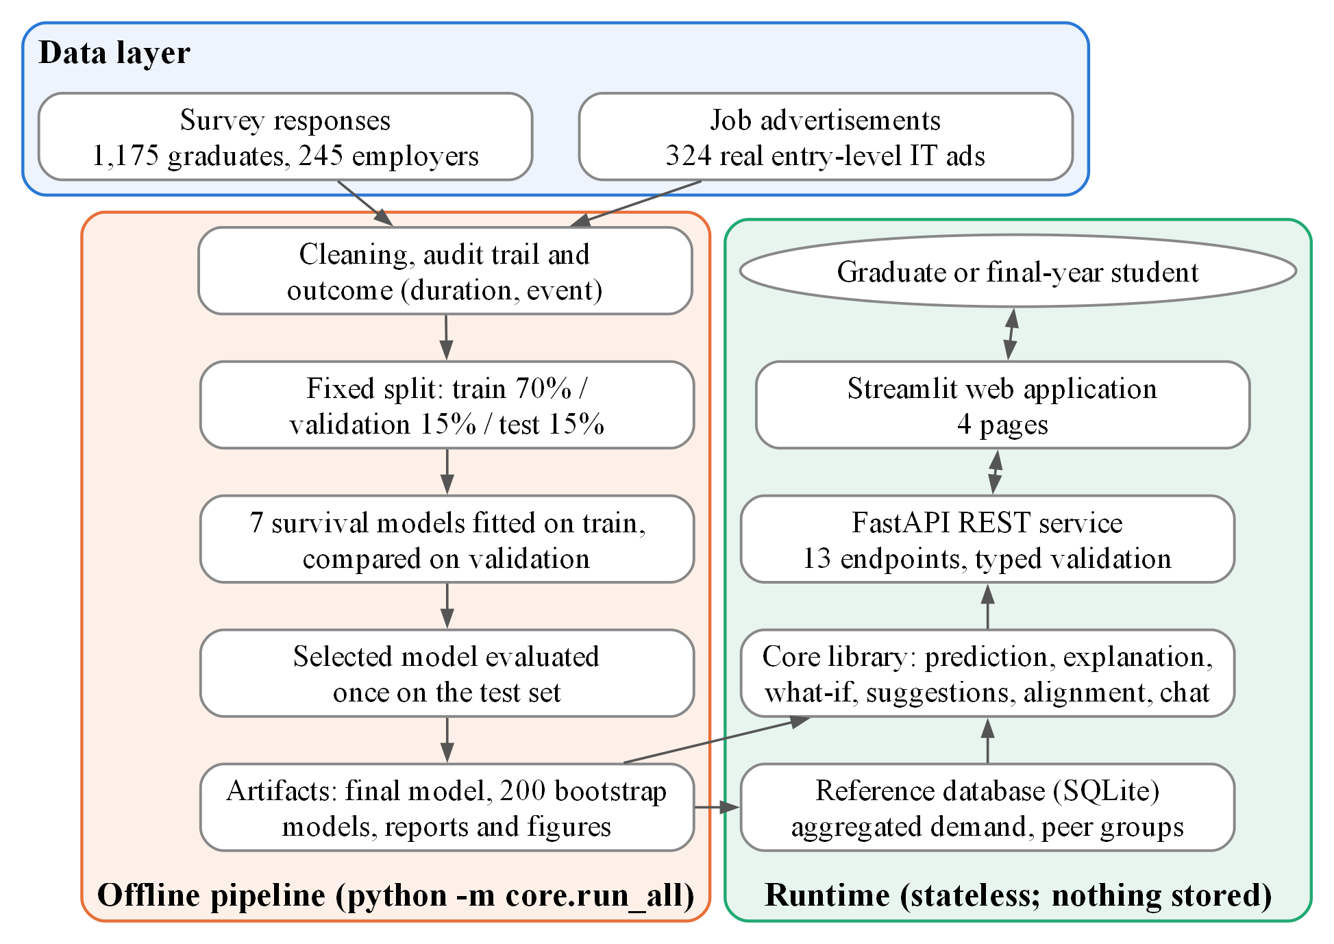
Figure 4.2: System architecture
The components in Figure 4.2 have the following roles:
- Survey responses and job advertisements (data layer): the graduate, employer and advertisement records, kept unchanged; the pipeline reads them but never alters them.
- Cleaning, audit trail and outcome: applies the documented cleaning rules, records every exclusion and computes each graduate's duration and event.
- Fixed split: assigns each modelling graduate once to the training (70%), validation (15%) or test (15%) set, stratified by event and institution type, and saves the assignment so that no module can change it.
- Model fitting and comparison: fits the seven candidate survival models on the training set and compares them on the validation set under the selection rule fixed in advance.
- Single test evaluation: evaluates the selected model once on the locked test set.
- Artifacts: the final model, 200 bootstrap models, reports and figures written by the pipeline and loaded by the runtime.
- Reference database (SQLite): aggregated employer ratings, job-advertisement demand and peer-group survival summaries, with no individual records.
- Core library: the prediction, explanation, what-if, suggestion, alignment and chat functions that turn a profile into results using the artifacts.
- FastAPI REST service: thirteen endpoints that validate every request against typed schemas and return the core library's results; it holds no state.
- Streamlit web application: the four pages through which the user enters a profile and reads the results; it calls only the API.
- Graduate or final-year student: the end user, who sees only the web application.
This architecture keeps the interface free of model logic: the web application only calls the API, so the same service could serve another interface, such as a mobile application, without change. The API holds no state, and the reference database contains only aggregated data, so no individual profile is ever stored.

4.5 System Design
Data model. A single schema module defines every questionnaire field, its valid values and its role: model input, outcome construction, fairness check only, or descriptive. The cleaning rules, the API request and response schemas and the data dictionary are all generated from it, which prevents inconsistencies between components. Gender is defined as a fairness-check field and can never reach the model.
Outcome design. The time origin is the month of degree completion (Q5a). A graduate who has started a paid IT role (Q17) is an event, with duration equal to the months from completion to the first IT role (Q17a); a graduate still searching is censored at the survey month. Graduates who found work at or before completion (117 of the 885) receive a duration of half a month, because survival models require a positive time. Graduates in further studies or not seeking work are excluded from the model, because they are not in the IT job market.
API design. The service exposes thirteen endpoints: eight accept a JSON profile (/predict, /explain, /whatif, /suggestions, /market-alignment, /peer-benchmark, /insights, /chat) and five return pre-computed results (/job-market, /questionnaire, /research, /model-info, /health). Figure 4.4 shows the sequence for a prediction: the request is validated, the selected model and its bootstrap refits produce the estimate, the other profile endpoints are called in the same way, and a what-if change repeats the cycle; nothing is stored at any step. A request to a prediction endpoint must contain the core model inputs; one that omits any of them is rejected with a plain-language message instead of being silently imputed.
Interface design. The interface uses a consistent visual system: a header banner, headline-number cards, colour by meaning (blue for the user and technical skills, orange for employers and soft skills, green for job advertisements) and a data-source label on every section. Figure 4.3 shows the results dashboard of the interface as redesigned after the usability study, and Appendix A shows every page; the pages described in Section 4.3 were regrouped into a step-by-step profile, a dashboard and further pages, with no change to the model or the API.
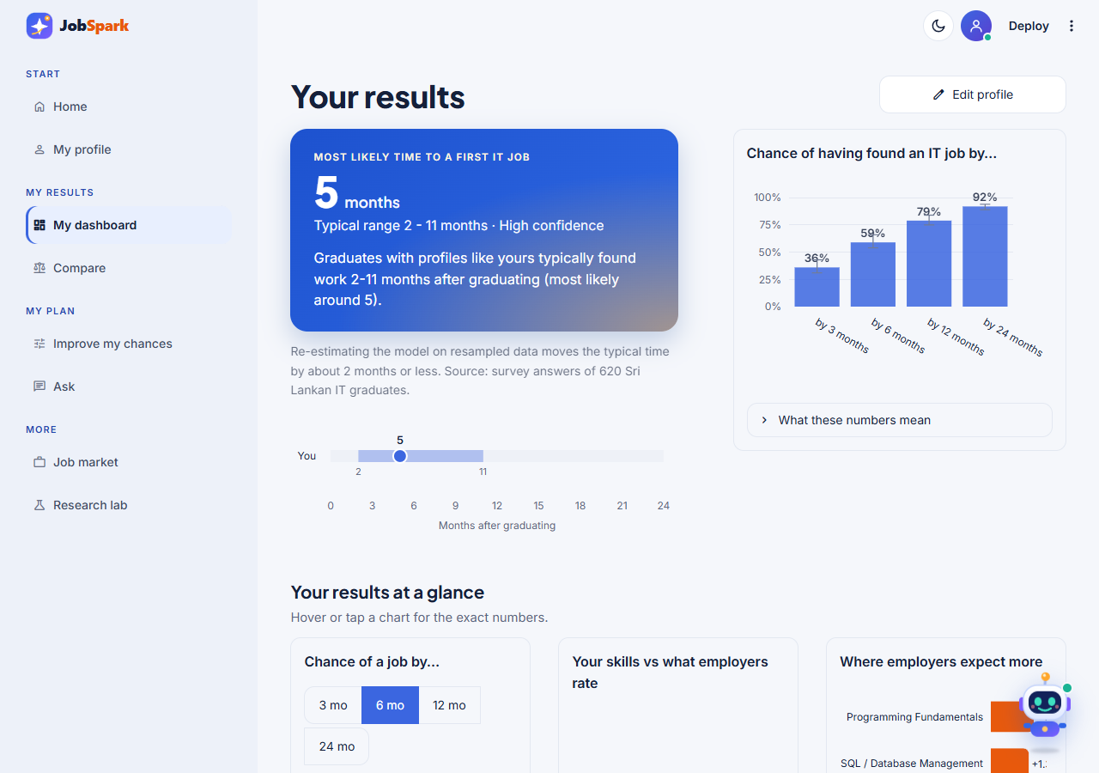
Figure 4.3: The results dashboard of the redesigned interface (most likely time, range, confidence and chance of employment)
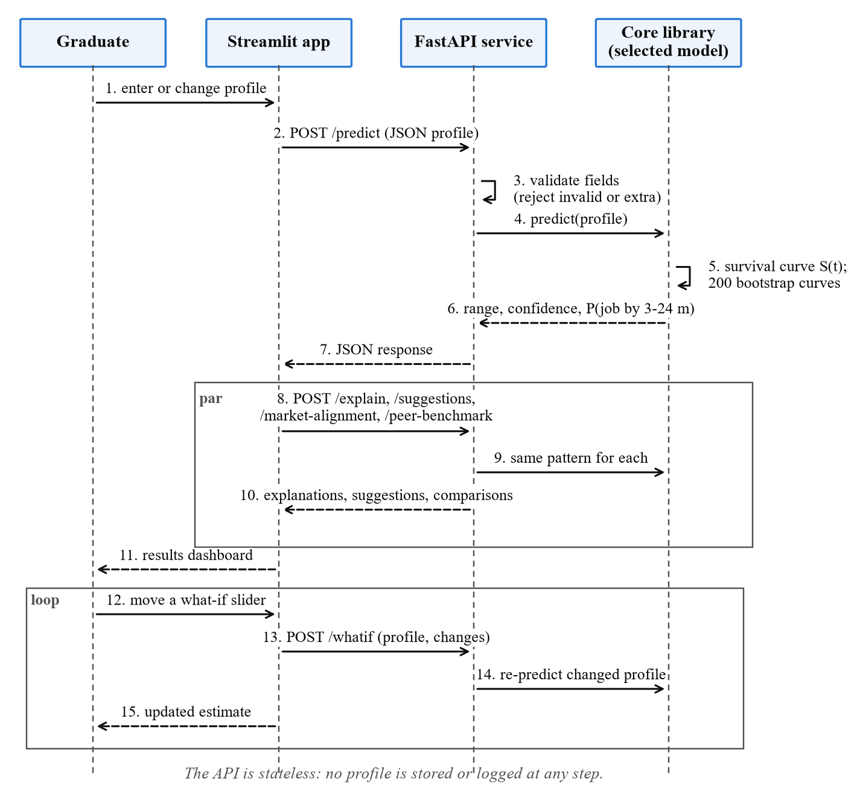
Figure 4.4: Sequence diagram of a prediction request
Figure 4.5 shows the decisions made for one prediction request: the validation of the profile, the treatment of graduates who are still looking for their first IT job, and the caution shown when an input lies outside the range seen in training.
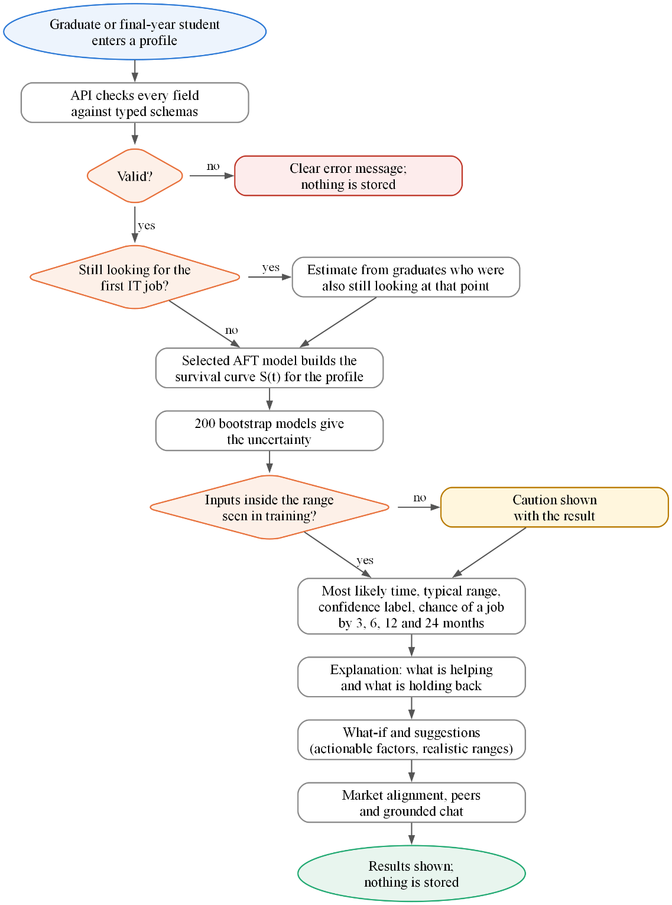
Figure 4.5: Flow chart of a prediction request

4.6 Algorithms/Models
Seven models from the four families named in Section 3.10 were compared (Table 4.4). Each was fitted on the training set only; hyperparameters were tuned on the validation set, and the AFT distribution was chosen by AIC on the training set.
Table 4.4: Candidate models and the settings tuned on the validation set
Model | Type | Settings tuned (grid)
Cox proportional hazards | Semi-parametric, linear | Ridge penalty: 0, 0.01, 0.1, 0.5
Elastic Net Cox | Regularised, linear | Penalty strength (5 values) x L1 ratio (0.1, 0.5, 0.9)
AFT Weibull, Log-Normal, Log-Logistic | Parametric | None; the best distribution by AIC is the AFT candidate
DeepSurv | Neural network (Cox loss) | Width (8, 16, 32), layers (1, 2), dropout (0.1, 0.3), learning rate (0.001, 0.01)
Selection rule (fixed in advance). The candidate with the highest validation Uno's C-index is selected; if another is within 0.02, the simpler model is preferred (Cox and AFT, then Elastic Net, then DeepSurv), and then the better calibrated. The selected model is fitted once on the training set and is the model the artifact uses; 200 bootstrap refits of the training set quantify its uncertainty.
Figure 4.6 shows how the seven candidates are fitted on the training set, compared on the validation set and reduced to one selected model, which is then evaluated once on the locked test set.
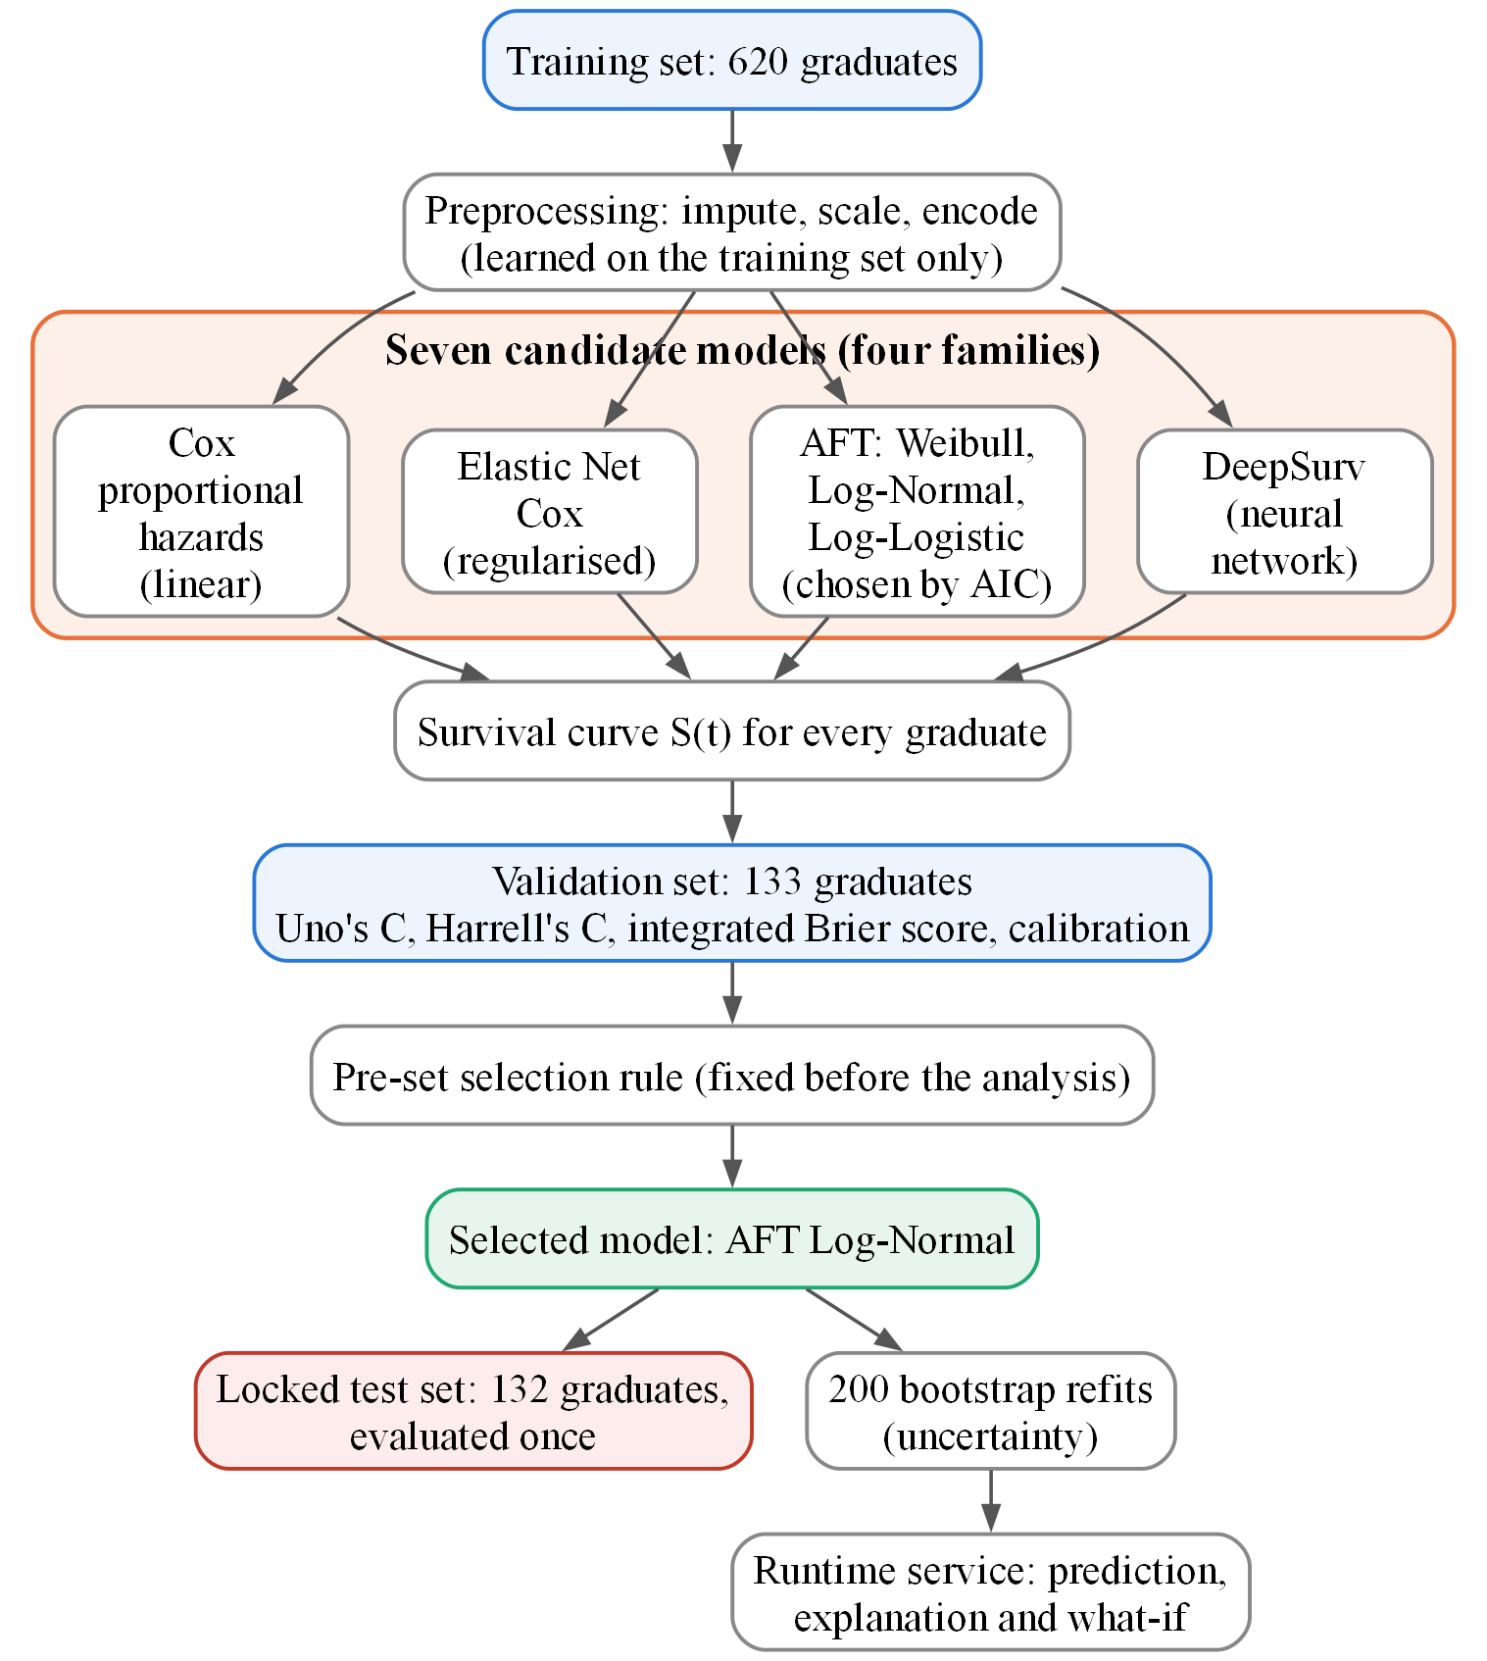
Figure 4.6: Processing flow of the candidate models
For a profile, the selected model produces an individual survival curve S(t), the probability of still searching at month t. The typical range is read from the curve, as planned in Section 3.9: the lower bound is where S(t) falls to 0.75, the most likely time where it falls to 0.50, and the upper bound where it falls to 0.25. If a level is not reached within the follow-up horizon, the result is reported as "more than" the horizon rather than extrapolated. The same calculation on the 200 bootstrap models gives an 80% interval for the most likely time; the confidence label is High if this interval is at most 2 months wide, Medium if at most 4 months, and Low otherwise or when fewer than 20 training graduates were still followed at that point. For a graduate who has already searched m months, the curve is conditioned on still searching: S(t | T > m) = S(t) / S(m).
- Explanation. For the Cox and AFT models, each factor's contribution is its coefficient multiplied by the difference between the profile and the average training graduate; for DeepSurv, SHAP values are used (Mosca et al., 2022). Only factors a graduate can change are listed, at most three helping and three holding back.
- What-if. The profile is predicted again after changes to actionable factors only, within realistic ranges; a change outside the range seen in the training data triggers a caution.
- Suggestions. A search over small combinations of realistic changes returns up to three combinations linked with finding work at least one month sooner, each using different factors.
- Market alignment. For each of the 26 skills, the graduate's rating is compared with the employers' mean importance rating and the share of advertisements naming it, and the largest gaps are shown with free learning resources.
- Chat assistant. A question typed by the user is matched by fixed keyword rules to one of a small set of question types - for example why the estimate is what it is, what would change after a given step, which skills to learn, how to find work sooner, how the user compares with similar graduates and whether the estimate can be trusted. The answer is assembled from the same prediction, explanation, what-if, suggestion, market, peer and evaluation outputs and the same wording module as the dashboard, so every number in it is one the model produced. No language model is used, questions outside the system's scope are declined, and nothing is stored.

4.7 Data Sets/Data Preparation
Collection. The main-study responses were collected through Google Forms (47 graduate items, 21 employer items), and the exported response workbooks are kept as the raw record. A conversion script turns each workbook into the CSV format read by the pipeline. The pilot (21 graduates, 9 employers) and a small technical test of the form were collected separately and are not used in any analysis (Section 3.11). Every response was given the same reference survey date, the end of collection (6 October 2026). This affects only graduates who were still searching, whose follow-up may be overstated by up to about two months; it is reported as a deviation from the plan.
Graduate data. The 1,175 graduate responses were cleaned with the documented rules (Figure 4.7). Four duplicate submissions and 24 responses that failed the attention check were removed; 230 final-year students were set aside for descriptive use only; and 32 graduates were removed for impossible or missing dates, for being outside the eligibility window, or for being outside the IT job market. Free-text answers typed under "Other" for the degree programme and the institution were mapped to the "other" programme group and to the institution-type lookup, so no response was lost through an unrecognised label. The 885 modelling graduates were split once, stratified by event and institution type, with a fixed seed.
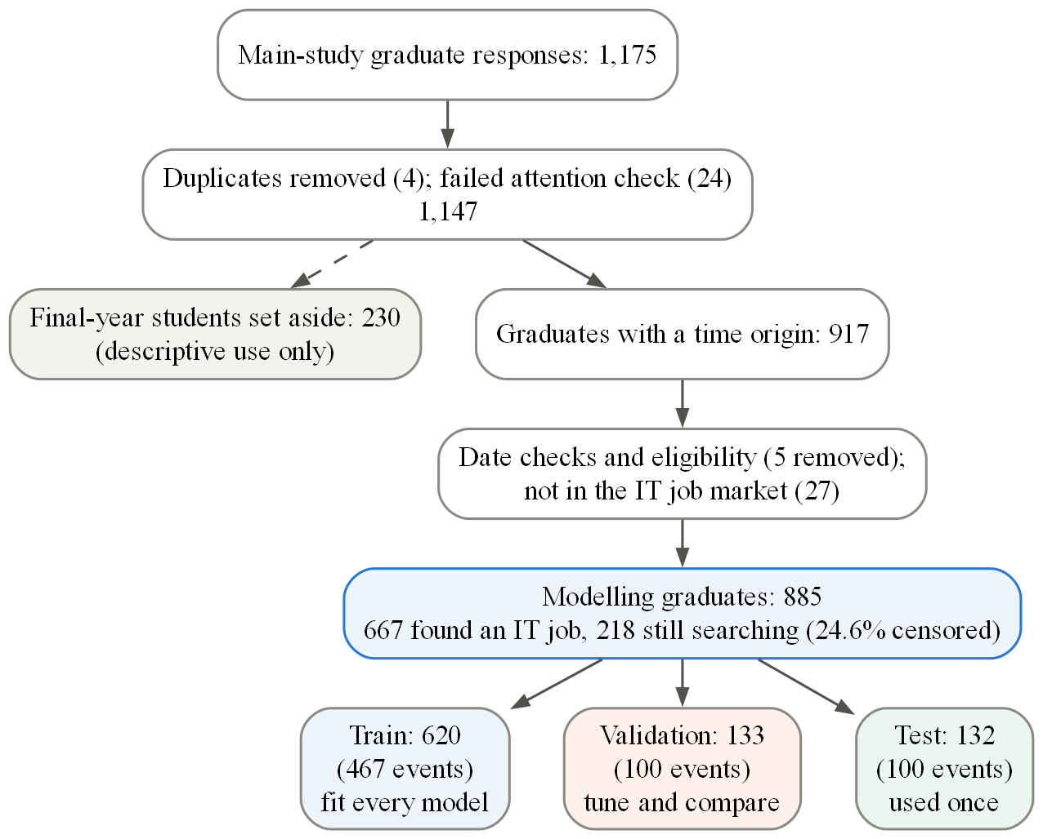
Figure 4.7: Data preparation and the fixed three-way split (graduate data)
Predictors. The 17 technical and 9 soft-skill ratings were averaged into two scores after the reliability check (Cronbach's alpha 0.92 and 0.91 on the 885 modelling graduates). The model uses 14 predictors - GPA, degree group, institution type, internship months, certifications, projects, the two skill scores, and the six preparation items portfolio (Q14), years of preparation (Q20), self-learning (Q21), hackathons (Q23), open source (Q24) and SDLC familiarity (Q29) - giving 16 model columns and 467 training events, or 29.2 events per parameter, well above the minimum of 10. Imputation, scaling and encoding are learned from the training set only. No outcome or post-employment field can reach the model, which is checked automatically.
Employer data and job advertisements. Of 245 employer responses, 6 failed the attention check, leaving 239 (102 software-development companies; 73 organisations with more than 500 staff). The 324 job advertisements were posted by 211 employers between 12 July and 11 October 2026; each was coded to the same 26-skill vocabulary, assigned a role family by fixed title rules, and classified as intern/trainee or junior/associate.

4.8 Technology Selection
Table 4.5: Technology selection
Concern | Technology (version) | Reason
Survival models | lifelines 0.30, scikit-survival 0.28, pycox 0.3 on PyTorch 2.14 | Established libraries for Cox, Elastic Net Cox, AFT and neural survival models, as planned in Section 3.8
Explanations | SHAP 0.51 | Local explanations for the neural model
API | FastAPI 0.142 with Pydantic 2 | Fast, typed request validation and automatic documentation
Interface | Streamlit 1.65 with Plotly | Python-only stack for a single developer; interactive charts
Reference data | SQLite | Read-only aggregated data; no database server to run or secure
Testing | pytest | Automated unit, integration and API tests
Two choices differ from Section 3.8. Streamlit replaced Next.js for the interface, because a single Python codebase allowed the multi-panel dashboard, its charts and the model code to be built and tested by one developer within the timeline, while the separation between interface and FastAPI service planned in Section 3.8 was kept. SQLite replaced PostgreSQL, because the reference data are small, read-only and aggregated, so a file-based database removes a server without losing any function. Both remain web-based and are accessible from a mobile browser.

4.9 Implementation
The system was implemented as a Python 3.11 project with four packages: core (schema, import and cleaning, preprocessing, models, evaluation, prediction, explanation and the studies), api (the FastAPI service), frontend (one module per page and a shared style module) and tests. A single command, python -m core.run_all, reproduces the entire analysis from the raw files and regenerates every report and figure; random seeds are fixed, so running it twice gives identical results. Key implementation decisions were to learn all preprocessing from the training set only, to write the split to a file that every module reads so that no graduate can change role, to evaluate the test set in one function called once after selection, and to make the API stateless. The implementation is covered by 295 automated tests (Chapter 5). The complete source code, tests and documentation are available at https://github.com/ShaznaSalman/final-research-employability-survival_COBSCCOMP24.2P019.
Deployment and environment. The system runs as two processes on one machine: the FastAPI service (uvicorn api.main:app) and the Streamlit web application (streamlit run frontend/app.py), which calls only the API. The service loads the saved artifacts when it starts, so the offline pipeline (python -m core.run_all, about five minutes) must have been run first or the artifacts supplied with the code. The host needs Python 3.11 and the packages listed in the requirements files of the repository; the measurements in Section 5.5 were taken on a laptop with an AMD Ryzen 5 7535HS processor and 16 GB of memory. A user needs only a current web browser: nothing is installed, no account or camera is needed, and nothing that is entered is stored. No special training was needed in the usability sessions (Section 5.7).
Testing plan. Table 4.6 shows how correctness and quality are checked; the results are reported in Chapter 5.
Table 4.6: Testing plan
Test | What is checked | Method | Pass criterion
1. Data and outcome | Duration and event are built correctly; no validation or test graduate reaches model fitting | Automated tests on import, cleaning, the split and preprocessing (Appendix F, Table F.1) | All tests pass
2. Models | Every candidate returns valid survival curves; no forest or boosting model is present | Automated model tests | All tests pass
3. Predictive performance | Discrimination, overall error and calibration | Uno's C, integrated Brier score and calibration on the validation set, then on the locked test set once (Section 5.6) | Pre-set conditions (Table 3.6)
4. Explanations and wording | Contributions add up; wording is associational and free of jargon | Automated wording tests; additivity check on three profiles (Section 5.4) | All tests pass; contributions sum exactly
5. API and privacy | Typed validation; nothing about a profile is stored | API tests with invalid inputs; a test that no file, database or log is written (NFR3, NFR4) | All tests pass
6. Response time | Every endpoint is responsive | 30 requests per endpoint (Section 5.5, Table 5.4) | Under 1 second (NFR2)
7. Functional scenarios | The running system behaves correctly from input to output | Contrasting profiles (Table 5.2) | Expected range, explanation and suggestion
8. Usability | Ease of use | System Usability Scale with 12 participants (Section 5.8) | Mean of at least 68 (NFR1)
9. Benchmark against an LLM | Value beyond a general-purpose model | The same 132 test profiles scored with Uno's C (Section 5.9, Table H.1) | Model higher (paired bootstrap)

4.10 Chapter Summary
This chapter presented the proposed solution: requirements traced to components, a four-page decision-support application, a three-layer architecture separating a reproducible offline pipeline from a stateless runtime service, seven candidate survival models with a selection rule fixed in advance, the prediction, explanation and what-if algorithms, and the preparation of the data into 885 modelling graduates split once into training, validation and test sets. Table 4.7 shows where each objective is addressed in this chapter and where it is verified in Chapter 5.
Table 4.7: Traceability of the objectives to the proposed solution and its evaluation
Objective (Section 1.3) | Addressed in Chapter 4 | Verified in Chapter 5
O1: factors associated with time to employment | Data preparation and outcome (Section 4.7); explanation module (FR3, Section 4.6) | Kaplan-Meier and log-rank results (Section 5.4, Figure 5.1); adjusted associations (Table 5.3, Figure 6.1)
O2: alignment with employer requirements and job-market demand | Reference database and market-alignment component (FR4, Section 4.4); employer and advertisement data (Section 4.7) | Skill comparison (Figure 5.2); coding agreement of the advertisements (Section 5.4, Appendix I)
O3: compare the survival models and select the best | Seven candidate models and the selection rule (Section 4.6, Table 4.4); fixed split (Section 4.7); prediction module (FR2) | Validation comparison (Table 5.5, Figure 5.3); locked test result, calibration and checks (Table 5.6, Figure 5.4)
O4: prototype, usability and benchmark against an LLM | Four-page application, API and chat (Sections 4.3 to 4.5; FR1, FR5 to FR7; NFR1 to NFR4); technologies (Table 4.5) | Functional scenarios and tests (Table 5.2, Appendix F); response times (Table 5.4); SUS (Table 5.9); LLM benchmark (Table H.1)

Chapter 5
Evaluation and Results

5.1 Introduction
This chapter evaluates the solution against the research objectives using the real main-study data: 885 modelling graduates (train 620, validation 133, test 132), 239 employers and 324 job advertisements, and relates every result to its objective and research question. Interpretation is reserved for Chapter 6.

5.2 Evaluation Framework
The evaluation follows the Design Science principle that an artifact must be shown both to work and to be useful (Haryanti et al., 2024); it is the evaluation stage of the Design Science Research Methodology (Section 3.4) and covers four levels:
- Technical correctness: automated testing and response-time measurement.
- Analytical validity: factors, accuracy, calibration, stability and fairness on the fixed training, validation and locked test sets, judged against the pre-set conditions of Table 3.6.
- Market alignment: the graduate-employer comparison and the job-advertisement study.
- Usefulness and usability: the System Usability Scale and the benchmark against a general-purpose LLM.

5.3 Evaluation Criteria
Table 5.1 lists the criteria and targets, all fixed in Chapter 3 before the data were analysed (the reason for each measure is given in Table 3.2), together with the result against each target, which is reported in the sections that follow.
Table 5.1: Evaluation criteria (fixed before analysis) and the results against them
Criterion | Measure | Target | Result | Met?
Functional correctness | Automated tests mapped to requirements | All tests pass | 295 of 295 tests pass | Yes
Responsiveness | API response time per request | Under 1 second | Slowest median 263 ms (/suggestions) | Yes
Discrimination (primary) | Uno's C-index on the locked test set, 95% bootstrap CI | CI above 0.5 | C = 0.619 (CI 0.557-0.683) | Yes
Overall error | Integrated Brier score (IBS) vs the Kaplan-Meier baseline | Lower than the baseline | IBS 0.167 vs baseline 0.164 | No
Calibration | Predicted vs observed share employed at 3, 6 and 12 months | Within each other's intervals | Under-prediction of 8-17 points | No
Stability and transfer | Validation vs test C-index; held-out institution types | Similar C-index | Validation 0.693 vs test 0.619; intervals overlap | Partly
Fairness | C-index and calibration by gender and institution type | No large gap | Test C: women 0.724, men 0.574; overlapping CIs | Partly
Usability | System Usability Scale (8-12 users) | Mean of at least 68 (Hyzy et al., 2022) | Mean 76.3 (n = 12) | Yes
Value over an LLM | Uno's C of model vs LLM on the same held-out profiles | Model higher (paired bootstrap) | C 0.619 vs ChatGPT 0.539 (difference 0.081, CI 0.030-0.131) | Yes

5.4 Experimental/Test Results
The pilot (21 graduates and 9 employers, excluded from the main sample) confirmed that duration and event could be calculated for every graduate. Cronbach's alpha was 0.75 for the technical and 0.61 for the soft-skill block, below the 0.70 target on this small sample; in the main study both were 0.91-0.92. The test-retest check of recalled dates was not carried out, so recall error remains a limitation.
Six experts reviewed the questionnaires and design: three academics (research methodology, software engineering and survival analysis) and three industry practitioners (a recruitment manager, a talent acquisition specialist and a software company leader). All judged the study relevant and recommended proceeding. Their main points - consistent dates and terminology, rating skills as applied ability, handling censoring and leakage, role-specific requirements and actionable, non-judgemental guidance - were addressed (Table 3.8 and Appendix B). The review was qualitative, and item-level ratings were not collected, so I-CVI and S-CVI were not computed.
All 295 automated tests in 23 modules pass (Appendix F). They verify the construction of duration and event, that no outcome field or validation or test graduate reaches model fitting, that ranges are ordered and never extrapolated, and that every endpoint returns its schema, rejects invalid or unexpected fields and stores nothing. Further tests check that the chat assistant repeats only the model's own numbers and declines off-topic questions, and that the SUS scoring reproduces a hand calculation. Table 5.2 shows the running system on four contrasting profiles; each result is consistent with the factors found in the data; for the weak profile still searching after 6 months the estimate rose to 16 months (10 to more than 24), as conditioning requires. Invalid input (a GPA of 5.2, or a gender field) was rejected.
Table 5.2: Functional test scenarios (final model, real data)
Profile | Estimate (range; confidence) | Explanation shown | First suggestion
Strong: GPA 3.6, 12 months internship, 3 certifications, skills 3.5-4.5 | 2 months (1-5; High) | Helping: internship, technical skills, certifications | None needed
Average: GPA 3.0, 6 months internship, 1 certification, skills about 3 | 5 months (2-11; High) | Helping: internship; holding back: soft skills | +3 internship months: about 1 month sooner
Weak: GPA 2.6, no internship, no certification, skills about 2 | 9 months (4-21; Low) | Holding back: no internship, technical skills, soft skills | None found
Sample and data quality. The training, validation and test sets were similar on every characteristic (Appendix E, Table E.1): 24.7%, 24.8% and 24.2% were still searching, mean GPA was 3.09, 3.06 and 3.07, and the Kaplan-Meier median was 4, 4 and 3 months. Only one predictor had missing values (hackathons, 11.6% of the training set), imputed within the pipeline. Predictors were at most moderately correlated (strongest Spearman rho 0.59, between the technical and soft-skill scores) and every variance inflation factor was below 2.6, so multicollinearity was not a concern. The times of graduates who found work were right-skewed (skewness 2.30), consistent with the log-normal AFT model fitting best, and outcomes were similar across completion years (66.3%, 66.6% and 68.9% employed by six months for 2024, 2025 and 2026). Compared with published Sri Lankan figures (Appendix E, Table E.5), the share of employed graduates hired by completion (17.5% against 18.1%) was close, but more of the sample were in IT work (75.4% against 60.5%) and they found it sooner (5.0 against 8.0 months on average).
Validity of the skill scores. On the training set both skill blocks were suitable for factor analysis (KMO 0.945 and 0.948; Bartlett p < 0.001; Field, 2024). Reliability was high (Cronbach's alpha 0.925 and 0.902; McDonald's omega 0.926 and 0.902) and every item loaded at least 0.45 on its block. The soft-skill block met the convergent-validity threshold (average variance extracted 0.506), but the technical block fell short (0.429; threshold 0.50; Hair et al., 2022), and parallel analysis suggested three related sub-factors among the technical items, such as programming against cloud and DevOps. The technical score is therefore a summary of related abilities rather than one narrow construct, which is reported as a limitation. The two scores were distinct (HTMT 0.676, below 0.85; Fornell-Larcker criterion met), and each correlated with a related single question (technical score with applying knowledge to unfamiliar problems, rho = 0.553; soft-skill score with communicating to non-technical people, rho = 0.669). Details are in Appendix E.
Of the 885 modelling graduates, 43.6% had found an IT job by 3 months after completing their degree, 67.0% by 6 months, 80.9% by 12 months and 89.8% by 24 months (Kaplan-Meier; Figure K.1); the median was 4 months, and 117 graduates (13.2%) had started an IT role before completion. Log-rank tests on the training set showed clear differences by GPA (median 4 months for GPA 3.0 or higher against 7 months below 3.0; p < 0.001), internship (4 against 6 months; p = 0.003) and portfolio (p = 0.006), but not by institution type (p = 0.84) or degree group (p = 0.47) (Figure 5.1).
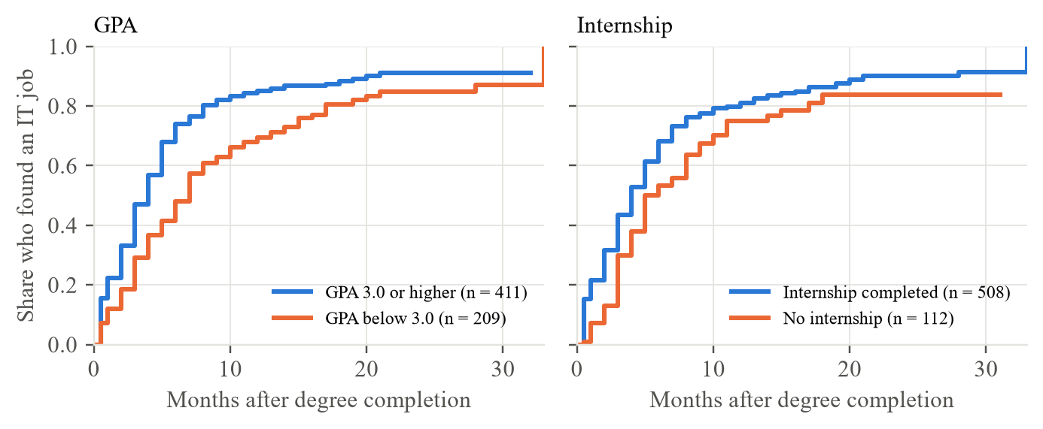
Figure 5.1: Share of training graduates who had found an IT job, by GPA and internship (Kaplan-Meier)
Table 5.3 reports the adjusted associations. In both the Cox model and the selected AFT model, only GPA and internship experience were clearly associated with time to the first IT job when the other factors were held constant: one standard deviation higher GPA (about 0.4 points) was associated with a 20% shorter time (time ratio 0.80, 95% CI 0.70-0.92) and one standard deviation more internship experience (about 3.5 months) with a 16% shorter time (0.84, 0.76-0.94). Both associations remained significant after Holm correction for the 16 coefficients tested (adjusted p = 0.022 for GPA and 0.021 for internship experience), as did the log-rank differences by GPA, internship and portfolio after correction for the six group comparisons (adjusted p < 0.001, 0.017 and 0.023). Certifications and technical skill ratings pointed in the same direction but their intervals included no effect. Institution type, degree group, soft-skill ratings and the six preparation items showed no clear association. No predictor violated the proportional-hazards assumption (all Schoenfeld p > 0.10; Figure K.4).
Table 5.3: Adjusted associations with time to first IT job (training set, n = 620, 467 events)
Factor (numeric: per one SD) | Cox hazard ratio (95% CI); > 1 = sooner | AFT time ratio (95% CI); < 1 = sooner
GPA | 1.24 (1.10-1.40) | 0.80 (0.70-0.92)
Internship months | 1.12 (1.03-1.23) | 0.84 (0.76-0.94)
Professional certifications | 1.09 (1.00-1.19) | 0.95 (0.86-1.05)
Projects outside coursework | 1.07 (0.95-1.20) | 0.98 (0.86-1.11)
Technical skill rating (mean) | 1.13 (0.98-1.31) | 0.92 (0.79-1.08)
Soft skill rating (mean) | 0.98 (0.87-1.12) | 0.97 (0.85-1.10)
Six preparation items (portfolio, hackathons, open source, SDLC, preparation, self-learning) | 0.93 to 1.02 (all CIs include 1) | 0.95 to 1.06 (all CIs include 1)
Degree group: IT/IS; specialised (vs computing) | 1.12 (0.91-1.38); 1.06 (0.83-1.35) | 0.91 (0.72-1.15); 0.90 (0.69-1.17)
Institution: non-state; foreign-affiliated (vs state) | 1.14 (0.88-1.47); 1.03 (0.83-1.27) | 0.86 (0.65-1.14); 0.96 (0.76-1.21)
Employers rated 25 of the 26 skills as more important than graduates rated their own proficiency at completion, and the gap was statistically significant for 24 of them after false-discovery-rate correction (Mann-Whitney U; 1,115 graduates, 239 employers; Figure 5.2). The largest gaps were in cloud computing (+1.20 on the 1-5 scale), software testing (+1.20), DevOps/CI-CD (+1.12), Docker (+0.93), cybersecurity (+0.91), problem solving (+0.90) and communication (+0.84). The 324 advertisements asked most often for problem solving (69%, 95% CI 64-74%), teamwork (61%), communication (55%) and self-learning (52%), and among technical skills for software testing (44%), SQL (37%) and REST APIs (33%). Employers' stated priorities were only moderately related to what they advertised (Spearman rho = 0.39, p = 0.052). The gap compares graduates' own proficiency with employers' view of importance, so it shows where graduates fall short of what employers value rather than an exact deficit. Combining a large gap with high advertised demand, the most actionable skills were software testing, problem solving, communication, REST APIs, Git and SQL.
Employers ranked technical skill depth (78.3% in their top three), problem solving (60.6%) and interview performance (58.8%) highest, and rated GPA (3.21 of 5) and certifications (3.25) least important. English showed the largest perceived gap (graduates' proficiency 3.38 of 5 against employers' importance 4.31), and internship advertisements asked for self-learning twice as often as junior roles (61% against 31%, q < 0.001). Where graduates' and employers' priorities differ is shown in Figure 6.2.
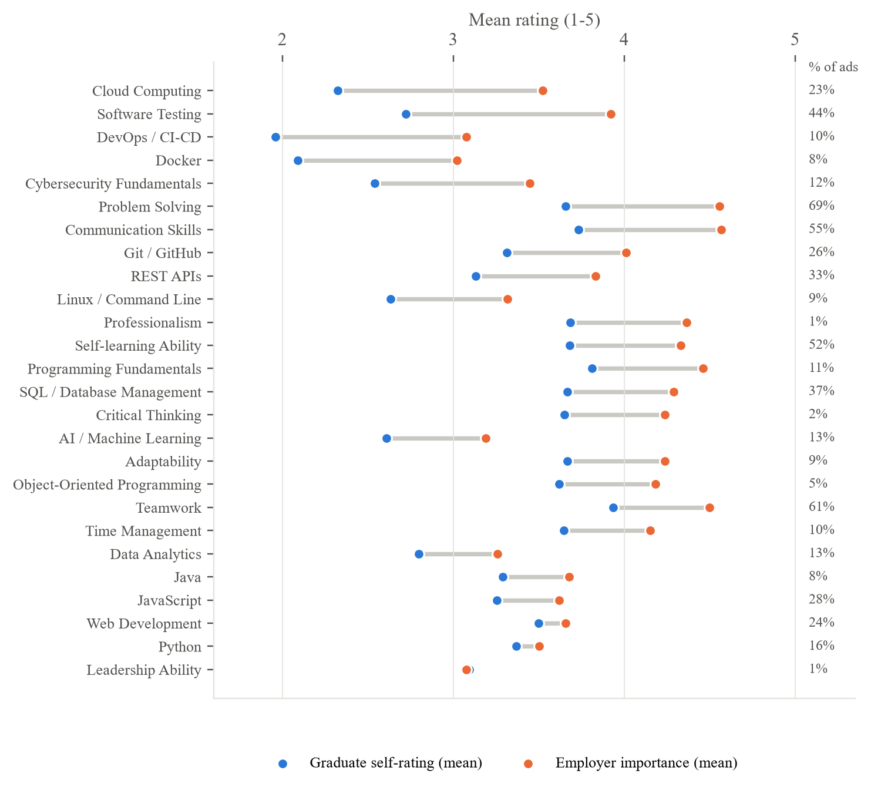
Figure 5.2: Graduate self-ratings at completion vs employer importance, with the share of job advertisements naming each skill
The keyword coding of the advertisements was checked against hand coding by an independent coder, blind to the keyword result, on a random sample of 40 advertisements (python -m core.coding_agreement); 36 were coded, the other four could no longer be opened. Pooled Cohen's kappa was 0.83, above the pre-set target of 0.60 and conventionally regarded as almost perfect agreement. The keyword rules had a precision of 0.96 and a recall of 0.80: they rarely credited a skill that was not asked for but missed about one mention in five, mostly for broadly worded skills such as programming fundamentals (kappa 0.40), web development (0.46) and critical thinking (0.09). Advertised demand for these skills is therefore, if anything, understated. The per-skill results are in Appendix I.

5.5 System Performance Results
Response times were measured on the development laptop on 14 October 2026 over 30 requests per endpoint, with the final model and 200 bootstrap models loaded (Appendix F, Table F.3). Median times were 56 ms for /predict, 63 ms for /explain, 124 ms for /whatif, 30 ms for /peer-benchmark, 12 ms for /market-alignment and 164 ms for /chat; the slowest endpoint, /suggestions, which evaluates many candidate profile changes, took 263 ms (95th percentile 380 ms). Every endpoint therefore met the one-second target. The measurements were taken on a laptop with an AMD Ryzen 5 7535HS processor and 16 GB of memory running Windows 11, with the service and the client on the same machine. The service starts in about 5.2 seconds, mostly to load the 200 bootstrap models (15 MB in total); the final model itself occupies 99 KB and has 18 parameters. The complete offline pipeline runs in about five minutes with one command. Performance with many simultaneous users was not measured. Table 5.4 summarises the measurements against the targets.
Table 5.4: System performance (development laptop, 30 requests per endpoint, 14 October 2026)
Measure | Target | Result | Met?
Response time, /predict (median; 95th percentile) | Under 1 second | 56 ms; 60 ms | Yes
Response time, /explain | Under 1 second | 63 ms; 70 ms | Yes
Response time, /whatif | Under 1 second | 124 ms; 136 ms | Yes
Response time, /chat | Under 1 second | 164 ms; 225 ms | Yes
Response time, /suggestions (slowest endpoint) | Under 1 second | 263 ms; 380 ms | Yes
Start-up time with all models loaded | Reported | 5.2 seconds | -
Final model size | Reported | 99 KB (18 parameters) | -
200 bootstrap models | Reported | 15 MB in total | -
Individual profiles stored | None | None (checked by an automated test) | Yes

5.6 Accuracy/Precision/Recall or Other Technical Measures
As explained in Section 3.9, accuracy, precision and recall are not used, because the outcome of the 24.6% of graduates who were still searching is unknown. Discrimination (Uno's C), overall error (integrated Brier score) and calibration are reported instead.
All seven models discriminated well above chance on the 133 validation graduates (Figure 5.3). AFT Log-Normal had the highest Uno's C (0.693, 95% CI 0.636-0.745) and a low integrated Brier score (0.171), and was selected by the pre-set rule. DeepSurv reached 0.679 and Cox proportional hazards 0.667; the intervals overlap substantially, so the ranking of models should not be over-interpreted. Against simpler baselines (Appendix J, Table J.5), GPA alone reached a validation C of 0.637 and GPA with internship months 0.675, so most of the selected model's ranking comes from these two inputs. The log-normal AFT model fitted the training data best (AIC 2,724.8 against 2,729.8 for log-logistic and 2,766.7 for Weibull; Figure K.3) because time to a first job is strongly right-skewed - most graduates found work within a few months (median 3 months among those employed) while a minority searched much longer - and the log-normal shape lets the chance of finding work rise soon after completion and then fall for those still searching, which a Weibull model cannot represent.
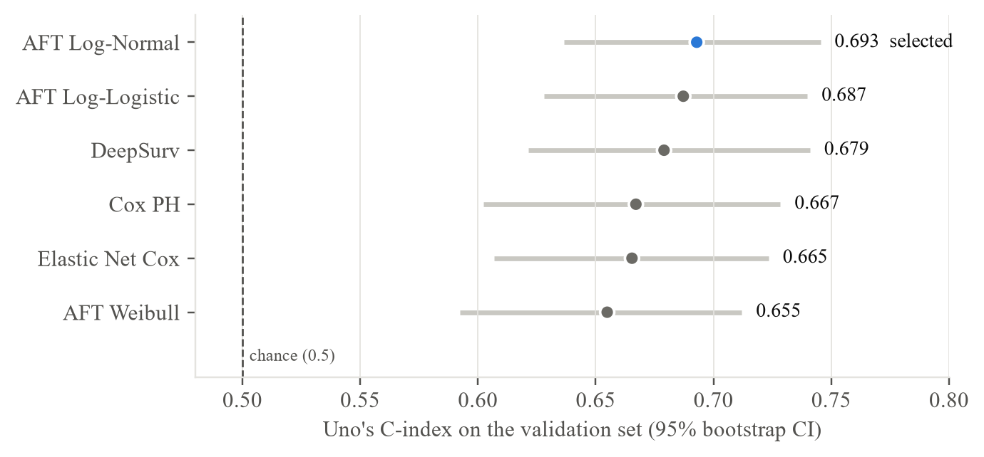
Figure 5.3: Uno's C-index of the candidate models on the validation set
Table 5.5 reports every candidate model on the validation set.
Table 5.5: All candidate models on the validation set (133 graduates)
Model | Uno's C (95% CI) | Harrell's C | IBS | Calibration error at 3 / 6 / 12 months | Selected
Cox PH | 0.667 (0.602-0.728) | 0.666 | 0.179 | 0.110 / 0.092 / 0.035 | No
Elastic Net Cox | 0.665 (0.607-0.723) | 0.664 | 0.175 | 0.132 / 0.111 / 0.056 | No
AFT Weibull | 0.655 (0.592-0.712) | 0.653 | 0.179 | 0.106 / 0.091 / 0.024 | No
AFT Log-Normal | 0.693 (0.636-0.745) | 0.692 | 0.171 | 0.126 / 0.118 / 0.088 | Yes
AFT Log-Logistic | 0.687 (0.628-0.740) | 0.686 | 0.171 | 0.093 / 0.100 / 0.079 | No
AFT (best by AIC) | 0.693 (0.636-0.745) | 0.692 | 0.171 | 0.126 / 0.118 / 0.088 | Yes (same as Log-Normal)
DeepSurv | 0.679 (0.621-0.741) | 0.676 | 0.175 | 0.100 / 0.113 / 0.068 | No
AFT (best by AIC) is the distribution chosen by AIC on the training set, which was the log-normal, so its row repeats AFT Log-Normal. IBS is the integrated Brier score (lower is better). Calibration error is the mean absolute difference between the predicted and the observed share employed at that month (lower is better). The selected model is the one chosen by the pre-set rule.
The selected model was evaluated once on the 132 test graduates. It reached Uno's C = 0.619 (95% CI 0.557-0.683) and Harrell's C = 0.626: given two test graduates, it ranked correctly which one found work first about 62 times in 100. Its integrated Brier score was 0.167, against 0.164 for the Kaplan-Meier baseline that predicts the same curve for everyone. The model under-predicted employment (Figure 5.4): the predicted share employed differed from the observed share by 15 percentage points at 3 months, 17 at 6 months and 8 at 12 months on average (for example, 61% predicted against 77% observed by 6 months). Possible reasons - the small evaluation sets, faster hiring of later cohorts and the single reference survey date - are discussed in Section 6.2. An error analysis on the validation set (Appendix J) shows the same pattern from another angle: predictions are pulled towards the typical search of four to five months, so very fast and very slow searches are predicted least well.
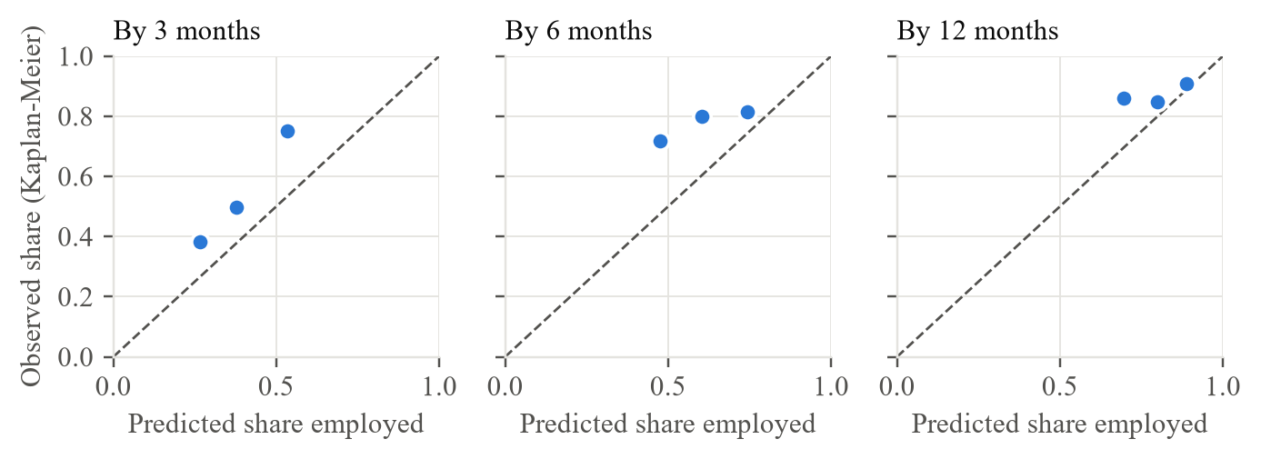
Figure 5.4: Calibration of the selected model on the test set (tertiles of predicted risk)
Table 5.6 checks the result against the conditions fixed in Table 3.6.
Table 5.6: Conditions under which the model is claimed to work (Table 3.6) and the evidence
Condition | Evidence | Met?
Better than no model | Test C-index CI 0.557-0.683, above 0.5; but IBS 0.167 vs baseline 0.164 | Partly: ranks, but no lower overall error
Probabilities are correct | Under-prediction of 8-17 points at 3, 6 and 12 months | No
Results are stable | Validation 0.693 vs test 0.619; intervals overlap (0.636-0.683) | Partly
Works across institutions | Fitted without one type, C on that type (validation): state 0.702, non-state 0.695, foreign-affiliated 0.658 | Yes
Fair across groups | Test C: women 0.724, men 0.574 (overlapping CIs); under-prediction in most groups | Partly (see below)
Model assumptions hold | No Schoenfeld violation (all p > 0.10); AFT family chosen by AIC | Yes
Not overfitted | Training C 0.613 vs test 0.619 | Yes
Following Table 3.6, because the probabilities were not well calibrated the artifact should present time ranges and treat the probabilities as indicative only. The validation-test difference is within the overlap of the two bootstrap intervals and reflects the small evaluation sets (about 130 graduates each).
These results are reported to users on the artifact's Research lab page (Appendix A, Figure A.11).
In response, the artifact presents the time range as the main result and labels the chance-of-employment bars as indicative, with a note that they tend to under-estimate employment; recalibration on a new cohort is left as future work (Section 6.6).
Two properties of the explanations were checked on the strong, average and weak profiles. First, additivity: the contributions summed exactly to the difference from the average graduate's predicted log-time (largest discrepancy 3 x 10^-16). Second, stability: across the 200 bootstrap refits, the direction of each profile's three largest contributions agreed in 76-100% of refits (GPA and internship 100%), so the leading explanations are stable but smaller ones should be read with care. Whether users understand them was not tested.
- Sensitivity. Across alternative data decisions (job-before-completion time, excluding 118 rounded recall times, complete cases, multiple imputation), validation C ranged from 0.659 to 0.707 and no clear association changed direction: the only change was the specialised-degree group, which had no clear effect in any variant, moving from a hazard ratio of 1.06 to 1.00 when graduates with a missing input were excluded (Figure K.6).
- Temporal validation. Trained on cohorts completing up to August 2025 and tested on later cohorts, the AFT model reached C = 0.721, but again under-predicted early employment (by about 12 points at 3 and 6 months).
- Clustering and competing risks. Clustering by the 23 institutions changed no conclusion; treating another path (37 graduates) as a competing event lowered the share in IT work by 12 months only from 81.9% to 77.8% (Figure K.2).
- Fairness. On the test set C was 0.724 for women and 0.574 for men, a gap above the 0.05 flag but with overlapping intervals (48 and 78 graduates); predictions were too pessimistic for every group except non-state institutions. Gender is never a model input. Figure K.5 shows the results for each subgroup.
- Feature set. The six preparation items added only +0.003 to validation C and did not meet the pre-registered rule (a log-transformed set did: +0.011); they were kept so that the preparation questions feed the app, a reported deviation.
- Neural models and sample size. DeepHit (0.590), Cox-Time (0.674) and N-MTLR (0.666) did not beat the selected model; trained on 25-100% of the training set, its validation C rose from 0.641 to 0.693 (mean of 20 random subsets at each size; Figure J.2) and was levelling off, so more respondents with the same questions would add little.

5.7 User Evaluation
In the main survey, 64.3% of graduates would use such a system before applying for jobs (Q46) and 70.3% of employers rated it useful (E16); the explanations most wanted (skills to improve, missing skills) are both provided by the artifact.
Twelve participants (P01-P12) took part in one-to-one sessions on 14 October 2026: six final-year undergraduates and six graduates (three still looking for a first IT job, two working in IT and one working outside IT), from foreign-affiliated (6), non-state (4) and state (2) institutions and studying software engineering (4), information technology (3), computer science (3), information systems (1) or another computing degree (1). They were recruited from the researcher's peers. In the online form each confirmed that they had not answered the main survey, had not helped to build or test the website and were 18 or older, and gave consent before starting; no names were recorded. On the researcher's laptop, each entered a profile (seven used their own details, three the example profile card and two a mix), read the estimated time and range, explained the confidence label, moved a what-if slider, asked the chat assistant a question and found the most requested skill on the Job market page, then completed the System Usability Scale and four open questions. Completion and time were not recorded task by task; two participants asked the researcher for help, one to get started (P06) and one to interpret a chart (P11). The parts found most useful were the comparisons of the participant's skills with employer and job-advertisement demand (6 of 12), the suggestions and having the estimate, reasons and suggestions together (4), the what-if sliders (2) and the chat assistant (2); two participants added that the site was very helpful for fresh graduates or that they would use it again before applying. Table 5.7 summarises the participants. They used the earlier four-page version of the interface (Section 4.3), which was redesigned afterwards (Appendix A).
Table 5.7: Profile of the usability participants (n = 12)
Characteristic | Categories | Number (n = 12)
Background | Final-year undergraduate; graduate still looking; graduate working in IT; graduate working outside IT | 6; 3; 2; 1
Institution type | Foreign-affiliated; non-state; state | 6; 4; 2
Degree | Software engineering; information technology; computer science; information systems; other computing | 4; 3; 3; 1; 1
Profile entered | Own details; example profile card; a mix | 7; 3; 2
Use of career or job-search sites | Weekly or more; monthly; a few times a year; never | 5; 4; 2; 1

5.8 Usability Evaluation
Table 5.8 inspects the artifact against the non-functional requirements of Table 4.3. The inspection was carried out by the researcher and does not replace testing with users.
Table 5.8: Inspection against the non-functional requirements
Requirement | Observation | Outcome
NFR1 Usability | Plain-language wording; four pages; ranges rather than single numbers; data-source label on every section | Met: mean SUS 76.3 with 12 users (below)
NFR2 Response time | /predict 56 ms median; slowest endpoint 263 ms (95th percentile 380 ms); start-up 5.2 s | Met
NFR3 Input validation | Out-of-range values and unexpected fields rejected with an explanatory error; covered by automated tests | Met
NFR4 Privacy | Stateless API; no file, database or log writes (checked by a test); reference data aggregated only | Met
The ten SUS statements were scored following the standard SUS procedure (Hyzy et al., 2022): each positively worded item contributes the answer minus one and each negatively worded item five minus the answer, and the sum of the ten contributions is multiplied by 2.5, giving a score from 0 to 100 (python -m core.sus_study). All 12 responses were complete, gave consent and passed the eligibility screen, and none gave the same answer to every statement or agreed with both the positive and the negative statements. The scored items were internally consistent (Cronbach's alpha = 0.90). The questionnaire, every participant's answers and score, and all comments are in Appendix G.
The mean SUS score was 76.3 (SD 10.6, 95% CI 69.5-83.0; median 73.8, range 60.0-92.5; Figure 5.5). The pre-set criterion of a mean of at least 68 (Hyzy et al., 2022) was met, and the lower limit of the confidence interval is also above 68 (one-sample t(11) = 2.70, p = 0.021; Wilcoxon signed-rank test p = 0.034). Ten of the 12 participants scored 68 or more. A mean of 76.3 is roughly at the 75th percentile of the benchmark distribution of SUS scores (68 ± 12.5; Hyzy et al., 2022) and close to the mean of 76.6 reported across 114 digital health apps in the same meta-analysis. Table 5.9 summarises the result.
Table 5.9: System Usability Scale results (n = 12)
Measure | Result | Target | Met?
Mean SUS score (SD) | 76.3 (10.6) | Mean of at least 68 | Yes
95% confidence interval | 69.5 to 83.0 | Lower limit above 68 | Yes
Median (minimum to maximum) | 73.8 (60.0 to 92.5) | - | -
Participants scoring 68 or more | 10 of 12 (83%) | - | -
One-sample t-test against 68 | t(11) = 2.70, p = 0.021 | - | -
Wilcoxon signed-rank test against 68 | p = 0.034 | - | -
Cronbach's alpha (ten items) | 0.90 | - | -
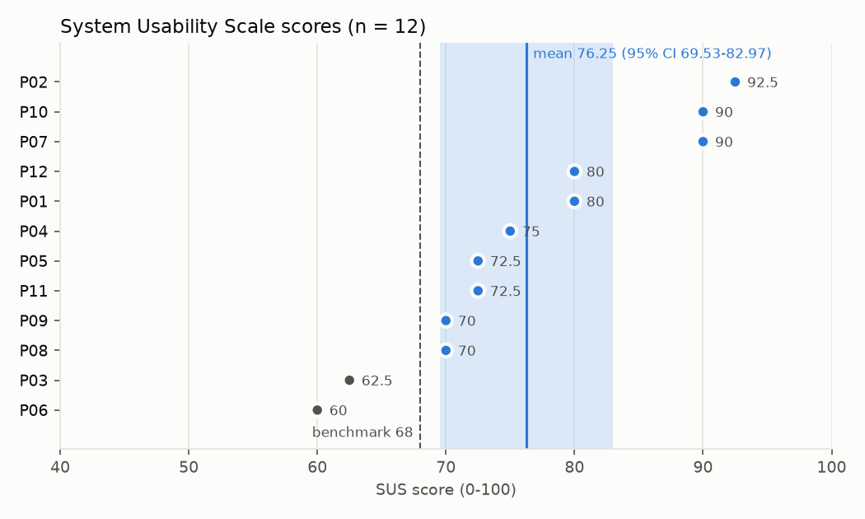
Figure 5.5: System Usability Scale score of each participant, with the mean, its 95% confidence interval and the benchmark of 68
Item means show where usability was weakest: the lowest contributions were for the functions being well integrated (SUS5, mean 3.75 of 5) and for needing to learn a lot before getting going (SUS10, mean 2.17 on a negatively worded item). The open comments explain both. Three participants found too much on one page or were unsure which number was the main result (P03, P06, P08); three wanted terms such as "range" and "confidence", or the charts, explained and suggested a short guide at the start (P01, P06, P11); two found the Research lab page disconnected or labels inconsistent between pages, or took time to find the chat (P05, P09); two were unsure whether the numbers applied to them or asked for the date of the job-advertisement data (P08, P12); and single comments concerned the chart axis labels, the length of the profile form on a phone and a dark mode. Two participants reported no problem. After the study the artifact was changed in response: a "How to read this result" guide under the estimate now explains the most likely time, the range, the confidence label and the charts, and points to the chat assistant; a line under the estimate states the data source; the chat assistant was moved into a collapsible section so that the estimate stays the focus of the page; and the page headings now match the menu. These changes were made after the evaluation and were not re-tested, so the SUS score describes the version the participants used.
Scores were lower among the three participants who used the example profile card than among the seven who entered their own details (mean 64.2 against 82.5), and rose with how often participants use career or job-search websites (Spearman rho = 0.84). These groups are too small for firm conclusions, but they suggest that the artifact is easiest to use with one's own profile and for people familiar with such sites, and that a short introduction would help less experienced users. Because the participants were the researcher's peers, the ratings may be somewhat favourable, and the SUS measures perceived usability rather than task success.

5.9 Comparison with Existing Solutions
Table 5.10: Comparison with existing solutions
Solution | Users | Main features | Limitations for Sri Lankan IT graduates
ITConnect (Karunanayake et al., 2023) | Working IT professionals in Sri Lanka | Fake-job detection, job-posting filtering, resume evaluation | Not aimed at graduates or final-year students; no time-to-employment estimate or skill-gap forecast
Career-path predictor (Rukais et al., 2025) | Sri Lankan IT employees | Ensemble model over 31 attributes (skills, education, internships) predicting a career-path category | Predicts a category, not a time; no employer or job-advertisement data; explanations harder to present
Scopira (Sribharathi et al., 2025) | Job seekers in general | Resume parsing, skill-gap detection and job matching | Not Sri Lanka-specific; no degree, GPA or certification data; no time estimate
Resume Ranker (Gangoda et al., 2024) | Recruiters and candidates (Japanese data) | Resume parsing, skill matching and skill-improvement suggestions | Not designed for undergraduates; no academic data; no time estimate
AI mock-interview platform (Amarasena et al., 2024) | Fresh IT graduates | Generated interview questions and analysis of non-verbal behaviour | Interview preparation only; no prediction or market alignment
Workera and SkillWaze (commercial) | Learners and employers | Skill-gap assessment dashboards; skills verification and micro-internship matching | Not built for Sri Lanka; no time-to-employment range; no employer and job-advertisement triangulation
CareerBuilder with Textkernel, Gigged.AI (commercial) | Recruiters | Candidate-to-job matching | Recruiter-facing; no guidance or estimate for the graduate
General-purpose LLM (ChatGPT, GPT-5.6) | Anyone | Free-text answers to any career question | No local outcome data; on the 132 test graduates Uno's C 0.539 against 0.619, over-optimistic and inconsistent across repeated runs (Section 5.9)
This study | Sri Lankan IT final-year students and graduates | Survival-based time range with confidence, explanations, what-if, questions about the result, comparison with employers, job advertisements and peers; accuracy reported on held-out data | Moderate accuracy (test C 0.619); probabilities under-predict employment; survey-based
The artifact differs mainly in predicting time to employment with survival methods, which keep graduates still searching, and in triangulating graduate, employer and job-advertisement data; its accuracy is modest but openly reported, whereas the reviewed systems report classification accuracy that cannot be compared directly.
Table 5.11 compares the capabilities that define the research gap (Section 2.4) across the solutions reviewed in Chapter 2 and a general-purpose language model.
Table 5.11: Capabilities of existing solutions and of this study
Capability | Rukais et al. | ITConnect | Scopira | Commercial tools | ChatGPT | This study
Sri Lankan IT focus | Yes | Yes | No | No | No | Yes
Predicts the time to a first job | No | No | No | No | Partial | Yes
Uses graduates who are still searching | No | No | No | No | No | Yes
Gives a range with its uncertainty | No | No | No | No | Partial | Yes
Explains the result and offers what-ifs | No | No | Partial | Partial | Partial | Yes
Tested against a general-purpose LLM | No | No | No | No | - | Yes
Yes, No and Partial are judged from the published descriptions reviewed in Section 2.3. ChatGPT is shown as Partial where it can give a month estimate, a range or an explanation when asked but, in the benchmark below, ranked graduates close to chance and gave different answers to the same profile.
Comparison with a general-purpose LLM. A benchmark module exports the held-out test profiles as standard prompts without outcomes and scores the LLM's answers with the same Uno's C and calibration measures as the model, with a paired bootstrap of the difference and the consistency of repeated answers. ChatGPT is a general language model trained on web text to predict words; it was not trained on Sri Lankan graduate outcomes and cannot use graduates who are still searching, whereas the model here is trained on 620 real local graduates for this one outcome and treats those still searching as censored. ChatGPT remains better at general advice and wording.
The 132 test profiles were exported as standard prompts without outcomes and entered by hand into ChatGPT (GPT-5.6, free tier) on 14 October 2026, each in a new temporary chat; 30 profiles were entered three times, giving 192 answers, none of them unparseable. ChatGPT's Uno's C was 0.539 (Harrell's C 0.542) against 0.619 for the model on the same graduates; the difference of 0.081 (paired bootstrap 95% CI 0.030 to 0.131) excludes zero, so the model ranked graduates better. ChatGPT expected every graduate outside the slowest third to be employed within six months, against 71-80% observed, giving a six-month calibration error of 0.227 against 0.224 for the model under the same rule. Its answers were also unstable: only one of the 30 repeated profiles (3.3%) received the same answer in all three runs, the answers for the same profile differed by 1.4 months on average (standard deviation), and the mean Spearman correlation between runs was 0.42. The prompt and the full results are in Appendix H.

5.10 Results Related to Research Objectives
Table 5.12: Results by research objective
Objective | How to achieve | Result | Status
O1: factors associated with time to employment (target about 400) | Graduate survey; duration and event per graduate; Kaplan-Meier and log-rank; multivariable Cox and AFT with confidence intervals; proportional-hazards check; sensitivity analyses | 885 modelling graduates (1,115 incl. final-year); GPA and internship experience clearly associated; institution, degree and soft skills not | Achieved
O2: alignment with employers (target 30-50) and job ads | Employer survey and job-advertisement collection; coding to the 26-skill vocabulary with an independent coding check; Mann-Whitney U with false-discovery-rate correction; Spearman correlation of priorities and demand | 239 employers and 324 ads; significant gaps for 24 of 26 skills; actionable skills identified; coding agreement kappa 0.83 | Achieved
O3: compare Cox, Elastic Net Cox, AFT and DeepSurv | Fixed 70/15/15 split; seven models fitted on training; pre-set selection rule on validation; one evaluation on the test set (Uno's C, IBS, calibration) with bootstrap intervals | 7 models compared on validation; AFT Log-Normal selected (0.693); test C 0.619; calibration not met | Achieved, with a calibration limitation
O4: prototype, SUS (8-12 users) and LLM benchmark | FastAPI and Streamlit prototype with automated tests; response-time measurement; SUS sessions with 8-12 users; the same test profiles given to a general-purpose LLM, compared with a paired bootstrap | Four-page prototype with chat assistant; 295 tests passing; responses under 0.5 s; SUS 76.3 (95% CI 69.5-83.0, n = 12); C 0.619 vs ChatGPT 0.539 | Achieved (small usability sample)

5.11 Chapter Summary
Most graduates found an IT job within six months (median 4), and GPA and internship experience were the only factors clearly associated with a shorter search. Graduates fell short of employers' expectations on almost every skill. The selected AFT Log-Normal model ranked graduates better than chance on the test set (C = 0.619) but under-predicted employment, so its probabilities are indicative only. The system passed all its tests and responded within half a second. Twelve users rated its usability above the benchmark (mean SUS 76.3 against 68), and it ranked the test graduates better than ChatGPT (C 0.619 against 0.539).

Chapter 6
Discussion, Conclusions and Recommendations

6.1 Introduction
This chapter interprets the results of Chapter 5 in the light of the literature reviewed in Chapter 2, assesses how far each objective was achieved, answers the four research questions, and makes recommendations for graduates, universities, employers, developers and the artifact, before proposing future research and concluding the study. It corresponds to the communication stage of the Design Science Research Methodology (Section 3.4).

6.2 Discussion of Findings
This section states what this study found. Each finding is given as what I found, how I found it and what it means, with the evidence traced to the tables and figures of Chapter 5; the related literature is in Chapter 2.

6.2.1 Finding 1: A quarter of graduates were still searching, so survival analysis was needed
What I found: Of the 885 modelling graduates, 218 (24.6%) had not yet found an IT job when they were surveyed.
How I found it: The outcome of each graduate was built as the months from degree completion to the first IT job, or to the survey date for those still searching, who were treated as censored (Section 4.7). The Kaplan-Meier estimate uses these graduates up to the month in which they were last observed (Figure K.1).
What it means: A classification model would have had to discard these graduates or count them as failures. Survival analysis kept the information that they had not found work by a given month, and its output, a time range and the chance of employment by fixed months, answers the question graduates ask more directly than a category label.

6.2.2 Finding 2: Most graduates found IT work quickly, but not all
What I found: The median time from degree completion to a first IT job was 4 months. Of the 885 graduates, 43.6% had found an IT job by 3 months, 67.0% by 6 months, 80.9% by 12 months and 89.8% by 24 months, and 117 graduates (13.2%) had started an IT role before completing their degree.
How I found it: Kaplan-Meier estimate for all 885 modelling graduates (Section 5.4, Figure K.1).
What it means: A single employment rate at one point in time hides this spread. About one in ten graduates was still searching after two years, so a typical value should always be shown together with a range.

6.2.3 Finding 3: GPA and internship experience, not institution type, were associated with a shorter search
What I found: After adjusting for the other factors, one standard deviation more GPA was associated with a 20% shorter search (time ratio 0.80, 95% CI 0.70-0.92), and one standard deviation more internship experience with a 16% shorter search (0.84, 0.76-0.94). Institution type and degree programme showed no clear difference.
How I found it: Adjusted time ratios of the selected AFT model and hazard ratios of the Cox model on the 620 training graduates (Table 5.3, Figure 6.1), supported by log-rank tests: the median was 4 months for GPA 3.0 or higher against 7 months below 3.0, and 4 against 6 months with and without a longer internship (p = 0.003), while institution type (p = 0.84) and degree group (p = 0.47) showed no difference.
What it means: Employers rated GPA the least important hiring factor (3.21 of 5), yet GPA had the strongest association with the outcome. This could mean that GPA acts as a screening signal at shortlisting, or that it stands for effort and ability that were not measured; the data cannot separate the two. Because the study is observational, these are associations and not causes, and they describe this non-probability sample.
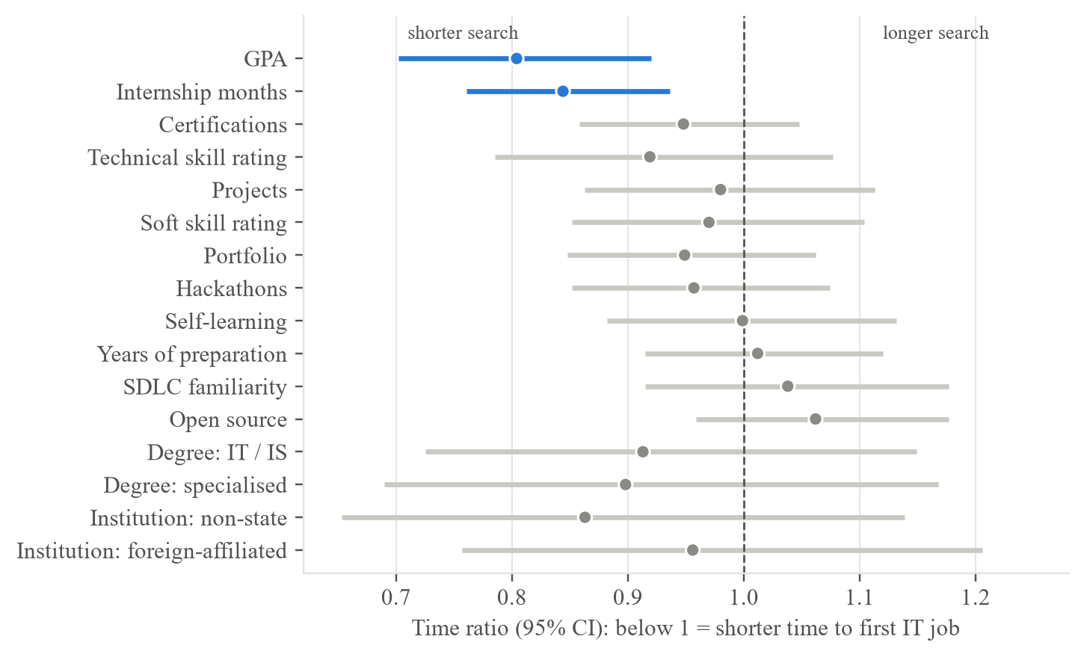
Figure 6.1: Adjusted time ratios of the selected AFT model (training set); only GPA and internship months exclude 1

6.2.4 Finding 4: Self-rated skills, certifications and preparation activities added little
What I found: Technical skill ratings (time ratio 0.92, 95% CI 0.79-1.08), certifications (0.95, 0.86-1.05), a portfolio (0.95, 0.85-1.06) and soft-skill ratings (0.97, 0.85-1.10) all had intervals that included 1, and the preparation activities showed no clear association either.
How I found it: The same adjusted model as in Finding 3 (Table 5.3).
What it means: The same graduates rated themselves below employers on almost every skill (Finding 7), yet their ratings ranked their own outcomes only weakly. Self-ratings are an imperfect measure of competence (Section 1.7); in this study they were more useful for showing gaps than for predicting the time to a job.

6.2.5 Finding 5: The model ranks graduates moderately well, but its probabilities are too pessimistic
What I found: On the 132 graduates of the locked test set the selected model reached Uno's C = 0.619 (95% CI 0.557-0.683) and Harrell's C = 0.626, so it ranked correctly which of two graduates found work first about 62 times in 100. Its integrated Brier score (0.167) was no lower than that of the Kaplan-Meier baseline (0.164), and it under-predicted employment by 8 to 17 percentage points, for example 61% predicted against 77% observed by 6 months.
How I found it: The test set was evaluated once, after the model had been chosen on the validation set (Section 5.6, Table 5.6, Figure 5.4).
What it means: Three explanations are plausible: the evaluation sets are small (about 130 graduates); later cohorts found work faster than earlier ones, as the temporal validation showed (it under-predicted early employment by about 12 points); and the single reference survey date (Section 4.7) may have lengthened the follow-up of graduates still searching. I reported the result instead of tuning the model until it improved, so the artifact shows a range as its main result and labels the probabilities as indicative.

6.2.6 Finding 6: A simple model was as good as complex ones, and accuracy is limited by what was measured
What I found: The parametric AFT Log-Normal model had the highest validation Uno's C (0.693). DeepSurv (0.679) and three further neural survival models (DeepHit 0.590, Cox-Time 0.674, N-MTLR 0.666) did not improve on it. GPA alone reached 0.637 and GPA with internship months 0.675.
How I found it: The seven models were compared on the 133 validation graduates (Table 5.5, Figure 5.3); the further neural models, the learning curve and the baselines are in Appendix J (Figure J.2, Table J.5).
What it means: Most of the model's ranking comes from the two inputs that were clearly associated with the outcome. The learning curve rose from 0.641 to 0.693 and was levelling off, so more respondents answering the same questions would add little. The remaining variation most likely reflects what was not measured, such as personal networks, job-search effort and interview performance, which employers themselves ranked highly (interview performance was in 58.8% of employers' top three). The most interpretable model was therefore also the best supported.

6.2.7 Finding 7: Graduates fall short of employers' expectations on 25 of 26 skills, and the two groups value different things
What I found: Graduates rated themselves below employers' importance ratings on 25 of 26 skills. The largest gaps were in cloud computing (+1.20), software testing (+1.20), DevOps (+1.12), Docker (+0.93) and cybersecurity (+0.91). The job advertisements asked most for problem solving (69%), teamwork (61%) and communication (55%) and, among technical skills, for software testing (44%), SQL (37%) and REST APIs (33%), with cloud computing in 23%. Graduates over-estimated the importance of internships and certifications and under-estimated interview preparation and English, which employers rated at 4.31 of 5.
How I found it: I compared the self-ratings of graduates at degree completion with the importance ratings of employers on the same 26 skills, the 324 coded job advertisements, and the graduate and employer top-three rankings (Figures 5.2 and 6.2). What employers said was important agreed only moderately with what they advertised (Spearman rho = 0.39).
What it means: At entry level, employers appear to look for strong foundations and the ability to learn more than for emerging specialisms: internship advertisements asked for self-learning in 61% of cases against 31% for junior roles. Software testing stands out, with a large gap and a place in 44% of advertisements. About two-thirds of the employers' importance ratings were 4 or 5, so I used them to rank skills against each other and not as absolute levels. The differences between graduates and employers concern where graduates spend their preparation time, so they are actionable.
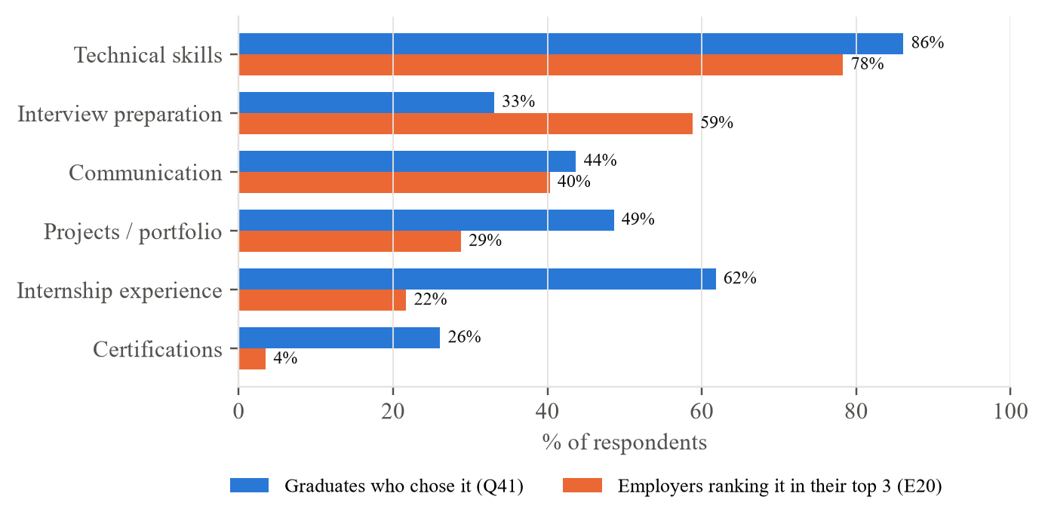
Figure 6.2: What graduates think matters most for employability vs what employers rank in their top three

6.2.8 Finding 8: The system ranked graduates better than ChatGPT and was rated usable
What I found: On the same 132 test graduates, ChatGPT reached Uno's C = 0.539, close to chance, against 0.619 for the model (difference 0.081, 95% CI 0.030-0.131). It was over-optimistic about employment within six months and gave different answers to the same profile on repeated runs. Twelve participants gave a mean System Usability Scale score of 76.3 (95% CI 69.5-83.0), above the benchmark of 68, and ten of the twelve scored 68 or more.
How I found it: The held-out test profiles were entered into ChatGPT without their outcomes and scored with the same measures as the model (Section 5.9, Table H.1). Usability was measured in one-to-one sessions with 12 participants (Section 5.8, Table 5.9, Figure 5.5).
What it means: A general-purpose language model given the same profile did not rank Sri Lankan graduates better than chance, which supports building a system trained on local outcomes; it does not show that such models are useless for general advice. The usability result describes the version that the participants used, they were the researcher's peers, and the changes made afterwards were not re-tested.
The findings are subject to the following limitations, which extend those anticipated in Section 1.7.
- Skills, preparation and outcomes were self-reported; self-ratings are an imperfect measure of competence. Certifications (Q9), internship months (Q12) and projects (Q13) were asked as totals at the time of the survey rather than at degree completion, unlike the skill and preparation items, so some may have been gained after graduating; this could slightly overstate their association with finding work, although many internships are completed as part of the degree.
- The months of completion and of the first job were recalled; 118 job-start times fell on round values and the planned test-retest check of recalled dates was not carried out.
- Every response was given one reference survey date, which may overstate the follow-up of graduates still searching (Section 4.7).
- The sample is non-probability: about a third of responses came from one institution, and graduates who found work may have been more willing to respond, so the results do not generalise statistically to all Sri Lankan IT graduates.
- Personal networks, job-search effort and interview performance were not measured, which limits accuracy.
- Employers' importance ratings clustered at 4 and 5 (about two-thirds of the ratings), which may reflect social desirability; they were therefore used to rank skills against each other and not as absolute levels.
- The evaluation sets were small (about 130 graduates each), and the model's probabilities were not well calibrated on the test set.
- The job advertisements describe advertised vacancies over three months only, not all hiring.
- The usability evaluation involved 12 participants recruited from the researcher's peers, which may favour positive ratings, and task completion was not recorded task by task.
Legal and privacy. The study collected only the data needed for the research questions, in line with Sri Lanka's Personal Data Protection Act, No. 9 of 2022 (Parliament of the Democratic Socialist Republic of Sri Lanka, 2022): every response recorded consent, no names or contact details were asked for, institutions are reported only by type or as "Institution 1 ... k", and the artifact stores no profile, holding only aggregated reference data. Responses were submitted individually through Google Forms, so no respondent could see another's answers.
Social impact and fairness. A pessimistic estimate could discourage a graduate, and the model did under-predict employment in most groups, with a lower C-index for men than for women. The artifact therefore presents ranges with their uncertainty, uses associational wording, shows only factors a graduate can change and states on every page that it is decision support, not a hiring or screening tool. Gender is used only for the fairness check and never as a model input. Institution type is an input; it showed no clear association with the outcome, but its use should be reviewed whenever the model is refitted. Two further risks remain. First, a graduate may read the what-if results as promises - for example, that a longer internship would shorten their own search by the amount shown - although they describe patterns among past graduates, not causes; the wording says so, but such a reading cannot be ruled out. Second, the LLM benchmark sent the answers of the 132 test graduates to ChatGPT as anonymous profiles (degree, GPA, experience and skill ratings, with no names, contact details or institution names), so no respondent can be identified, but their answers were still processed by an external service; future studies should state such processing explicitly in the consent form.
Professional conduct. The analysis plan, the primary metric and the model-selection rule were fixed before the data were analysed, the test set was used once, and every deviation - the reference survey date, the feature set and the technology changes - is reported with its reason (Sonabend et al., 2022; Collins et al., 2024). Results that did not meet the pre-set conditions, such as calibration, are reported rather than tuned away, and all results can be regenerated from the stored code and data.

6.3 Achievements of Research Objectives
Figure 6.3 summarises each objective, its main result and its status; the detail follows.
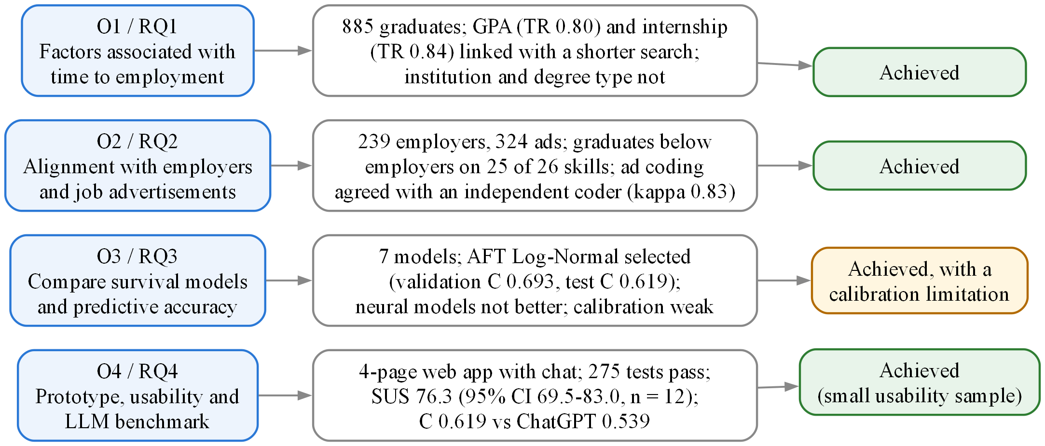
Figure 6.3: Achievement of the research objectives and questions
- O1 - achieved. Survival analysis of 885 modelling graduates (1,115 respondents including final-year students, above the target of about 400) identified GPA and internship experience as the factors clearly associated with time to employment, with hazard and time ratios, confidence intervals, a proportional-hazards check and sensitivity analyses.
- O2 - achieved. 239 employer responses (target 30-50) and 324 job advertisements were compared with graduate self-ratings on 26 skills; significant gaps were found for 24 skills and the most actionable were identified. The keyword coding of the advertisements agreed closely with an independent coder (Cohen's kappa 0.83).
- O3 - achieved, with a calibration limitation. Cox, Elastic Net Cox, three AFT models and DeepSurv were compared under a fixed split and a pre-set rule; AFT Log-Normal was selected (validation C = 0.693) and evaluated once on the test set (C = 0.619). The calibration condition was not met.
- O4 - achieved. A four-page web prototype was implemented, verified by 295 automated tests and responds within half a second; it also answers questions about a result through a grounded chat assistant.
In the usability evaluation, 12 final-year students and recent graduates gave a mean SUS score of 76.3 (95% CI 69.5-83.0), above the pre-set benchmark of 68, and on the 132 test profiles the model ranked graduates better than ChatGPT (Uno's C 0.619 against 0.539; difference 0.081, 95% CI 0.030-0.131). O4 is therefore achieved, with two qualifications: the usability sample was small and drawn from the researcher's peers, and task completion was not recorded task by task.

6.4 Answers to Research Questions
RQ1 - What academic, technical, professional, and experiential factors are significantly associated with time-to-employment for final-year IT undergraduates and entry-level IT graduates in Sri Lanka? Higher GPA and more internship experience were associated with a shorter time to the first IT job: one standard deviation in each was linked with a 20% and a 16% shorter search. Certifications and technical skill ratings pointed the same way without clear evidence, and institution type, degree programme, soft-skill ratings and preparation activities showed no clear association.
RQ2 - How well do final-year/graduate profiles align with current employer requirements and job-market demand, and what are the most significant and actionable gaps? Alignment is weak: graduates rated themselves below employers' importance ratings on 25 of 26 skills. The largest gaps were in cloud computing, software testing, DevOps and Docker, cybersecurity, problem solving and communication; combined with advertised demand, the most actionable were software testing, problem solving, communication, REST APIs, Git and SQL.
RQ3 - How accurately and reliably can a survival-analysis-based machine learning framework predict time-to-employment for this population, and how do the linear, regularised, parametric, and nonlinear approaches compare? With survey information, moderately: the selected parametric AFT model reached a validation C of 0.693 and a test C of 0.619, ranking graduates better than chance but with probabilities that under-predict employment. The linear, regularised, parametric and neural approaches performed similarly (validation C 0.655-0.693), and the neural networks did not improve on the simpler models.
RQ4 - To what extent does the prototype web-based decision-support application provide accurate, explainable, and actionable guidance to final-year students and graduates, as measured through usability evaluation and a structured benchmark comparison against a general-purpose LLM given identical input? The prototype provides individual time ranges with confidence levels, explanations limited to factors a graduate can change, what-if scenarios and skill comparisons with real employer and job-market data, and it does so correctly and quickly.
Users found it usable: twelve final-year students and recent graduates gave a mean SUS score of 76.3 (95% CI 69.5-83.0), above the benchmark of 68, while asking for less information on one screen and plainer explanations of terms such as "confidence". Its guidance is also more accurate than that of a general-purpose LLM given the same information: ChatGPT ranked the 132 test graduates close to chance (Uno's C 0.539 against 0.619; difference 0.081, 95% CI 0.030-0.131), was over-optimistic about employment within six months, and gave different answers to the same profile on repeated runs.

6.5 Recommendations
The recommendations follow directly from the findings and are grouped by the people who can act on them (Figure 6.4). Each states the finding it rests on (rationale), what should be done (action) and what it is expected to achieve (benefit).
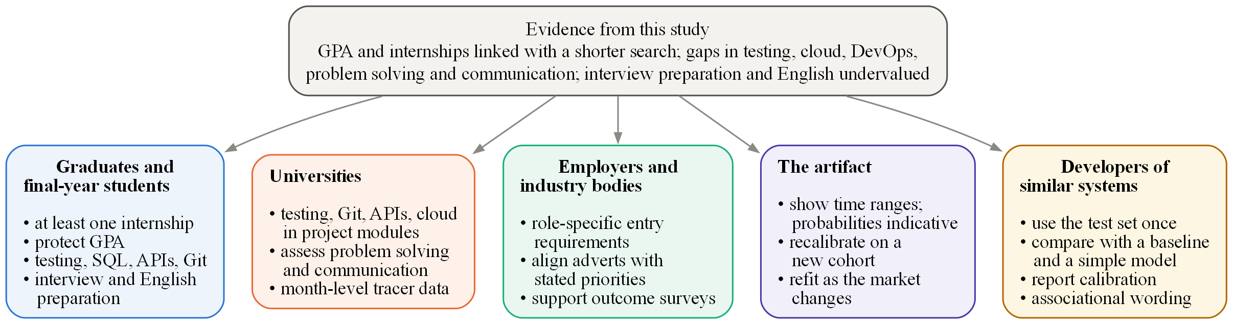
Figure 6.4: Recommendations by stakeholder
- Graduates and final-year students - gain internship experience. Rationale: Internship experience was one of the two factors clearly associated with a shorter search (16% shorter per standard deviation). Action: Complete at least one substantial internship before or soon after completing the degree. Expected benefit: A shorter expected search and practical evidence that employers value.
- Graduates and final-year students - protect academic performance and build in-demand skills. Rationale: GPA was associated with a 20% shorter search per 0.4 GPA points (one standard deviation), and the most actionable skill gaps were software testing, SQL, REST APIs and Git. Action: Keep GPA up and build practical, demonstrable skill in these areas. Expected benefit: A profile that matches what employers advertise most often.
- Graduates and final-year students - prepare for interviews in English. Rationale: Employers ranked interview performance among their top three factors (58.8%), and English showed the largest perceived gap (3.38 against 4.31). Action: Practise interviews and explaining technical work in English. Expected benefit: More applications turned into offers.
- Universities - close the practical skills gap. Rationale: Graduates rated themselves below employers' expectations on 25 of 26 skills, most in cloud computing, software testing and DevOps. Action: Embed testing, version control, APIs, cloud and DevOps practice in project modules, and assess problem solving and communication explicitly. Expected benefit: Graduates who are closer to job-ready at completion.
- Universities - track time to the first job. Rationale: Existing tracer reports measure employment at one point in time, so the time taken cannot be analysed. Action: Record the month of completion and of the first job for every graduate. Expected benefit: Outcomes that can be analysed over time and used to recalibrate tools such as this one.
- Employers and industry bodies - state entry-level requirements clearly. Rationale: Employers' stated priorities agreed only moderately with what they advertised (rho = 0.39). Action: Publish role-specific entry-level requirements and support graduate outcome surveys. Expected benefit: Graduates prepare for what is actually required, and better data become available.
- The artifact - recalibrate and simplify. Rationale: Probabilities under-predicted employment on the test set, and usability participants asked for less on one screen and plainer terms. Action: Present ranges, treat probabilities as indicative until the model is recalibrated on a new cohort and refitted periodically; add a short guided introduction and explain range and confidence where they appear. Expected benefit: Estimates users can trust and interpret without help.
- Developers of similar systems - keep evaluation honest. Rationale: Survey-based models reach only moderate accuracy, and poor calibration can go unnoticed. Action: Keep the test set separate and use it once, compare with a no-model baseline and a simple model, report calibration as well as ranking, and state associations, never causes. Expected benefit: Claims that others can rely on and reproduce.

6.6 Future Research
- Measure what drives hiring. Add questions on job-search effort (applications and interviews), referrals and contacts, the target role, internship conversion and location, and supplement self-ratings with objective skill evidence. These are the most likely route to better accuracy.
- Better dates. Record the real date of each response and the exact months of completion and of the first job, and repeat the test-retest check of recalled dates.
- A new evaluation cohort. Collect a fresh group of graduates that has never been used, to recalibrate the model and evaluate it once more without reusing any respondent; following final-year students through graduation would give prospective rather than recalled outcomes.
- Larger samples for neural models. With several thousand graduates, neural survival models may capture non-linear effects that this study could not.
- Continuous market monitoring. Repeat the job-advertisement collection to track how demand changes.
- A constrained language-model layer. A language model could rewrite the explanations in plainer words if every number in its reply were checked against the model's output and no profile left the device; this would need its own evaluation of faithfulness and usability.

6.7 Conclusion
This study set out to give Sri Lankan IT graduates and final-year students an explainable, individual and evidence-based estimate of their time to a first IT job, linked to real labour-market demand and with transparently established accuracy. Using 1,175 graduate and 245 employer responses and 324 real job advertisements, it found that most graduates found IT work within about four months, that GPA and internship experience were the factors most clearly linked with a shorter search, and that graduates fall short of employers' expectations most in modern engineering practice, problem solving and communication. Among linear, regularised, parametric and neural survival models, a parametric AFT model was as accurate as any and the most interpretable, but its accuracy on unseen graduates was moderate and its probabilities under-predicted employment, a limit set more by what surveys measure than by the choice of algorithm. Users rated the application's usability above the benchmark (mean SUS 76.3 against 68), and it ranked graduates more accurately and more consistently than a general-purpose LLM given the same information. The study contributes a reproducible, explainable time-to-employment framework, a working decision-support application, and a current, triangulated picture of entry-level IT skill demand in Sri Lanka, together with an honest account of where such predictions can and cannot be trusted.
Reflection. Three things worked well. Fixing the split, the primary metric and the selection rule before looking at any result, and using the test set once, meant that a modest test result (Uno's C 0.619) could be reported honestly instead of being tuned away. Writing the whole analysis as code that one command re-runs made every number in this thesis traceable. And testing the system against ChatGPT on the same graduates turned an open criticism into evidence. If I repeated the study, I would measure what the data could not, such as job-search effort, contacts and interview performance, and I would record each respondent's own survey date. I would also test the application with users earlier, so that the changes they asked for could be tested again. I learned that in survival analysis the people who have not yet found a job are part of the answer and not missing data, that a model can rank people well while its probabilities are poor, and that an honest limit is easier to defend than an inflated result.

6.8 Chapter Summary
This chapter discussed the findings in the light of the literature. Survival analysis proved the appropriate frame because a quarter of graduates were still searching, GPA and internship experience were the factors most clearly associated with a shorter search, self-reported skills added little, and simple models were as accurate as complex ones while the selected model's probabilities under-predicted employment. It also examined the gaps between graduates, employers and the job market, and evaluated the ethical, legal and professional dimensions of the work. Each objective was then assessed and each research question answered, recommendations were made for graduates, universities, employers, developers and the artifact, future research was proposed, and the study was concluded.

References
Abdallah, J. M. (2024). A review of sample size determination for common experimental designs: Further simplified equations. An-Najah University Journal for Research - A (Natural Sciences), 38(1), 8–16. https://doi.org/10.35552/anujr.a.38.1.2120
Acemoglu, D., Autor, D., Hazell, J., & Restrepo, P. (2022). Artificial intelligence and jobs: Evidence from online vacancies. Journal of Labor Economics, 40(S1), S293–S340. https://doi.org/10.1086/718327
Aljohani, N. R., Aslam, A., Khadidos, A. O., & Hassan, S.-U. (2022). Bridging the skill gap between the acquired university curriculum and the requirements of the job market: A data-driven analysis of scientific literature. Journal of Innovation & Knowledge, 7(3), Article 100190. https://www.sciencedirect.com/science/article/pii/S2444569X22000300
Amarasena, N., Rathnayaka, S. C., Fernando, S., Deiyagala, T., Biyon, H., & Chandrasiri, N. (2024). Enhancing employability through an advanced mock interview platform for fresh IT graduates. IEEE Access. https://ieeexplore.ieee.org/document/10963436
Amarasooriya, P. M. D. S. (2024). Analysis of future demand for Sri Lankan ICT undergraduates in ICT industry: Mapping the ACM/IEEE computing degrees with emerging technologies [Preprint]. SSRN. https://papers.ssrn.com/sol3/papers.cfm?abstract_id=4811746
Atanacio, M. L., Rebong, C. B., Atanacio, M. L., Bulanhagui, A. D., Dimaano, K. I., & Gadiana, B. (2025). JobFinder: Job matching platform for PWDs with resume parsing and data analytics. IEEE Access. https://ieeexplore.ieee.org/document/11369056
Bates, S., Hastie, T., & Tibshirani, R. (2024). Cross-validation: What does it estimate and how well does it do it? Journal of the American Statistical Association, 119(546), 1434–1445. https://doi.org/10.1080/01621459.2023.2197686
Bennett, D., & Ananthram, S. (2022). Development, validation and deployment of the EmployABILITY scale. Studies in Higher Education, 47(7), 1311–1325.
Burk, L., Zobolas, J., Bischl, B., Bender, A., Wright, M. N., & Sonabend, R. (2024). A large-scale neutral comparison study of survival models on low-dimensional data [Preprint]. arXiv. https://doi.org/10.48550/arXiv.2406.04098
Collins, G. S., Moons, K. G. M., Dhiman, P., Riley, R. D., Beam, A. L., Van Calster, B., Ghassemi, M., Liu, X., Reitsma, J. B., van Smeden, M., Boulesteix, A.-L., Camaradou, J. C., Celi, L. A., Denaxas, S., Denniston, A. K., Glocker, B., Golub, R. M., Harvey, H., Heinze, G., . . . Logullo, P. (2024). TRIPOD+AI statement: Updated guidance for reporting clinical prediction models that use regression or machine learning methods. BMJ, 385, Article e078378. https://doi.org/10.1136/bmj-2023-078378
Department of Census and Statistics. (2025). Sri Lanka labour force survey: Quarterly bulletin, first quarter 2025 (Issue No. 108). https://www.statistics.gov.lk/Resource/en/LabourForce/Bulletins/LFS_Q1_Bulletin_2025.pdf
Fernando, R. L. S., Kularathna, E. A. I., & Kumarasinghe, I. D. C. D. (2023). Employability of management graduates of state universities in Sri Lanka: Problems and prospects. International Journal of Governance, Public Policy and Administration. https://journals.sjp.ac.lk/index.php/ijgppa/article/view/6217
Field, A. (2024). Discovering statistics using IBM SPSS Statistics (6th ed.). SAGE.
Gangoda, N., Yasantha, K. P., Sewwandi, C., Induvara, N., Thelijjagoda, S., & Giguruwa, N. (2024). Resume Ranker: AI-based skill analysis and skill matching system. IEEE Access. https://ieeexplore.ieee.org/document/10756304
Hair, J. F., Hult, G. T. M., Ringle, C. M., & Sarstedt, M. (2022). A primer on partial least squares structural equation modeling (PLS-SEM) (3rd ed.). SAGE.
Haryanti, T., Rakhmawati, N. A., & Subriadi, A. P. (2024). Measuring the digital transformation maturity level independently with the design science research methodology. Systems Engineering, 27(1), 159–176. https://doi.org/10.1002/sys.21714
Hofer, L., & Held, L. (2022). Comparing confidence intervals for a binomial proportion with the interval score (arXiv:2207.03199). arXiv. https://doi.org/10.48550/arXiv.2207.03199
Hoffman, R. R., Mueller, S. T., Klein, G., & Litman, J. (2023). Measures for explainable AI: Explanation goodness, user satisfaction, mental models, curiosity, trust, and human-AI performance. Frontiers in Computer Science, 5, Article 1096257. https://doi.org/10.3389/fcomp.2023.1096257
Hyzy, M., Bond, R., Mulvenna, M., Bai, L., Dix, A., Leigh, S., & Hunt, S. (2022). System Usability Scale benchmarking for digital health apps: Meta-analysis. JMIR mHealth and uHealth, 10(8), Article e37290. https://doi.org/10.2196/37290
Kapoor, S., & Narayanan, A. (2023). Leakage and the reproducibility crisis in machine-learning-based science. Patterns, 4(9), Article 100804. https://doi.org/10.1016/j.patter.2023.100804
Karunanayake, K. R. D. S. K., Chandrawansa, K. T. M., Gunatilleke, L. C. T., Menuranga, K. Y. D. B., Gawesha, A., & Manathunga, K. (2023). ITConnect: Real-time personalized job posting platform for IT professionals. In 2023 8th International Conference on Information Technology Research (ICITR). IEEE. https://doi.org/10.1109/ICITR61062.2023.10382750
Lai, J. W., Zhang, L., Sze, C. C., & Lim, F. S. (2025). Learning analytics for bridging the skills gap: A data-driven study of undergraduate aspirations and skills awareness for career preparedness. Education Sciences, 15(1), Article 40. https://doi.org/10.3390/educsci15010040
Lee, A. T., Ramasamy, R. K., & Subbarao, A. (2025). Understanding psychosocial barriers to healthcare technology adoption: A review of TAM technology acceptance model and unified theory of acceptance and use of technology and UTAUT frameworks. Healthcare, 13(3), Article 250. https://doi.org/10.3390/healthcare13030250
Li, M., Gao, Q., & Yu, T. (2023). Kappa statistic considerations in evaluating inter-rater reliability between two raters: Which, when and context matters. BMC Cancer, 23, Article 799. https://doi.org/10.1186/s12885-023-11325-z
Mosca, E., Szigeti, F., Tragianni, S., Gallagher, D., & Groh, G. (2022). SHAP-based explanation methods: A review for NLP interpretability. In Proceedings of the 29th International Conference on Computational Linguistics (pp. 4593–4603). International Committee on Computational Linguistics. https://aclanthology.org/2022.coling-1.406
Nandi, A., Ghosh, P., Mandal, S., Ghosh, A., Das, A. K., & Dutta, S. (2025). Hybrid multi-entity reinforcement learning approach for intelligent, scalable career path recommendations in alumni networks. IEEE Access. https://ieeexplore.ieee.org/document/11365848
Ning, B. (2025). Leveraging predictive analytics for skill gap analysis in undergraduate career management systems. IEEE Access. https://ieeexplore.ieee.org/document/11323755
Parimi, S. K., Cherukuri, R., Yarram, V. K., & Jegajothi, B. (2025). AI-assisted web platform for personalized job recommendation using machine learning techniques. IEEE Access. https://ieeexplore.ieee.org/document/11330313
Parliament of the Democratic Socialist Republic of Sri Lanka. (2022). Personal Data Protection Act, No. 9 of 2022.
Roy, M., & Sharma, K. (2026). AI-powered career guidance: A scalable model for personalized recommendations. IEEE Access. https://ieeexplore.ieee.org/document/11373141
Rukais, S. L. M., Adeeba, S., Herath, G. A. C. A., & Kumara, B. T. G. S. (2025). An ensemble model for predicting career paths of Sri Lankan IT undergraduates. IEEE Access. https://ieeexplore.ieee.org/document/11031069
Samaradivakara, C., Bell, R., & Raghubansie, A. (2024). The conceptualisation of employability among higher education administrators in Sri Lanka's turbulent labour market. Higher Education, Skills and Work-Based Learning. https://doi.org/10.1108/HESWBL-10-2023-0289
Saunders, M. N. K., Lewis, P., & Thornhill, A. (2023). Research methods for business students (9th ed.). Pearson.
Sisk, R., Sperrin, M., Peek, N., van Smeden, M., & Martin, G. P. (2023). Imputation and missing indicators for handling missing data in the development and deployment of clinical prediction models: A simulation study. Statistical Methods in Medical Research, 32(8), 1461–1477. https://doi.org/10.1177/09622802231165001
SLASSCOM. (2024). Employability skills report 2024.
Sonabend, R., Bender, A., & Vollmer, S. (2022). Avoiding C-hacking when evaluating survival distribution predictions with discrimination measures. Bioinformatics, 38(17), 4178–4184. https://doi.org/10.1093/bioinformatics/btac451
Sribharathi, B., Balamurugan, S., Megavarmaraj, S., Deepak, S., & Kajendhiran, S. (2025). Scopira: An AI-driven career guidance system using resume parsing, skill gap analysis, and intelligent job matching. IEEE Access. https://ieeexplore.ieee.org/document/11346170
Tarkhan, A., & Simon, N. (2024). An online framework for survival analysis: Reframing Cox proportional hazards model for large data sets and neural networks. Biostatistics, 25(1), 134–153. https://doi.org/10.1093/biostatistics/kxac039
Tomlinson, M., McCafferty, H., Port, A., Maguire, N., Zabelski, A. E., Butnaru, A., Charles, M., & Kirby, S. (2022). Developing graduate employability for a challenging labour market: The validation of the graduate capital scale. Journal of Applied Research in Higher Education, 14(3), 1193–1209. https://doi.org/10.1108/JARHE-04-2021-0151
University of Kelaniya. (2022). Graduate employability 2021 [Report]. University Statistics & Data Monitoring Unit. https://units.kln.ac.lk/usdmu/media/attachments/2024/11/07/report_graduate-employability-2021_20230316---final1.pdf
Wang, X., Zhou, Z., & Wu, C. (2025). Enhancing vocational students' identities through program-occupation-skill alignment and learning experiences. Vocational & Technical Education Journal. https://www.hksmp.com/journals/vte/article/view/888
Weraduwa, S., Kannangara, M., Gayantha, N., Piyumantha, K., & Rajapaksa, C. (2025). An agent-based model to address the gap in internship opportunities for IT undergraduates in Sri Lanka. IEEE Access. https://ieeexplore.ieee.org/document/10963178
Wiegrebe, S., Kopper, P., Sonabend, R., Bischl, B., & Bender, A. (2024). Deep learning for survival analysis: A review. Artificial Intelligence Review, 57(3), Article 65. https://doi.org/10.1007/s10462-023-10681-3
Ye, J., Huang, D., Meng, S., Long, C., Zhang, Y., & Liu, L. (2025). Development and validation of the perceived university employment support scale among undergraduate students. Frontiers in Psychology, 16, Article 1657774. https://doi.org/10.3389/fpsyg.2025.1657774
Zhao, Z., Zobolas, J., Zucknick, M., & Aittokallio, T. (2024). Tutorial on survival modeling with applications to omics data. Bioinformatics, 40(3), Article btae132. https://doi.org/10.1093/bioinformatics/btae132

Appendix A: Application Screenshots
This appendix shows the decision-support application, named JobSpark, running with the final model trained on the real main-study data (Chapter 4). The screenshots show the interface as redesigned after the usability study: the pages described in Section 4.3 were regrouped into a step-by-step profile, a results dashboard and further pages, with no change to the model, the API or the results. The 12 participants of Section 5.7 used the earlier four-page version. The example profile is the application's default, a graduate in Information Technology from a state university with a GPA of 3.00, six months of internship, three projects and one certification; no real person's answers are shown. Every section is labelled with the source of its data, and the Research lab uses real data except its Simulation study tab, which is a check of the method and not a finding about graduates.
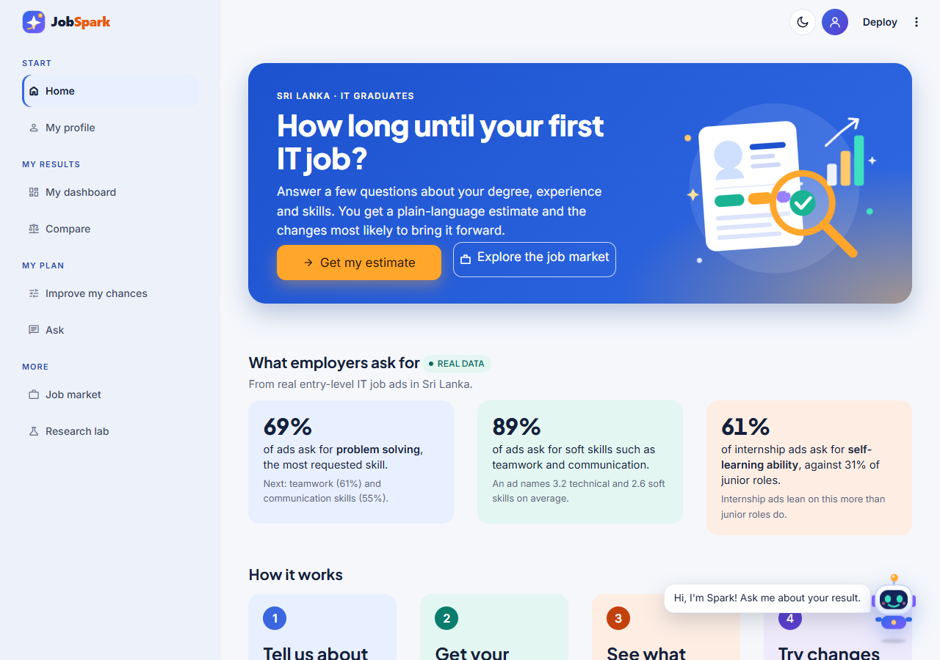
Figure A.1: Home: the purpose of the application, headline figures from the real job advertisements and the steps to an estimate
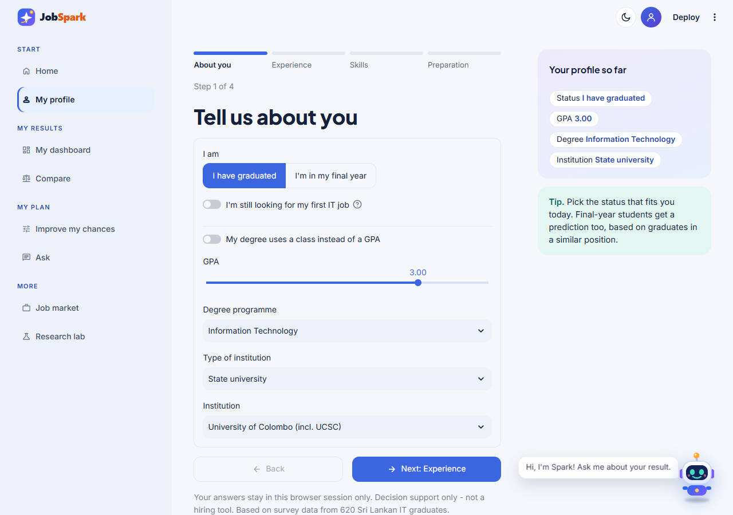
Figure A.2: My profile, step 1 (About you): status, GPA, degree programme and institution
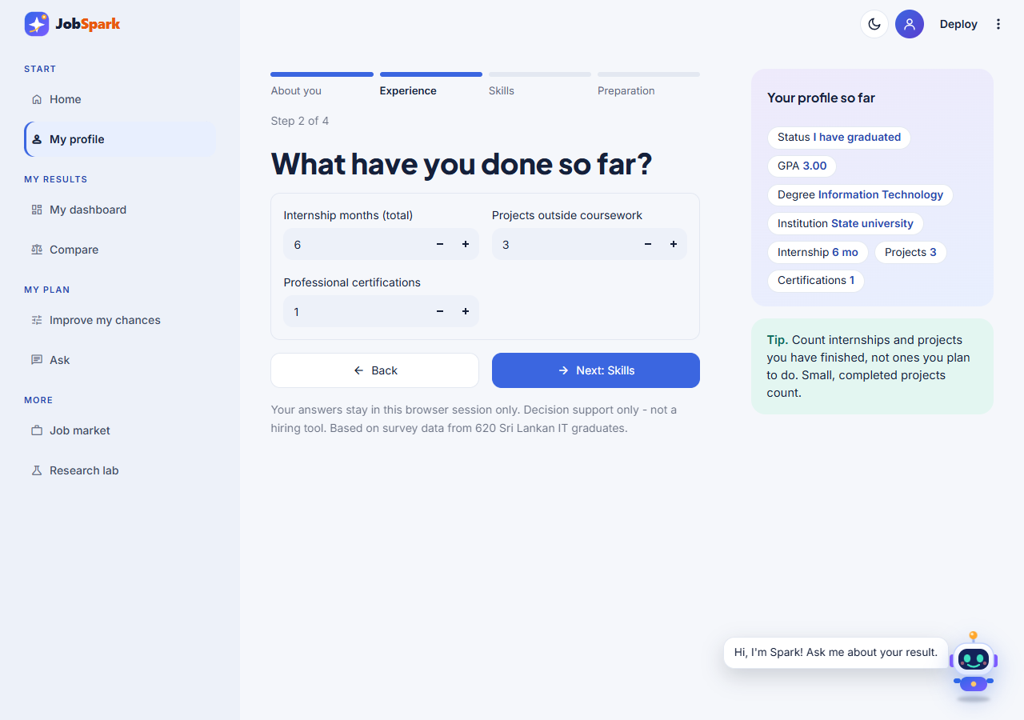
Figure A.3: My profile, step 2 (Experience): internship months, projects and certifications
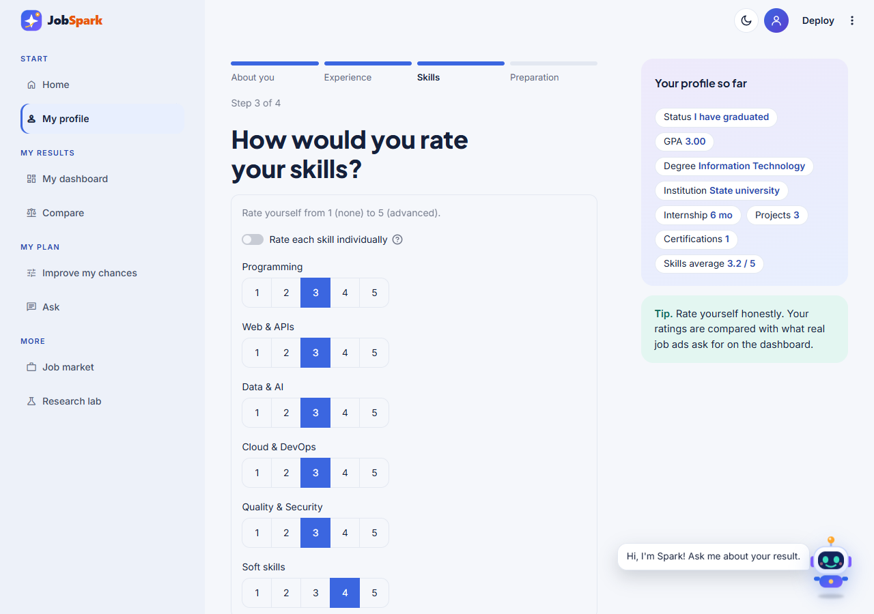
Figure A.4: My profile, step 3 (Skills): self-ratings of the skill areas
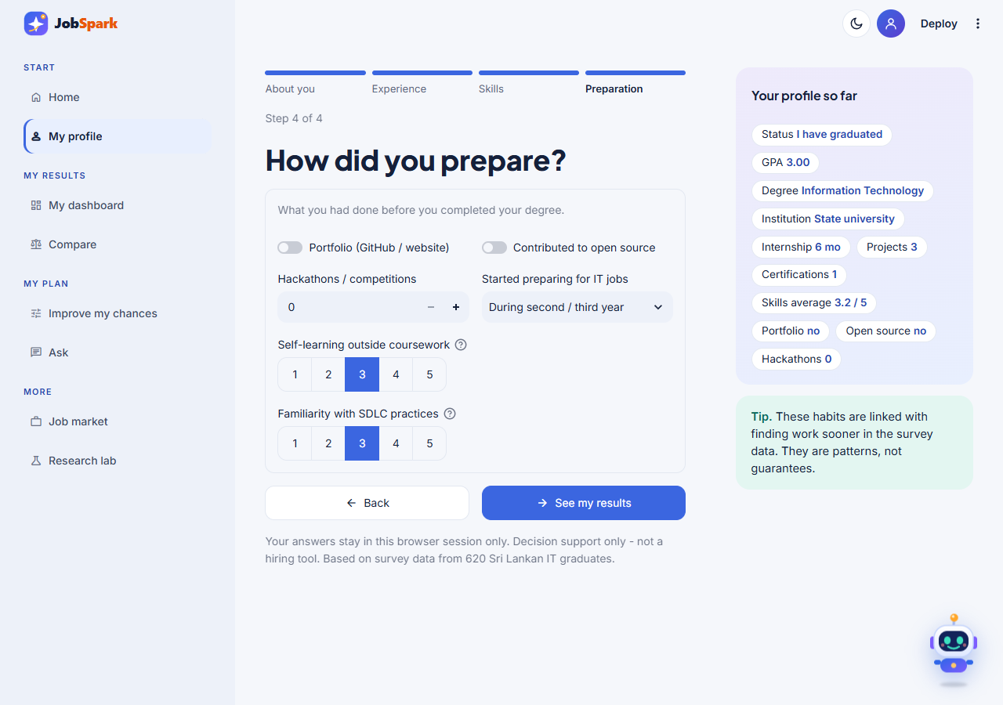
Figure A.5: My profile, step 4 (Preparation): portfolio, open source, hackathons and preparation habits
Figure A.6: My dashboard: most likely time with its range and confidence, and the chance of a job by 3, 6, 12 and 24 months
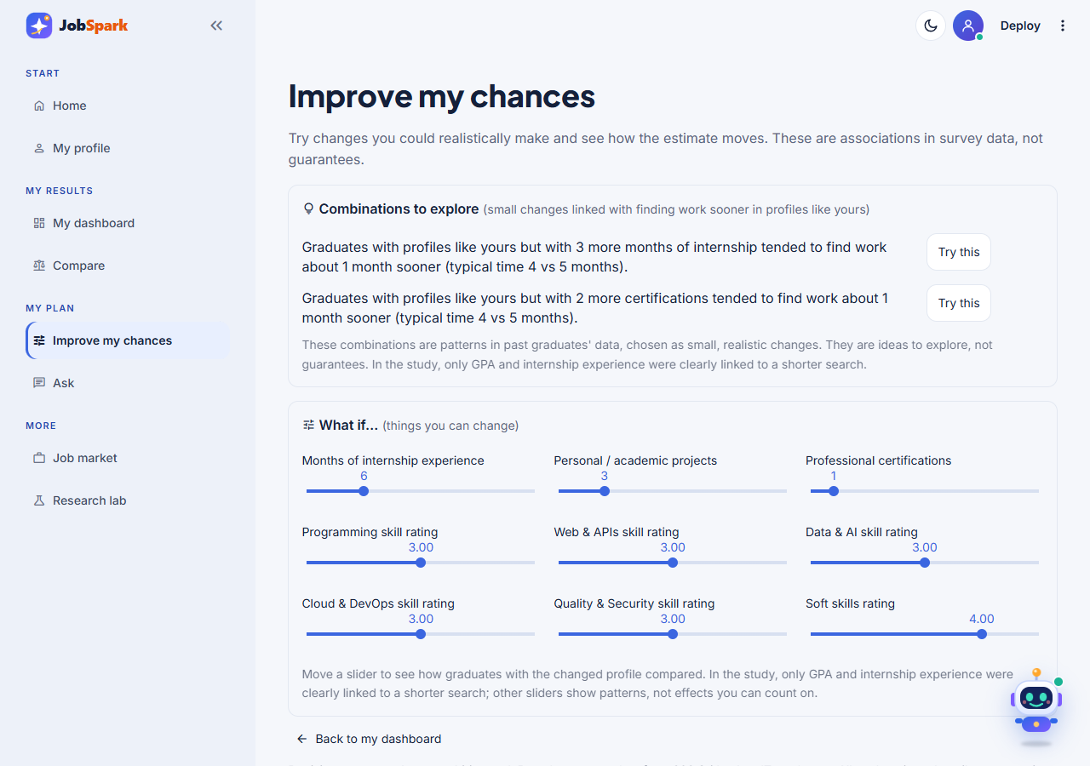
Figure A.7: Improve my chances: combinations to explore and the what-if sliders
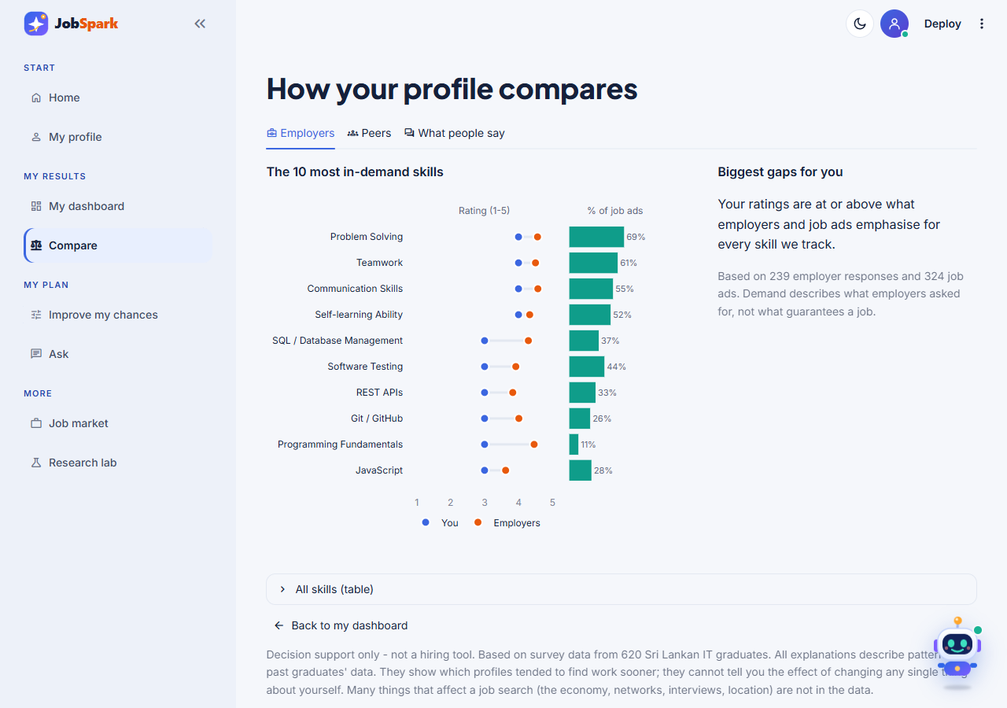
Figure A.8: Compare: the profile against employer importance ratings and job-advertisement demand
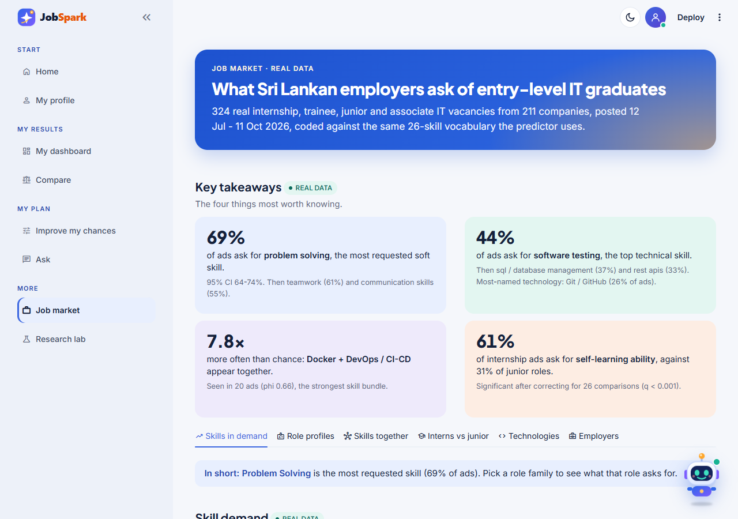
Figure A.9: Job market: headline figures, key findings and skill demand in the 324 real advertisements
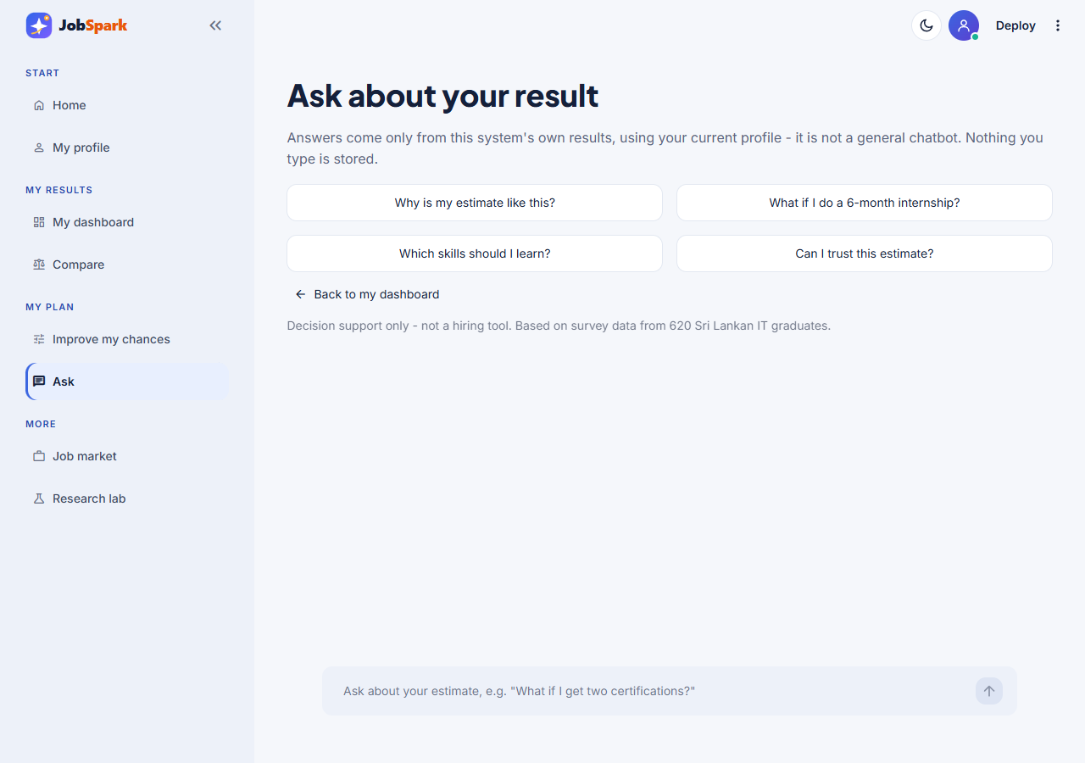
Figure A.10: Ask: questions about the result, answered only from the system's own results
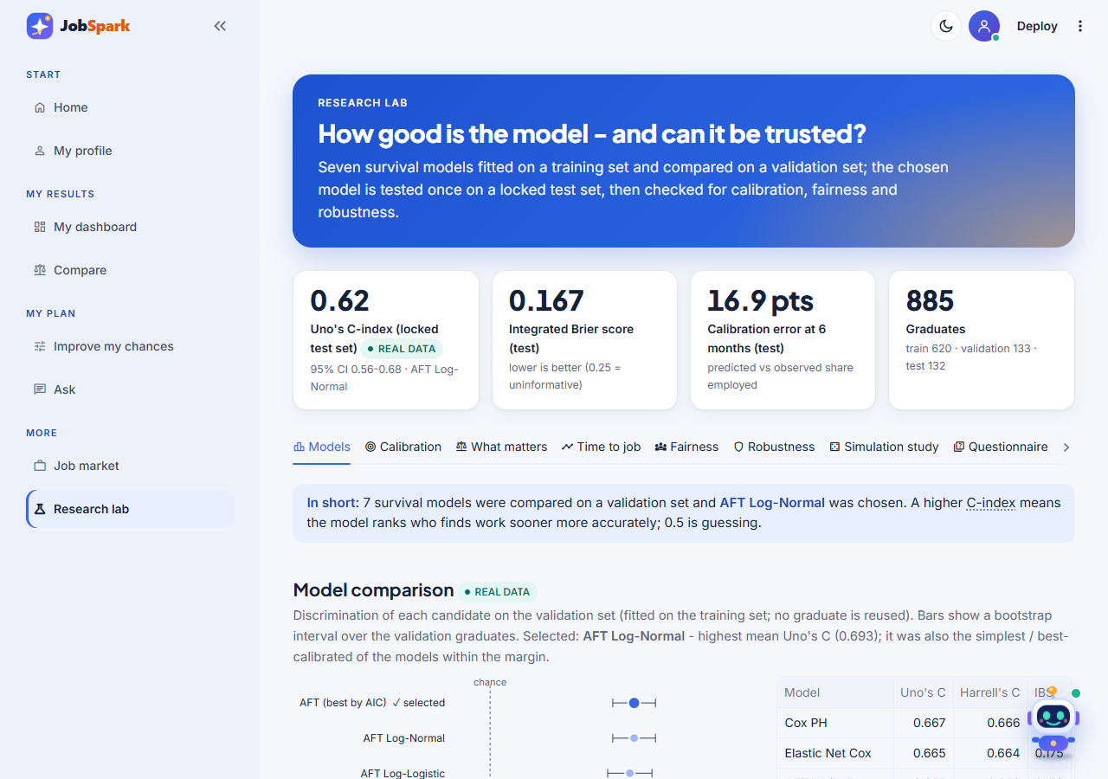
Figure A.11: Research lab: model comparison on the validation set (real data)
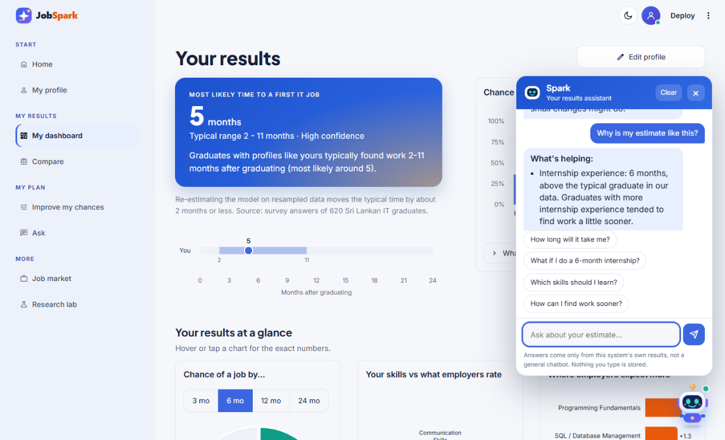
Figure A.12: The Spark assistant open on the dashboard
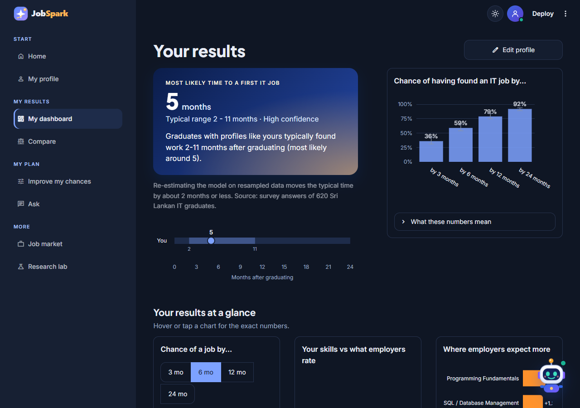
Figure A.13: The dark theme (My dashboard)
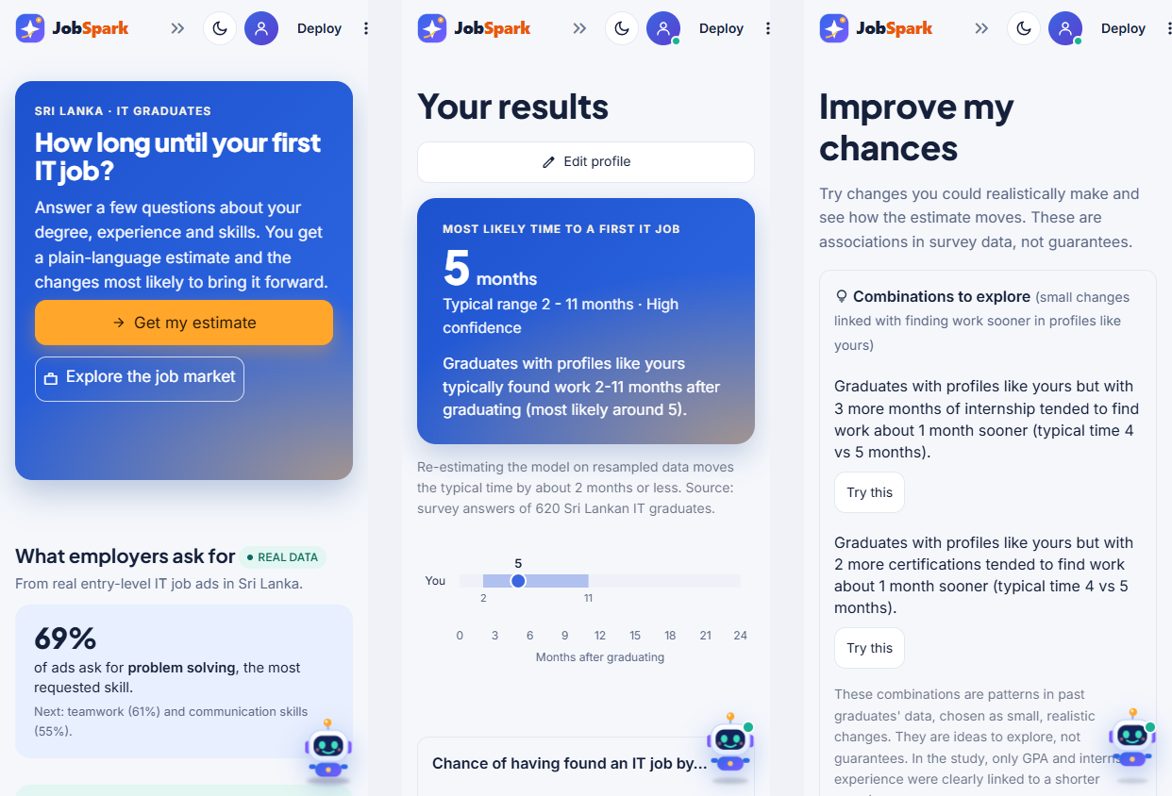
Figure A.14: The phone layout: home, dashboard and improve my chances

Appendix B: Expert Review of the Questionnaires and Design
Six experts reviewed the graduate and employer questionnaires and the research design before the main data collection. Table B.1 lists each reviewer's main recommendation and how it was addressed. The reviews were written comments; item-level relevance ratings were not collected, so I-CVI and S-CVI are not reported.
Table B.1: Expert recommendations and how they were addressed
Expert | Main recommendation | How it was addressed
Expert 1: Academic, research methodology | Measure clearly defined constructs; collect completion and job dates consistently; explain censoring, justify the model, ensure sample size is adequate; document questionnaire revisions | Month and year of completion and first job (Q5a, Q17a); censoring defined in Section 4.5; seven models compared under a fixed rule; 29.2 events per parameter; revisions recorded in the questionnaire revision log
Expert 2: Industry, recruitment | Distinguish essential from desirable skills; employers do not all use the same criteria; present output as guidance, not judgement | Employers rated the importance of each skill (1-5); job-ad demand analysed by role family; the artifact uses associational wording and states that it is decision support only
Expert 3: Academic, software engineering | Distinguish theory from applied ability (debugging, version control, testing, teamwork); clear skill wording; consistent terminology between graduates and employers; requirements vary by role | Skills rated at degree completion; Git, testing and teamwork included; one 26-skill vocabulary used for graduates, employers and job ads; role profiles reported (Figure A.9)
Expert 4: Industry, software company leadership | Recommendations should be actionable: name the competency and suggest a learning or practical activity | Explanations show only changeable factors; suggestions give specific changes; each skill gap links to free learning resources
Expert 5: Academic researcher, survival analysis | Handle right-censoring; clear selection criteria; avoid leakage; use the test set once; justify predictors and distribution; acknowledge missing data, selection bias, limited follow-up and competing pathways; keep claims proportionate | Fixed 70/15/15 split with the test set used once; selection rule set in advance; AFT distribution chosen by AIC; competing paths defined from Q16a; limitations listed in Section 6.2; modest accuracy reported openly
Expert 6: Industry, talent acquisition | Capture experience from projects, internships and other activities; do not rely on one skill rating; outcomes also depend on market conditions, location and hiring practices | Projects, internships, hackathons and open source asked separately; skill blocks averaged; unmeasured market factors acknowledged as a limitation and in the artifact's wording

Appendix C: Questionnaires Used in the Main Study
The graduate and the employer questionnaires used in the main study (47 graduate and 21 employer items) are reproduced below from the instrument documents (version 2.2, Section 3.7), including the notes used to build the online form.
Graduate Employability Questionnaire (Version 2.2)
A Survival-Analysis Framework for Predicting and Explaining Time-to-Employment for Final-Year IT Undergraduates in Sri Lanka
Note for building the online form: the small italic line under each question gives the Google Forms question type to use (and marks REQUIRED questions). It is a build instruction only - do not copy it into the form.
Participant Information Sheet
Dear Participant, you are invited to take part in a research study investigating the factors that influence employability among entry-level IT graduates and final-year undergraduates in Sri Lanka. The purpose of this questionnaire is to identify relationships between graduate/undergraduate characteristics, industry requirements and employment outcomes using statistical analysis and machine-learning techniques.
Your participation is voluntary and all responses will be treated anonymously and used only for academic research purposes. No personally identifiable information will be disclosed in any report or publication arising from this study. Personal data is handled in accordance with Sri Lanka's Personal Data Protection Act, No. 9 of 2022.
Estimated completion time: 15–20 minutes
Eligibility Criteria
☐ You are currently in your final year of an IT/computing-related degree at a Sri Lankan higher education institution (within approximately 6 months of expected graduation), OR you have graduated from such a degree within the last two years.
☐ If graduated: you have less than two years of professional IT work experience.
☐ You are comfortable answering questions about your current academic/professional profile, even if you have not yet started job-seeking.
Consent Statement
By proceeding with this questionnaire, you confirm that you meet the eligibility criteria above, that you are participating voluntarily, and that you consent to your anonymised responses being used for academic research purposes.
Right to Withdraw: Your participation is voluntary. You may withdraw at any point before submitting the questionnaire without penalty, and any partial responses will not be recorded. As responses are collected anonymously, once submitted, individual responses cannot be identified or withdrawn.
Data Retention: Your anonymised responses will be stored securely on password-protected devices, accessible only to the researcher, retained only for the duration of the research and securely deleted when the study is completed. No raw data is shared with any third party.
Contact Information: If you have any questions or concerns about this study, please contact the researcher, M. S. F. Shazna (COBSCCOMP242P-019@student.nibm.lk), or the supervisor, Ms. L. Sumudu Chathurika (sumudu@nibm.lk), School of Computing and Engineering, NIBM.
How to answer: Some questions ask about the time you completed your degree (graduates) - please answer about that time, not today. Final-year students answer about their current situation.
Section 1 — Demographic and Educational Background
Q1. Age group
Google Forms: Multiple choice
○ 20–22
○ 23–25
○ 26–28
○ Above 28
Q2. Gender
Google Forms: Multiple choice
○ Male
○ Female
○ Prefer not to say
Q3. University / Higher Education Institution
Google Forms: Dropdown (institutions grouped by type) + 'Other' | REQUIRED
Response: Dropdown grouped by institution type (state / private / foreign-affiliated), listing named institutions, with "Other: ____"
Q4. Degree programme
Google Forms: Multiple choice (tick 'Add Other') | REQUIRED
○ Computer Science
○ Information Technology
○ Software Engineering
○ Information Systems
○ Cyber Security
○ Data Science
○ Artificial Intelligence / Machine Learning
○ Other: ____________
Q5. What is your current graduation status?
Google Forms: Multiple choice (tick 'Add Other') | REQUIRED
○ Final-year student, expected graduation 2026
○ Final-year student, expected graduation 2027
○ Graduated in 2024
○ Graduated in 2025
○ Graduated in 2026
○ Other: ____________
Q5a. (Graduates only) In which month and year did you complete your degree?
Google Forms: Two Dropdowns titled "Q5a. ... [Month]" (Jan-Dec) and "Q5a. ... [Year]" (2023–2027) | REQUIRED
Use the month your final results were released — not the convocation/graduation ceremony. To take part, this must be within the last two years (see Eligibility).
Response: Month: [Jan–Dec] Year: [2023–2027]
Q5b. (Final-year students only) In which month and year do you expect to complete your degree (final results released)?
Google Forms: Two Dropdowns titled "Q5b. ... [Month]" (Jan-Dec) and "Q5b. ... [Year]" (2026–2028) | REQUIRED
Response: Month: [Jan–Dec] Year: [2026–2028]
Section 2 — Academic Background
Q6. What is your final GPA (graduates) or current cumulative GPA (final-year students), on a 4.0 scale?
Google Forms: Dropdown (one option per value, exactly as listed) | REQUIRED
Select the nearest value. If your degree does not use a GPA, choose 'My degree does not use a GPA' and answer Q6a.
Dropdown: My degree does not use a GPA, 1.9 or below, 2.0, 2.1, ..., 3.8, 3.9, 4.0
Full list: My degree does not use a GPA, 1.9 or below, 2.0, 2.1, 2.2, 2.3, 2.4, 2.5, 2.6, 2.7, 2.8, 2.9, 3.0, 3.1, 3.2, 3.3, 3.4, 3.5, 3.6, 3.7, 3.8, 3.9, 4.0
Q6a. (Only if your degree does not use a GPA) What is your final / expected degree class?
Google Forms: Multiple choice
Answer only if you chose 'My degree does not use a GPA' in Q6; otherwise leave it blank.
○ First class
○ Second class upper
○ Second class lower
○ Third class / General pass
Q7. Did your degree programme include industry-oriented modules (e.g. software engineering projects, cloud computing, cybersecurity, data analytics, industry placements)?
Google Forms: Multiple choice
○ Yes
○ No
○ Not sure
Q7a. What was the main medium of instruction in your degree programme?
Google Forms: Multiple choice
○ English
○ Sinhala
○ Tamil
○ Mixed (English and Sinhala / Tamil)
Q7b. How would you rate your English proficiency (speaking and writing) at the time you completed your degree? (Final-year students: your current level.)
Google Forms: Linear scale, 1 to 5 (add the two end labels)
 | 1 | 2 | 3 | 4 | 5
Very weak | ○ | ○ | ○ | ○ | ○ | Excellent
Q8. How relevant do you consider your degree programme to current IT industry requirements?
Google Forms: Linear scale, 1 to 5 (add the two end labels)
 | 1 | 2 | 3 | 4 | 5
Not relevant | ○ | ○ | ○ | ○ | ○ | Highly relevant
Section 3 — Professional Certifications
Q9. How many professional IT certifications have you obtained?
Google Forms: Dropdown (one option per value, exactly as listed) | REQUIRED
Count certifications you earned by passing an assessment: vendor or professional exams (e.g. AWS, Microsoft, Cisco, Oracle, Scrum.org) or verified online professional certificates (e.g. Coursera, edX). Do not count attendance or participation certificates, or your degree.
Dropdown: 0, 1, 2, 3, ..., 8, 9, 10 or more
Full list: 0, 1, 2, 3, 4, 5, 6, 7, 8, 9, 10 or more
Q10. Which certification areas have you completed? (select all that apply)
Google Forms: Checkboxes (tick 'Add Other')
☐ Cloud Computing (AWS / Azure / GCP)
☐ Cybersecurity
☐ Networking
☐ Database
☐ Programming
☐ Data Science / AI
☐ Agile / Scrum
☐ Other: ____________
Section 4 — Practical Experience and Industry Exposure
Q11. Have you completed an IT internship?
Google Forms: Multiple choice | REQUIRED
○ Yes
○ No
Q11a. (If Q11 = Yes) How many separate IT internships have you completed (including internships that were part of your degree)?
Google Forms: Dropdown (one option per value, exactly as listed) | REQUIRED
Dropdown: 1, 2, 3, 4, 5 or more
Q12. In total, how many months of IT internship experience do you have?
Google Forms: Dropdown (one option per value, exactly as listed) | REQUIRED
Select 0 if none.
Dropdown: 0, 1, 2, 3, ..., 23, 24, 25 or more
Full list: 0, 1, 2, 3, 4, 5, 6, 7, 8, 9, 10, 11, 12, 13, 14, 15, 16, 17, 18, 19, 20, 21, 22, 23, 24, 25 or more
Q13. How many personal or academic IT projects have you completed outside coursework?
Google Forms: Dropdown (one option per value, exactly as listed) | REQUIRED
Dropdown: 0, 1, 2, 3, ..., 14, 15, 16 or more
Full list: 0, 1, 2, 3, 4, 5, 6, 7, 8, 9, 10, 11, 12, 13, 14, 15, 16 or more
Q14. Did you have a technical portfolio (e.g. GitHub, personal website, project portfolio) before you completed your degree? (Final-year students: do you have one now?)
Google Forms: Multiple choice | REQUIRED
○ Yes
○ No
Q15. How frequently do you update your technical portfolio?
Google Forms: Multiple choice
○ Never
○ Rarely
○ Occasionally
○ Frequently
Section 5 — Employment Outcome
The following questions form the outcome variable used for the survival-analysis model.
Q16. What is your current employment status?
Google Forms: Multiple choice | REQUIRED
Final-year students: please choose 'Not yet graduated / have not started job-seeking'.
If you are currently in a paid IT internship or trainee role taken after your degree, choose "IT internship" here and answer "Yes" in Q17.
○ Full-time IT employment
○ IT internship
○ Graduated, currently seeking IT employment
○ Non-IT employment
○ Further studies
○ Self-employed
○ Not yet graduated / have not started job-seeking
Q16a. (Optional; shown only if Q16 = Non-IT employment, Self-employed or Further studies) In which month and year did you start your current non-IT job, self-employment or further studies?
Google Forms: Two Dropdowns titled "Q16a. ... [Month]" (Jan-Dec) and "Q16a. ... [Year]" (2020–2027)
Response: Month: [Jan–Dec] Year: [2020–2027]
Q17. (Graduates only) Have you ever started a paid IT role — full-time, part-time, contract, or a paid trainee/intern position taken after your degree?
Google Forms: Multiple choice | REQUIRED
A paid internship or trainee position taken after your degree counts as Yes. Do not count unpaid internships, or internships that were part of your degree programme.
○ Yes
○ No
Q17a. (If Q17 = Yes) In which month and year did your first such paid IT role start?
Google Forms: Two Dropdowns titled "Q17a. ... [Month]" (Jan-Dec) and "Q17a. ... [Year]" (2020–2027) | REQUIRED
If it started before you completed your degree, still give the actual month.
Response: Month: [Jan–Dec] Year: [2020–2027]
Section 6 — Technical Skill Self-Assessment
Q18. Please rate your proficiency in each of the following technical skills at the time you completed your degree. (Final-year students: rate your current level.)
Google Forms: Multiple choice grid - rows = items, columns = 1, 2, 3, 4, 5 (keep every row, incl. the attention check; if REQUIRED, tick 'Require a response in each row') | REQUIRED
Skill / Item | 1 | 2 | 3 | 4 | 5
Programming Fundamentals | ○ | ○ | ○ | ○ | ○
Object-Oriented Programming | ○ | ○ | ○ | ○ | ○
Java | ○ | ○ | ○ | ○ | ○
Python | ○ | ○ | ○ | ○ | ○
JavaScript | ○ | ○ | ○ | ○ | ○
SQL / Database Management | ○ | ○ | ○ | ○ | ○
Git / GitHub | ○ | ○ | ○ | ○ | ○
Software Testing | ○ | ○ | ○ | ○ | ○
Attention check - please select 4 for this row | ○ | ○ | ○ | ○ | ○
REST APIs | ○ | ○ | ○ | ○ | ○
Web Development | ○ | ○ | ○ | ○ | ○
Cloud Computing | ○ | ○ | ○ | ○ | ○
Linux / Command Line | ○ | ○ | ○ | ○ | ○
Docker | ○ | ○ | ○ | ○ | ○
DevOps / CI-CD | ○ | ○ | ○ | ○ | ○
Cybersecurity Fundamentals | ○ | ○ | ○ | ○ | ○
Data Analytics | ○ | ○ | ○ | ○ | ○
Artificial Intelligence / Machine Learning | ○ | ○ | ○ | ○ | ○
Scale: 1 = No knowledge • 5 = Advanced level
Section 7 — Soft Skill Self-Assessment
Q19. Please rate yourself on each of the following soft skills at the time you completed your degree. (Final-year students: rate your current level.)
Google Forms: Multiple choice grid - rows = items, columns = 1, 2, 3, 4, 5 (keep every row, incl. the attention check; if REQUIRED, tick 'Require a response in each row') | REQUIRED
Skill / Item | 1 | 2 | 3 | 4 | 5
Communication Skills | ○ | ○ | ○ | ○ | ○
Teamwork | ○ | ○ | ○ | ○ | ○
Problem Solving | ○ | ○ | ○ | ○ | ○
Critical Thinking | ○ | ○ | ○ | ○ | ○
Adaptability | ○ | ○ | ○ | ○ | ○
Time Management | ○ | ○ | ○ | ○ | ○
Professionalism | ○ | ○ | ○ | ○ | ○
Self-learning Ability | ○ | ○ | ○ | ○ | ○
Leadership Ability | ○ | ○ | ○ | ○ | ○
Scale: 1 = Very low • 5 = Excellent
Section 8 — Career Preparation and Industry Readiness
Q20. When did you start preparing for IT employment?
Google Forms: Multiple choice | REQUIRED
○ Before starting university
○ During first year of university
○ During second / third year
○ During final year
○ After graduation
○ I have not started preparing
Q21. During your degree, how frequently did you engage in self-learning activities outside your university coursework (e.g. online courses, tutorials, coding practice, technology blogs)?
Google Forms: Linear scale, 1 to 5 (add the two end labels) | REQUIRED
 | 1 | 2 | 3 | 4 | 5
Never | ○ | ○ | ○ | ○ | ○ | Very frequently
Q22. Which online learning platforms have you used? (select all that apply)
Google Forms: Checkboxes (tick 'Add Other')
☐ Coursera
☐ Udemy
☐ LinkedIn Learning
☐ Google Learning
☐ Microsoft Learn
☐ AWS Training
☐ YouTube technical channels
☐ AI tools (e.g. ChatGPT, GitHub Copilot)
☐ Other: ____________
Q23. Before you completed your degree, how many hackathons, coding competitions or technical events did you take part in? Enter 0 if none.
Google Forms: Short answer + Response validation: Number, between 0 and 30 | REQUIRED
Response: Number: 0 – 30
Q24. Had you contributed to open-source projects before you completed your degree? (Final-year students: have you contributed so far?)
Google Forms: Multiple choice | REQUIRED
○ Yes
○ No
Section 9 — Technical Experience Details
Q25. Which programming languages can you currently use confidently? (select all that apply)
Google Forms: Checkboxes (tick 'Add Other')
☐ Java
☐ Python
☐ JavaScript
☐ C / C++
☐ C#
☐ PHP
☐ Kotlin
☐ Other: ____________
Q26. Which development areas have you completed projects in? (select all that apply)
Google Forms: Checkboxes
☐ Web applications
☐ Mobile applications
☐ Desktop applications
☐ Data analytics
☐ Machine learning
☐ Cloud applications
☐ Cybersecurity projects
☐ IoT projects
☐ None
Q27. How confident are you in applying your technical knowledge to solve an unfamiliar problem?
Google Forms: Linear scale, 1 to 5 (add the two end labels)
 | 1 | 2 | 3 | 4 | 5
Not confident | ○ | ○ | ○ | ○ | ○ | Highly confident
Q28. Have you used any industry-standard software development practices? (select all that apply)
Google Forms: Checkboxes
☐ Version control (Git)
☐ Agile / Scrum
☐ Code reviews
☐ Testing practices
☐ Documentation
☐ CI/CD
☐ None
Q29. At the time you completed your degree, how familiar were you with software development lifecycle (SDLC) practices? (Final-year students: your current level.)
Google Forms: Linear scale, 1 to 5 (add the two end labels) | REQUIRED
 | 1 | 2 | 3 | 4 | 5
No knowledge | ○ | ○ | ○ | ○ | ○ | Advanced
Section 10 — Perceived Skill Gaps
Q30. Which areas do you believe require improvement? (select all that apply)
Google Forms: Checkboxes
☐ Programming
☐ Database
☐ Cloud Computing
☐ Cybersecurity
☐ DevOps
☐ AI / Machine Learning
☐ Communication
☐ Problem Solving
☐ Interview Skills
☐ Professional Experience
Q31. Which skills were requested by employers / interviewers that you lacked? (select all that apply)
Google Forms: Checkboxes
☐ Not applicable - I have not had a job interview yet
☐ Programming language
☐ Framework knowledge
☐ Cloud technologies
☐ Database skills
☐ Git / GitHub
☐ Communication skills
☐ Problem solving
☐ Experience
☐ Certifications
Section 11 — Soft Skills and Professional Behaviour
Q32. How comfortable are you communicating technical concepts to non-technical people?
Google Forms: Linear scale, 1 to 5 (add the two end labels)
 | 1 | 2 | 3 | 4 | 5
Very uncomfortable | ○ | ○ | ○ | ○ | ○ | Very comfortable
Q33. How confident are you working as part of a software development team?
Google Forms: Linear scale, 1 to 5 (add the two end labels)
 | 1 | 2 | 3 | 4 | 5
Not confident | ○ | ○ | ○ | ○ | ○ | Highly confident
Q34. Have you participated in group software projects?
Google Forms: Multiple choice
○ Yes
○ No
Q34a. (If Q34 = Yes) How many group software projects?
Google Forms: Multiple choice
○ 1–2
○ 3–5
○ More than 5
Q35. How do you usually improve a skill you do not currently possess? (select all that apply)
Google Forms: Checkboxes
☐ Online courses
☐ Documentation reading
☐ Practice projects
☐ Asking mentors
☐ Community discussions
☐ University resources
☐ AI tools (e.g. ChatGPT, GitHub Copilot)
Section 12 — Job Search Behaviour
Q36. Which platforms have you used to search for IT employment? (select all that apply)
Google Forms: Checkboxes (tick 'Add Other')
☐ LinkedIn
☐ TopJobs
☐ Indeed
☐ Company career websites
☐ University career services
☐ Recruitment agencies
☐ Other: ____________
Q37. How frequently do you update your CV / resume?
Google Forms: Multiple choice
○ Never
○ Once per year
○ Every few months
○ Before every application
Q38. Do you have a LinkedIn profile?
Google Forms: Multiple choice
○ Yes
○ No
Q38a. (If Q38 = Yes) How complete is your LinkedIn profile?
Google Forms: Linear scale, 1 to 5 (add the two end labels)
 | 1 | 2 | 3 | 4 | 5
Very incomplete | ○ | ○ | ○ | ○ | ○ | Fully complete
Q39. Have you received feedback from employers after interviews?
Google Forms: Multiple choice
○ Yes
○ No
○ Not applicable - I have not had a job interview yet
Q39a. (If Q39 = Yes) Which areas were commonly mentioned? (select all that apply)
Google Forms: Checkboxes (tick 'Add Other')
☐ Technical skills
☐ Communication
☐ Confidence
☐ Cultural fit
☐ Relevant experience
☐ Certifications
☐ Salary expectations
☐ Other: ____________
Section 13 — Graduate Perception of Employability
Q40. How employable do you currently consider yourself?
Google Forms: Linear scale, 1 to 5 (add the two end labels)
 | 1 | 2 | 3 | 4 | 5
Very low | ○ | ○ | ○ | ○ | ○ | Very high
Q41. What factors do you believe influence IT graduate employability the most? (select up to 5)
Google Forms: Checkboxes
☐ Technical skills
☐ Degree classification
☐ Internship experience
☐ Personal projects
☐ Certifications
☐ Communication skills
☐ Networking
☐ Interview preparation
☐ University reputation
☐ Industry connections
Q42. Do you believe your university prepared you sufficiently for industry employment?
Google Forms: Linear scale, 1 to 5 (add the two end labels)
 | 1 | 2 | 3 | 4 | 5
Strongly disagree | ○ | ○ | ○ | ○ | ○ | Strongly agree
Q43. What was the biggest challenge you faced when entering the IT job market?
Google Forms: Multiple choice (tick 'Add Other')
○ Not applicable - I have not started looking for IT jobs yet
○ Lack of technical skills
○ Lack of experience
○ Lack of confidence
○ Lack of industry knowledge
○ Lack of job opportunities
○ Interview difficulties
○ Other: ____________
Section 14 — Explainable AI System Requirements
Q44. If an AI system predicted your employability level, how important would it be to understand the reasons behind the prediction?
Google Forms: Linear scale, 1 to 5 (add the two end labels)
 | 1 | 2 | 3 | 4 | 5
Not important | ○ | ○ | ○ | ○ | ○ | Extremely important
Q45. Which type of explanation would be most useful to you? (select all that apply)
Google Forms: Checkboxes
☐ Skills I am strong in
☐ Skills I need to improve
☐ Comparison with industry requirements
☐ Recommended learning paths
☐ Similar successful graduate profiles
Q46. Would you use an AI-based employability improvement system before applying for jobs?
Google Forms: Linear scale, 1 to 5 (add the two end labels)
 | 1 | 2 | 3 | 4 | 5
Strongly disagree | ○ | ○ | ○ | ○ | ○ | Strongly agree
Q47. Additional comments about graduate employability (optional)
Google Forms: Paragraph
Response: Open-ended response
End of Questionnaire — Thank you for your participation.

Employer / Recruiter Questionnaire (Version 2.2)
A Survival-Analysis Framework for Predicting and Explaining Time-to-Employment for Final-Year IT Undergraduates in Sri Lanka
Note for building the online form: the small grey line under each question gives the Google Forms question type to use (and marks REQUIRED questions). It is a build instruction only - do not copy it into the form.
Participant Information Sheet
Dear Participant, you are invited to take part in a research study investigating the skills, qualifications and attributes expected from entry-level IT graduates in Sri Lanka. The purpose of this questionnaire is to understand employer expectations and to identify gaps between graduate capabilities and industry requirements.
Your responses will be used only for academic research purposes and will remain confidential. No individual respondent or organisation will be identified in any report or publication arising from this study. Personal data is handled in accordance with Sri Lanka's Personal Data Protection Act, No. 9 of 2022.
Estimated completion time: 8–12 minutes
Eligibility Criteria
☐ HR professionals involved in recruitment.
☐ Technical managers or team leads involved in hiring decisions.
☐ Software engineers or other technical staff who take part in graduate interviews.
☐ Recruitment professionals handling entry-level IT positions.
Consent Statement
By proceeding with this questionnaire, you confirm that you meet the eligibility criteria above, that you are participating voluntarily, and that you consent to your anonymised responses being used for academic research purposes.
Right to Withdraw: Your participation is voluntary. You may withdraw at any point before submitting the questionnaire without penalty, and any partial responses will not be recorded. As responses are collected anonymously, once submitted, individual responses cannot be identified or withdrawn.
Data Retention: Your anonymised responses will be stored securely on password-protected devices, accessible only to the researcher, retained only for the duration of the research and securely deleted when the study is completed. No raw data is shared with any third party.
Contact Information: If you have any questions or concerns about this study, please contact the researcher, M. S. F. Shazna (COBSCCOMP242P-019@student.nibm.lk), or the supervisor, Ms. L. Sumudu Chathurika (sumudu@nibm.lk), School of Computing and Engineering, NIBM.
Section 1 — Participant and Organisation Profile
Q1. What type of organisation do you represent?
Google Forms: Multiple choice (tick 'Add Other') | REQUIRED
○ Software development company
○ IT consulting company
○ Financial technology company
○ Banking / financial institution
○ Telecommunications company
○ BPO / KPO
○ Government IT organisation
○ Startup
○ Other: ____________
Q2. How many employees work in your organisation?
Google Forms: Multiple choice | REQUIRED
○ Less than 50
○ 50–200
○ 201–500
○ More than 500
Q3. What is your current role?
Google Forms: Multiple choice (tick 'Add Other') | REQUIRED
○ HR Manager
○ Recruiter
○ Technical Lead
○ Software Engineer involved in hiring
○ Engineering Manager
○ Project Manager
○ CTO / CIO
○ Other: ____________
Q4. How many years of experience do you have in IT recruitment or graduate hiring?
Google Forms: Multiple choice
○ Less than 1 year
○ 1–3 years
○ 4–6 years
○ 7–10 years
○ More than 10 years
Section 2 — Entry-Level Recruitment Requirements
Q5. Which entry-level IT roles does your organisation recruit? (select all that apply)
Google Forms: Checkboxes (tick 'Add Other')
☐ Software Engineer
☐ QA Engineer
☐ Data Analyst
☐ Data Scientist
☐ AI / ML Engineer
☐ Cloud Engineer
☐ DevOps Engineer
☐ Cybersecurity Analyst
☐ Business Analyst
☐ Network / System Administrator
☐ UI / UX Designer
☐ Other: ____________
Q6. Approximately how many entry-level IT graduates does your organisation recruit annually?
Google Forms: Multiple choice
○ None
○ 1–5
○ 6–10
○ 11–25
○ More than 25
Section 3 — Graduate Selection Criteria
Q7. How important are the following factors when recruiting entry-level IT graduates?
Google Forms: Multiple choice grid - rows = items, columns = 1, 2, 3, 4, 5 (keep every row, incl. the attention check; if REQUIRED, tick 'Require a response in each row') | REQUIRED
Skill / Item | 1 | 2 | 3 | 4 | 5
Degree qualification | ○ | ○ | ○ | ○ | ○
Academic performance / GPA | ○ | ○ | ○ | ○ | ○
Technical skills | ○ | ○ | ○ | ○ | ○
Internship experience | ○ | ○ | ○ | ○ | ○
Personal software projects | ○ | ○ | ○ | ○ | ○
Professional certifications | ○ | ○ | ○ | ○ | ○
GitHub / technical portfolio | ○ | ○ | ○ | ○ | ○
Communication skills | ○ | ○ | ○ | ○ | ○
Interview performance | ○ | ○ | ○ | ○ | ○
Scale: 1 = Not important • 5 = Extremely important
Section 4 — Technical Skill Requirements
Q8. Please rate the importance of the following technical skills for entry-level IT graduates.
Google Forms: Multiple choice grid - rows = items, columns = 1, 2, 3, 4, 5 (keep every row, incl. the attention check; if REQUIRED, tick 'Require a response in each row') | REQUIRED
Skill / Item | 1 | 2 | 3 | 4 | 5
Programming Fundamentals | ○ | ○ | ○ | ○ | ○
Object-Oriented Programming | ○ | ○ | ○ | ○ | ○
Java | ○ | ○ | ○ | ○ | ○
Python | ○ | ○ | ○ | ○ | ○
JavaScript | ○ | ○ | ○ | ○ | ○
SQL / Database Management | ○ | ○ | ○ | ○ | ○
Git / GitHub | ○ | ○ | ○ | ○ | ○
Software Testing | ○ | ○ | ○ | ○ | ○
Attention check - please select 4 for this row | ○ | ○ | ○ | ○ | ○
REST APIs | ○ | ○ | ○ | ○ | ○
Web Development | ○ | ○ | ○ | ○ | ○
Cloud Computing | ○ | ○ | ○ | ○ | ○
Linux / Command Line | ○ | ○ | ○ | ○ | ○
Docker | ○ | ○ | ○ | ○ | ○
DevOps / CI-CD | ○ | ○ | ○ | ○ | ○
Cybersecurity Fundamentals | ○ | ○ | ○ | ○ | ○
Data Analytics | ○ | ○ | ○ | ○ | ○
Artificial Intelligence / Machine Learning | ○ | ○ | ○ | ○ | ○
Scale: 1 = Not required • 5 = Essential
Section 5 — Soft Skill Requirements
Q9. Please rate the importance of the following professional / soft skills for entry-level IT graduates.
Google Forms: Multiple choice grid - rows = items, columns = 1, 2, 3, 4, 5 (keep every row, incl. the attention check; if REQUIRED, tick 'Require a response in each row') | REQUIRED
Skill / Item | 1 | 2 | 3 | 4 | 5
Communication | ○ | ○ | ○ | ○ | ○
Teamwork | ○ | ○ | ○ | ○ | ○
Problem Solving | ○ | ○ | ○ | ○ | ○
Critical Thinking | ○ | ○ | ○ | ○ | ○
Adaptability | ○ | ○ | ○ | ○ | ○
Time Management | ○ | ○ | ○ | ○ | ○
Professionalism | ○ | ○ | ○ | ○ | ○
Self-learning Ability | ○ | ○ | ○ | ○ | ○
Leadership Ability | ○ | ○ | ○ | ○ | ○
Scale: 1 = Not important • 5 = Extremely important
Q9a. How important is English proficiency (speaking and writing) for entry-level IT graduates in your organisation?
Google Forms: Linear scale, 1 to 5 (add the two end labels)
 | 1 | 2 | 3 | 4 | 5
Not important | ○ | ○ | ○ | ○ | ○ | Extremely important
Section 6 — Future Skill Demand
Q10. Which technologies do you expect to become more important for entry-level IT roles over the next 3–5 years? (select all that apply)
Google Forms: Checkboxes
☐ Artificial Intelligence
☐ Machine Learning
☐ Cloud Computing
☐ Cybersecurity
☐ Data Engineering
☐ DevOps
☐ Automation
☐ Blockchain
☐ IoT
☐ Software Engineering
Q11. How frequently does your organisation update the technical skills it requires from entry-level candidates?
Google Forms: Multiple choice
○ More often than once a year
○ Every 1–2 years
○ Every 3–5 years
○ Rarely
Section 7 — Graduate Skill Gap Identification
Q12. Which technical weaknesses do you commonly observe among fresh IT graduates? (select up to five)
Google Forms: Checkboxes (tick 'Add Other')
☐ Programming ability
☐ Software engineering practices
☐ Database knowledge
☐ Cloud technologies
☐ Testing skills
☐ Cybersecurity knowledge
☐ DevOps practices
☐ AI / ML knowledge
☐ Data analysis
☐ Other: ____________
Q13. Which soft-skill weaknesses do you commonly observe among fresh IT graduates? (select up to five)
Google Forms: Checkboxes
☐ Communication
☐ Teamwork
☐ Confidence
☐ Problem solving
☐ Adaptability
☐ Professional behaviour
☐ Time management
☐ Attitude / lack of interest in the job
Section 8 — University–Industry Alignment
Q14. How well do Sri Lankan computing graduates meet your organisation's expectations?
Google Forms: Linear scale, 1 to 5 (add the two end labels)
 | 1 | 2 | 3 | 4 | 5
Very poor alignment | ○ | ○ | ○ | ○ | ○ | Excellent alignment
Q15. Which areas should universities improve to increase graduate employability? (select all that apply)
Google Forms: Checkboxes
☐ Industry-based projects
☐ Internship opportunities
☐ Modern technologies
☐ Soft skills training
☐ Career preparation
☐ Professional certifications
☐ Practical software development
Section 9 — AI Employability System Requirements
Q16. Would an AI system that analyses graduate employability and identifies skill gaps be useful for your recruitment process?
Google Forms: Linear scale, 1 to 5 (add the two end labels)
 | 1 | 2 | 3 | 4 | 5
Not useful | ○ | ○ | ○ | ○ | ○ | Extremely useful
Q17. How important is it that an AI system explains why a particular prediction or recommendation was generated?
Google Forms: Linear scale, 1 to 5 (add the two end labels)
 | 1 | 2 | 3 | 4 | 5
Not important | ○ | ○ | ○ | ○ | ○ | Extremely important
Q18. Which AI-generated information would be useful to you? (select all that apply)
Google Forms: Checkboxes
☐ Candidate skill strengths
☐ Missing skills
☐ Industry-suitability score
☐ Recommended training areas
☐ Suitable job roles
☐ Interview preparation guidance
Section 10 — Hiring Challenges and Feedback
Q19. What is the biggest challenge when hiring fresh IT graduates? (select up to three)
Google Forms: Checkboxes (tick 'Add Other')
☐ Lack of technical skills
☐ Skill gap between curriculum and industry needs
☐ Weak communication / soft skills
☐ Lack of practical or internship experience
☐ Unrealistic salary expectations
☐ High early-stage attrition / turnover
☐ Long screening or interview process
☐ Other: ____________
Q20. Which factors most distinguish a more employable candidate from a less employable one? (rank your top 3, 1 = most important)
Google Forms: Multiple choice grid - rows = factors, columns = 1st, 2nd, 3rd; tick 'Limit to one response per column'
Factor | Rank (1-3)
Technical skill depth | ____
Portfolio / project quality | ____
Interview performance | ____
Professional certifications | ____
Internship experience | ____
Communication skills | ____
Demonstrated problem-solving ability | ____
Cultural fit | ____
Other: ____________ | ____
Q21. Additional comments (optional)
Google Forms: Paragraph
Response: Open-ended response
End of Questionnaire — Thank you for your participation.

Appendix D: Ethical Clearance Application
The application submitted for institutional ethical clearance is reproduced on the following pages.


NATIONAL INSTITUTE OF BUSINESS MANAGEMENT

School of Computing & Engineering
 | Form ID: | NCRF-ECAF-V1 |  | Version: | 1.0
 | Form Name: | Ethical Clearance Application Form
 | Contact: | Course Director |  | Date:
 | Notes: | This form is applicable for all undergraduate students enrolled in: BSc (Hons) Computing (Software Engineering), BSc (Hons) Information Technology for Business (ITB), and BSc (Hons) Ethical Hacking & Network Security (EHNS).
 | Compliance: | Ensure compliance with Sri Lanka's Personal Data Protection Act, No. 9 of 2022, where applicable.
 | Approved: |  |  | Date:
 | Approval Notes:
Complete all sections. Provide accurate information and follow ethical guidelines. Submit the completed form to the Ethics Committee (ethics-soce@nibm.lk) for approval.

Researcher Details
Student Name: | M. S. F. Shazna
Student ID: | COBSCCOMP242P-019
Student Email: | COBSCCOMP242P-019@student.nibm.lk
Supervisor Name: | Ms.Sumudu Chathurika
Supervisor Department: | School of Computing and Engineering
Supervisor Email: | sumudu@nibm.lk

Programme of Study
Degree Programme (tick one):
- [✓] BSc (Hons) Computing (Software Engineering)
- [ ] BSc (Hons) Information Technology for Business (ITB)
- [ ] BSc (Hons) Ethical Hacking & Network Security (EHNS)

Project Details
Research Title: A Machine Learning–Based System for Early Detection of Skill Deficiencies among Entry-Level IT Graduates from Sri Lankan Universities
Proposed Duration: From May 2026 To October 2026
Brief Summary (Research Objectives):
This research develops a machine learning–based system to detect skill deficiencies among entry-level IT graduates in Sri Lanka before they enter the workforce. The study analyses Sri Lankan IT job market trends and skill requirements, constructs two structured datasets from graduate profiles and hiring organizations, evaluates the suitable ML models to select the strongest performer, and delivers a prototype web application providing personalized suitability scores and skill deficiency visualizations to target users
Type of Data to be Collected (tick all that apply):
- [ ] Personal/Identifiable data (e.g., names, contact details)
- [ ] Sensitive data (e.g., health, financial, biometric)
- [✓] Demographic data (e.g., age, gender)
- [ ] Interview/Focus group responses (transcripts, audio)
- [✓] Online/Social media data
- [✓] Other (specify): Academic profile data including degree programme, GPA, certifications, technical and soft skills, and career aspirations collected via structured online questionnaire

Ethical Considerations
Does your research involve any of the following (tick all that apply):
- [✓] Human participants
- [✓] Use of personal or sensitive data
- [ ] Children or vulnerable groups
- [ ] Psychological stress or discomfort
- [✓] Use of online platforms or social media for data collection
- [ ] Observation without consent in public/private spaces
- [ ] Other ethical concerns (specify): ____________________
Briefly describe how you will address the ethical concerns:
All participants are informed of the research purpose before participation. Participation is entirely voluntary and participants may withdraw at any time without consequence. No personally identifiable information such as names or contact details is collected or stored. All data is anonymized at the point of collection and stored securely on password-protected devices. Data is used exclusively for academic research purposes and is not shared with third parties. The study complies with Sri Lanka's Personal Data Protection Act, No. 9 of 2022.

Informed Consent
Participants must be fully informed about the nature and purpose of the research. They must consent voluntarily without coercion.
Describe how consent will be obtained from participants (e.g., written, verbal, online):
Informed consent is obtained through a digital consent statement embedded at the beginning of the online questionnaire. Participants must actively confirm they have read and understood the research purpose, their right to withdraw, and the data handling procedures before proceeding. Submission of the questionnaire constitutes voluntary informed consent. No coercion or incentives are used.

Data Protection and Confidentiality
All data must be collected, processed, and stored in compliance with the Personal Data Protection Act, No. 9 of 2022.
Describe how data confidentiality will be ensured, and how data will be stored, protected, and disposed of:
All collected data is anonymized — no names, email addresses, or personally identifiable information are recorded. Responses are stored in a password-protected Google Form or equivalent platform, accessible only to the researcher. Data is retained only for the duration of the research and deleted securely upon completion of the study. No raw data is shared with any third party. All processing complies with Sri Lanka's Personal Data Protection Act, No. 9 of 2022.

Risk Assessment
Are there any potential risks to participants or researchers? (Y/N): N
If Yes, describe how the risks will be minimized or managed:
__________________________________________________________________________________________
__________________________________________________________________________________________
__________________________________________________________________________________________

Supervisor’s Approval
Supervisor Name: L. Sumudu Chathurika
Supervisor Signature: __________________ Date: 09.04.2026
Comments (if any):
__________________________________________________________________________________________
__________________________________________________________________________________________
__________________________________________________________________________________________

Student Declaration
I confirm that the information provided is accurate. I understand my ethical obligations as a researcher and agree to adhere to NIBM's ethical guidelines and the Personal Data Protection Act, No. 9 of 2022.
Student Name: M. S. F. Shazna
Student Signature: __________________ Date: 09.04.2026

Appendix E: Exploratory Data Analysis and Validity of the Skill Scores
All relationships were calculated on the training set only (n = 620), so the validation and test sets stayed untouched.
Table E.1: Sample characteristics by split
Characteristic | train | validation | test | all
n | 620 | 133 | 132 | 885
events | 467 | 100 | 100 | 667
censored | 24.7% | 24.8% | 24.2% | 24.6%
women | 33.4% | 29.3% | 36.4% | 33.2%
state / non-state / foreign | 33.1% / 22.6% / 44.4% | 33.1% / 22.6% / 44.4% | 32.6% / 22.7% / 44.7% | 33.0% / 22.6% / 44.4%
GPA mean (SD) | 3.09 (0.37) | 3.06 (0.41) | 3.07 (0.37) | 3.08 (0.37)
internship completed | 81.9% | 77.4% | 90.9% | 82.6%
internship months median (IQR) | 6 (3-6) | 6 (3-6) | 6 (4-6) | 6 (3-6)
certifications median (IQR) | 1 (0-2) | 1 (0-2) | 1 (0-1) | 1 (0-2)
projects median (IQR) | 3 (1-4) | 2 (1-4) | 2 (1-4) | 2 (1-4)
technical score mean (SD) | 2.98 (0.57) | 2.99 (0.54) | 2.97 (0.57) | 2.98 (0.56)
soft score mean (SD) | 3.64 (0.66) | 3.67 (0.68) | 3.60 (0.73) | 3.64 (0.67)
Kaplan-Meier median (months) | 4 | 4 | 3 | 4
Table E.2: Each predictor and the outcome (univariate Cox, training set) and variance inflation factors
Predictor | n | Hazard ratio per SD (95% CI) | p | VIF
GPA | 620 | 1.33 (1.21-1.45) | < 0.001 | 1.89
Projects | 620 | 1.24 (1.13-1.36) | < 0.001 | 1.71
Technical skill score | 620 | 1.22 (1.12-1.34) | < 0.001 | 2.53
Hackathons | 548 | 1.15 (1.06-1.26) | 0.002 | 1.38
Self-learning frequency | 620 | 1.15 (1.05-1.26) | 0.003 | 1.59
Portfolio | 620 | 1.14 (1.04-1.24) | 0.006 | 1.29
SDLC familiarity | 620 | 1.13 (1.04-1.24) | 0.007 | 1.62
Certifications | 620 | 1.12 (1.03-1.23) | 0.009 | 1.03
Internship months | 620 | 1.10 (1.01-1.20) | 0.033 | 1.05
Soft-skill score | 620 | 1.11 (1.01-1.22) | 0.034 | 1.61
Open source | 620 | 0.98 (0.89-1.08) | 0.690 | 1.05
Years of preparation | 620 | 1.01 (0.93-1.11) | 0.754 | 1.01
A hazard ratio above 1 means finding work sooner. Log-rank tests by degree group (p = 0.47) and institution type (p = 0.84) showed no difference.
Table E.3: Suitability for factor analysis, reliability and convergent validity of the skill blocks
Block | KMO | Factors (parallel analysis) | Cronbach's alpha (95% CI) | Omega | AVE | Loadings
Technical (17 items) | 0.945 | 3 | 0.925 (0.916-0.933) | 0.926 | 0.429 | 0.45-0.75
Soft (9 items) | 0.948 | 1 | 0.902 (0.890-0.913) | 0.902 | 0.506 | 0.68-0.74
Discriminant validity: HTMT = 0.676 (below 0.85), and each block's square root of AVE (0.655 technical, 0.711 soft) exceeded the correlation between the two scores (0.619). Thresholds follow Field (2024) and Hair et al. (2022).
Table E.4: Item loadings on a single factor per block (training set)
Item | Block | Loading | Communality
Git / GitHub | Technical | 0.752 | 0.565
Object-Oriented Programming | Technical | 0.734 | 0.539
Java | Technical | 0.727 | 0.529
Software Testing | Technical | 0.721 | 0.520
Programming Fundamentals | Technical | 0.718 | 0.515
SQL / Database Management | Technical | 0.699 | 0.489
Python | Technical | 0.699 | 0.489
JavaScript | Technical | 0.676 | 0.456
REST APIs | Technical | 0.670 | 0.449
Linux / Command Line | Technical | 0.647 | 0.419
Web Development | Technical | 0.635 | 0.403
Cloud Computing | Technical | 0.631 | 0.399
Docker | Technical | 0.614 | 0.377
DevOps / CI-CD | Technical | 0.571 | 0.326
Cybersecurity Fundamentals | Technical | 0.562 | 0.316
Artificial Intelligence / Machine Learning | Technical | 0.540 | 0.292
Data Analytics | Technical | 0.454 | 0.206
Communication Skills | Soft | 0.744 | 0.554
Time Management | Soft | 0.734 | 0.539
Problem Solving | Soft | 0.729 | 0.531
Critical Thinking | Soft | 0.722 | 0.522
Self-learning Ability | Soft | 0.705 | 0.497
Professionalism | Soft | 0.701 | 0.491
Adaptability | Soft | 0.695 | 0.482
Teamwork | Soft | 0.691 | 0.477
Leadership Ability | Soft | 0.676 | 0.457
Figure E.1 shows the Spearman correlations between the predictors on the training set (python -m core.eda_figures). The strongest was between the technical and soft-skill scores (rho = 0.59), followed by SDLC familiarity and the technical score (0.57) and GPA and projects (0.54); internship months, certifications, years of preparation and open-source contribution were almost unrelated to the other predictors. With every variance inflation factor below 2.6 (Table E.2), no pair was close enough to distort the adjusted estimates.
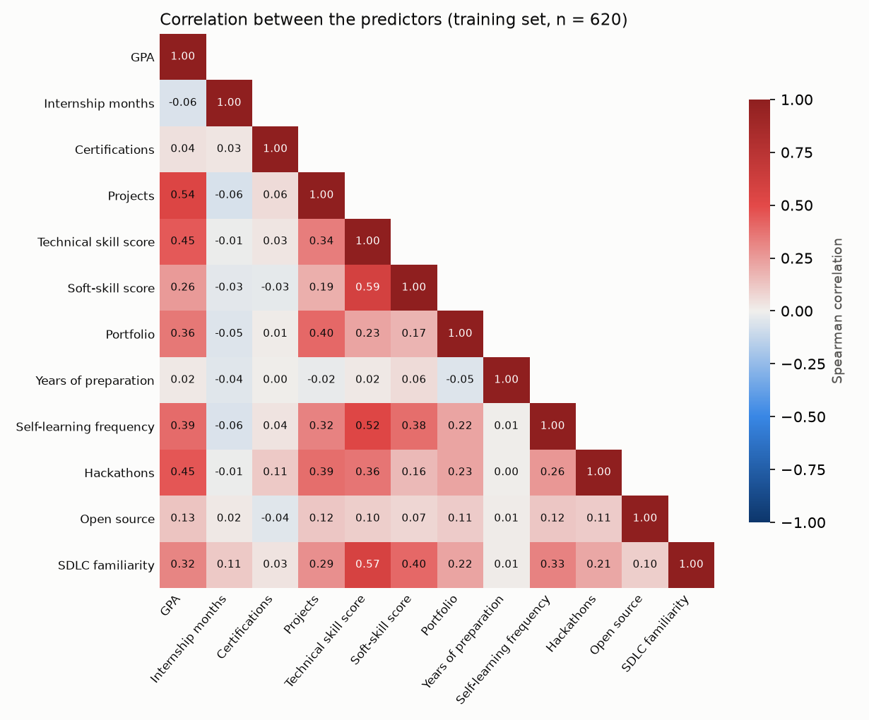
Figure E.1: Spearman correlation between the predictors (training set, n = 620)
Figure E.2 shows how graduates rated each skill at degree completion. Technical ratings were lowest for DevOps / CI-CD (mean 1.95), Docker (2.06) and Cloud Computing (2.33) - among the largest gaps to employer importance in Figure 5.2 - and highest for Programming Fundamentals (3.82). Soft-skill ratings were higher and closer together, from Leadership Ability (3.10) to Teamwork (3.92), with few graduates choosing the lowest rating.
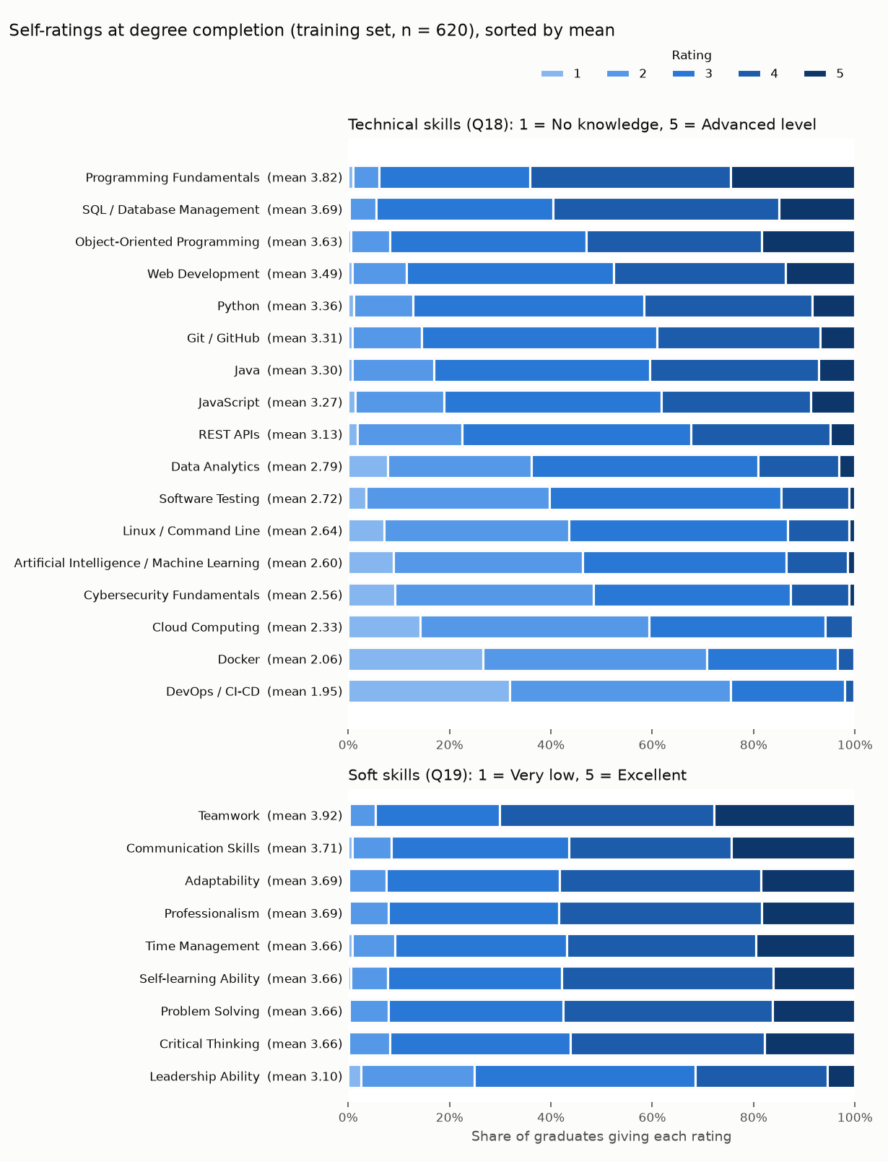
Figure E.2: Distribution of the skill self-ratings at degree completion (training set, n = 620)
Figure E.3 shows the scree plots behind the parallel analysis in Table E.3. In both blocks the first factor dominated: its eigenvalue was 7.84 for the technical items (46.1% of the variance) and 5.04 for the soft items (56.0%). For the soft items only the first factor exceeded the random-data threshold. For the technical items the second and third factors also exceeded it, but narrowly (1.64 and 1.34 against thresholds of 1.28 and 1.23), so a single technical score - supported by the dominant first factor and the reliability in Table E.3 - remains a reasonable summary; that the technical items also contain smaller sub-dimensions is a limitation of averaging them.
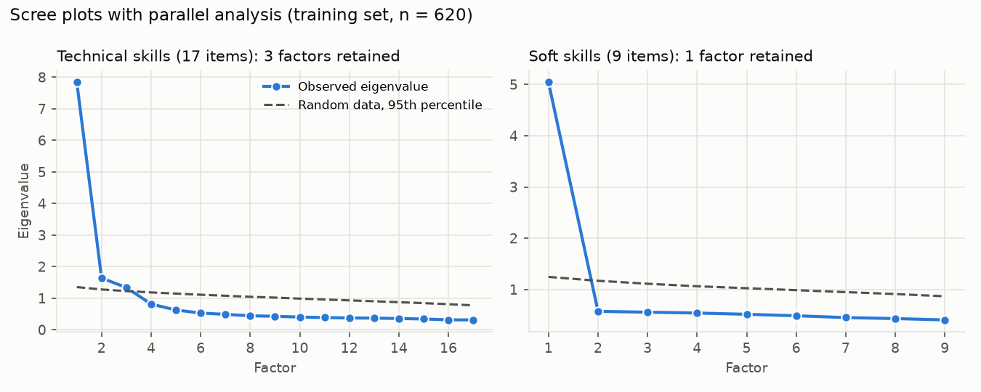
Figure E.3: Scree plots with parallel analysis for the technical and soft-skill items (training set, n = 620)
Table E.5 compares the modelling graduates with published Sri Lankan figures (python -m core.sample_comparison). The published figures describe another population - all faculties of one university - so the comparison shows direction only.
Table E.5: Sample compared with published Sri Lankan figures (all modelling graduates)
Measure | Sample | Published | Source of published figure
Employed graduates hired by completion (%) | 17.5 | 18.1 | University of Kelaniya (2022)
In an IT job at the survey (%) | 75.4 | 60.5 | University of Kelaniya (2022)
Mean months to the first IT job | 5.0 | 8.0 | University of Kelaniya (2022)
The share of employed graduates hired by completion was close to the published figure, but more of the sample were in IT work at the survey and they found it sooner. This is consistent with IT graduates doing better than all disciplines and with a voluntary sample over-representing graduates who found work, so the results describe this sample rather than all Sri Lankan IT graduates.

Appendix F: Test Evidence and System Performance
All 295 automated tests passed on 15 October 2026 (python -m pytest). Table F.1 maps each requirement to the tests that verify it, Table F.2 gives the number of tests in each module and Table F.3 the measured response times.
Table F.1: Requirements and the automated tests that verify them
Requirement | Test(s)
Cleaning: training set is graduates only | test_clean.py::test_training_set_is_graduates_only, ::test_exclusion_rules
Correct duration / event: employed, still searching, job before graduation | test_clean.py::test_duration_and_event_for_each_case
Audit counts add up (raw N -> exclusions -> final N) | test_clean.py::test_audit_counts_add_up
Every injected data defect is handled | test_clean.py::test_every_injected_defect_is_handled, ::test_out_of_range_values_become_missing
Real (Google Forms) export cleans identically to the canonical format | test_clean.py::test_google_forms_export_cleans_identically
Real data file takes priority over synthetic | test_clean.py::test_real_file_takes_priority_over_synthetic
No leakage of outcome / post-employment / fairness fields | test_clean.py::test_no_leakage_into_model_features, test_preprocess.py::test_output_has_exactly_the_model_columns
Preprocessing fitted on training folds only; missing categories imputed (never silently the reference level) | test_preprocess.py::test_fitted_on_training_fold_only, ::test_missing_category_is_imputed_not_treated_as_reference
Every graduate has exactly one role (train / validation / test), fixed and stratified | test_pipeline.py::test_split_gives_every_graduate_exactly_one_role
Tuning and model comparison never fit on validation or test rows | test_pipeline.py::test_tuning_and_comparison_never_fit_on_validation_or_test
Final model fitted on train only; test set used once for evaluation | test_pipeline.py::test_final_model_and_test_evaluation_use_each_set_once
Cox recovers known effect directions on synthetic data | test_synthetic.py::test_cox_recovers_true_effect_directions (generator truth), test_pipeline.py::test_cox_through_full_pipeline_recovers_known_directions (full pipeline)
Model interface: S(0)=1, curves non-increasing, pickling | test_models.py::test_model_interface[*] (all 6 models)
No forest / boosting / ensemble methods | test_models.py::test_no_forest_or_boosting_models
Model-selection rule | test_models.py::test_selection_*
Extended predictor set: candidates preprocessed, no leakage; pre-registered adoption rule needs size AND consistency; plain-language metrics | test_feature_sets.py
Bootstrap interval never NaN when some bootstrap medians are never reached; fast AFT bootstrap = lifelines | test_predict.py::test_bootstrap_interval_handles_never_reached_medians, ::test_fast_aft_bootstrap_matches_lifelines[*]
Predict: low <= median <= high | test_predict.py::test_values_are_ordered_for_many_profiles
Predict: "more than X" instead of extrapolating | test_predict.py::test_more_than_x_when_curve_never_reaches_level, ::test_crossings_beyond_horizon_are_not_reported
Fast bootstrap path = exact slow path | test_predict.py::test_fast_bootstrap_path_matches_slow_path
What-if rejects non-actionable features | test_explain_whatif.py::test_whatif_rejects_non_actionable[*]
What-if rejects out-of-range values; GPA rule for final-year | test_explain_whatif.py::test_whatif_rejects_out_of_range[*], ::test_gpa_change_only_for_final_year_within_limit
Adding internship experience does not lengthen predicted time | test_explain_whatif.py::test_adding_internship_does_not_lengthen_predicted_time
What-if flags profiles outside the training range | test_explain_whatif.py::test_whatif_flags_profiles_outside_training_range
All wording associational, no jargon | test_explain_whatif.py::test_all_wording_is_associational_and_jargon_free, ::test_generated_explanations_are_associational
Explanations for every model family (Cox, Elastic Net, AFT, DeepSurv/SHAP) | test_explain_whatif.py::test_*_uses_*
Graduates still looking: conditional prediction, never before "now", Low confidence when few comparable graduates | test_conditional_actionable.py::test_*searching*, ::test_remaining_months_are_relative_to_now, ::test_invalid_months_since_graduation
"What's helping / holding back" shows only actionable features (GPA for final-year only) | test_conditional_actionable.py::test_local_explanations_show_only_actionable_features, ::test_gpa_is_actionable_only_for_final_year
Peer benchmarks suppress n < 10 | test_market_peers.py::test_small_groups_are_suppressed
Peer medians are Kaplan-Meier, not raw | test_market_peers.py::test_peer_medians_are_kaplan_meier_not_raw
reference.db holds no respondent-level data; no scraping code | test_market_peers.py::test_reference_db_contents_and_privacy, ::test_no_web_scraping_code
Fairness: suppression n < 20, gender never a feature | test_fairness.py
Every API endpoint returns its declared schema | test_api.py::test_health, ::test_predict, ::test_explain, ::test_whatif, ::test_suggestions, ::test_market_alignment, ::test_peer_benchmark, ::test_model_info
Milestones rise over time with 80% ranges and skip months already passed; suggestions use only actionable features, different features each, effort <= 3, at least 1 month sooner, associational wording; nothing suggested at the top of every range; every skill has a free resource and top gaps carry up to 2 | test_guidance.py
Chat assistant: recognises each question type, turns what-if questions into allowed changes (clipped to valid ranges), repeats the model's own numbers and wording, refuses GPA changes for graduates and off-topic questions, stores nothing and calls no external service; /chat returns its schema and rejects empty, over-long or extra fields | test_chat.py, test_api.py::test_chat*
API rejects invalid / extra fields (e.g. gender) and never stores profiles | test_api.py::test_invalid_*, ::test_api_never_stores_profiles
SUS scoring follows the standard procedure (0 / 50 / 100 extremes, hand-calculated example); percentile against the benchmark distribution; t interval; excluded rows (no consent, not eligible, incomplete, duplicate code); straight-lining and acquiescence flags; every comment coded; the real export reproduces the reported mean 76.25 (95% CI 69.53-82.97) | test_sus_study.py
Benchmark scorer handles unparseable responses | test_benchmark.py::test_parse_months_unparseable[*], ::test_score_with_responses_including_unparseable
LLM API mode: fills template rows, resumes, appends a second LLM, saves on failure, records refusals, no network in tests | test_run_llm.py
Secondary analyses: Q16a leaves the main data unchanged and old exports without it are accepted; competing-outcome rules; cumulative incidences <= 1; careless / heaped detection; Rubin's rules; multiple imputation; earlier-vs-later split; conservative clustering CI never narrower, institutions never named | test_robustness.py
Prompt variants: standard prompt unchanged, Sri Lanka absent only in no_country, range parsing and coverage, variant rows kept separate in API mode, old responses without a variant column still scored | test_benchmark.py::test_*variant*, ::test_parse_range*, test_run_llm.py::test_variant_rows_are_kept_separate, ::test_range_prompts_are_sent_for_range_variant
Prompts contain no outcome; filled responses are never overwritten; stale responses refused | test_benchmark.py::test_prompts_contain_no_outcome, ::test_existing_responses_are_never_overwritten, ::test_score_refuses_stale_responses
Table F.2: Automated tests per module (parameterised cases counted separately)
Module | Tests
test_api.py | 45
test_benchmark.py | 28
test_chat.py | 21
test_clean.py | 13
test_conditional_actionable.py | 9
test_explain_whatif.py | 21
test_fairness.py | 5
test_feature_sets.py | 6
test_guidance.py | 7
test_market_peers.py | 9
test_market_study.py | 4
test_models.py | 14
test_pipeline.py | 4
test_predict.py | 14
test_preprocess.py | 7
test_real_lookup.py | 3
test_report_scripts.py | 20
test_robustness.py | 11
test_run_llm.py | 13
test_study_endpoints.py | 5
test_survey_study.py | 18
test_sus_study.py | 10
test_synthetic.py | 8
Total | 295
Table F.3: API response times (30 requests per endpoint after one warm-up, 14 October 2026)
Endpoint | Median (ms) | 95th percentile (ms) | Maximum (ms)
POST /predict | 56.3 | 60.0 | 62.1
POST /explain | 62.6 | 69.9 | 77.4
POST /whatif | 124.4 | 135.6 | 140.9
POST /suggestions | 263.1 | 380.0 | 423.6
POST /market-alignment | 11.5 | 13.1 | 14.1
POST /peer-benchmark | 30.0 | 36.1 | 42.1
POST /insights | 7.3 | 9.3 | 9.9
POST /chat | 163.9 | 225.2 | 279.4
GET /model-info | 6.0 | 6.7 | 7.1
GET /job-market | 7.9 | 8.8 | 9.5
GET /questionnaire | 14.9 | 17.6 | 18.8
GET /research | 32.5 | 33.7 | 38.6
GET /health | 5.6 | 6.1 | 6.4
Service start-up, until /health answered: 5.2 s. Target: under 1,000 ms per request; met by every endpoint.

Appendix G: Usability Evaluation Materials and Results
Participants completed an online form on the researcher's laptop after the hands-on session. The form opened with four consent statements (having read the information; voluntary participation with the right to stop at any time; no name or personal details recorded, only a participant code; agreement to take part) and an eligibility screen (a final-year IT or computing undergraduate or a graduate of such a degree; did not answer the main graduate survey; had not used or helped to build the website before; 18 or older). Background questions B1-B4, the ten SUS statements rated from 1 (strongly disagree) to 5 (strongly agree) and four open questions (C1-C4) followed.
Session tasks: (1) enter a profile, own or the example card, and read the estimated time and range; (2) explain the confidence label; (3) move a what-if slider and describe the change; (4) ask the chat assistant a question about the estimate; (5) find the most requested skill on the Job market page.
Table G.1: SUS statements and item results (n = 12)
Item | Statement | Mean (1-5) | SD | Mean contribution (0-4)
SUS1 | I think that I would like to use this system frequently. | 4.17 | 0.39 | 3.17
SUS2 | I found the system unnecessarily complex. | 1.92 | 0.67 | 3.08
SUS3 | I thought the system was easy to use. | 4.08 | 0.67 | 3.08
SUS4 | I think that I would need the support of a technical person to be able to use this system. | 1.67 | 0.49 | 3.33
SUS5 | I found the various functions in this system were well integrated. | 3.75 | 0.62 | 2.75
SUS6 | I thought there was too much inconsistency in this system. | 2.00 | 0.60 | 3.00
SUS7 | I would imagine that most people would learn to use this system very quickly. | 4.25 | 0.62 | 3.25
SUS8 | I found the system very cumbersome to use. | 2.00 | 0.43 | 3.00
SUS9 | I felt very confident using the system. | 4.00 | 0.60 | 3.00
SUS10 | I needed to learn a lot of things before I could get going with this system. | 2.17 | 0.72 | 2.83
Table G.2: Participants, answers to the ten SUS statements and SUS score
Code | Background | Profile used | Q1 | Q2 | Q3 | Q4 | Q5 | Q6 | Q7 | Q8 | Q9 | Q10 | SUS
P01 | Final-year | Own | 4 | 2 | 4 | 1 | 4 | 2 | 5 | 2 | 4 | 2 | 80
P02 | Graduate, seeking | Own | 5 | 1 | 5 | 1 | 4 | 2 | 5 | 1 | 5 | 2 | 92.5
P03 | Final-year | Example card | 4 | 2 | 3 | 2 | 3 | 3 | 4 | 2 | 3 | 3 | 62.5
P04 | Graduate, in IT | Own | 4 | 2 | 4 | 2 | 4 | 2 | 4 | 2 | 4 | 2 | 75
P05 | Final-year | Mix | 4 | 2 | 5 | 2 | 3 | 2 | 4 | 3 | 4 | 2 | 72.5
P06 | Graduate, outside IT | Example card | 4 | 3 | 3 | 2 | 3 | 3 | 3 | 2 | 4 | 3 | 60
P07 | Final-year | Own | 5 | 1 | 4 | 2 | 5 | 1 | 5 | 2 | 4 | 1 | 90
P08 | Graduate, seeking | Own | 4 | 3 | 4 | 2 | 4 | 2 | 4 | 2 | 3 | 2 | 70
P09 | Final-year | Example card | 4 | 2 | 4 | 2 | 3 | 2 | 4 | 2 | 4 | 3 | 70
P10 | Graduate, seeking | Own | 4 | 1 | 5 | 1 | 4 | 2 | 5 | 2 | 5 | 1 | 90
P11 | Final-year | Mix | 4 | 2 | 4 | 2 | 4 | 2 | 4 | 2 | 4 | 3 | 72.5
P12 | Graduate, in IT | Own | 4 | 2 | 4 | 1 | 4 | 1 | 4 | 2 | 4 | 2 | 80
Scoring (standard SUS procedure): odd items contribute the answer minus 1, even items 5 minus the answer; the sum is multiplied by 2.5. Mean 76.25 (SD 10.58; t-based 95% CI 69.53-82.97; bootstrap 95% CI 70.42-82.08); one-sample t(11) = 2.70 against 68, p = 0.021; Wilcoxon signed-rank p = 0.034; Cronbach's alpha 0.90.
Table G.3: Usability issues and most useful parts (open comments coded with fixed keyword rules)
Question | Theme | Participants | n
Confusing or to improve (C3) | Too much on one page / main result not obvious | P03, P06, P08 | 3
Confusing or to improve (C3) | Terms and charts need explaining (onboarding) | P01, P06, P11 | 3
Confusing or to improve (C3) | Navigation and consistency between pages | P05, P09 | 2
Confusing or to improve (C3) | Trust in and currency of the numbers | P08, P12 | 2
Confusing or to improve (C3) | No problem reported | P02, P10 | 2
Confusing or to improve (C3) | Chart readability | P04 | 1
Confusing or to improve (C3) | Mobile layout | P07 | 1
Confusing or to improve (C3) | Feature request | P02 | 1
Most useful (C2) | Skill gaps and in-demand skills (job market) | P02, P03, P05, P06, P10, P11 | 6
Most useful (C2) | Suggestions and overall presentation | P07, P08, P09, P12 | 4
Most useful (C2) | What-if sliders | P01, P10 | 2
Most useful (C2) | Chat assistant | P04, P12 | 2
Table G.4: Open comments (verbatim)
Code | Most useful (C2) | Confusing or to improve (C3) | Other comments (C4)
P01 | The what-if sliders showed me how much an internship would change my estimate. | The confidence label needs a short explanation.
P02 | The skill gaps against job ads told me exactly what to learn next. | Nothing really. Maybe a dark mode. | Very helpful for fresh graduates.
P03 | The job market page. | Too many sections on one page. I was not sure which number was the main result.
P04 | The chat explained the estimate in simple words. | The month-by-month chart could use axis labels that are easier to read.
P05 | Seeing which skills are most requested right now. | The research lab page felt disconnected from the rest of the site.
P06 | The list of in-demand skills. | I needed help to start. Terms like range and confidence were confusing and the page was long. | I don't usually use websites like this.
P07 | Having the estimate, the reasons and the suggestions all together. | Profile form is a bit long on mobile.
P08 | The suggestions on small changes that help. | A bit much information at once. I was not fully confident the numbers apply to me.
P09 | The estimate was easy to find. | Some labels were inconsistent between pages. Took time to find the chat.
P10 | The what-if sliders and the skill gap comparison. | Nothing major. | Would use this again before applying.
P11 | Comparing my skills with employer demand. | I asked the researcher once what the chart meant. A short guide at the start would help.
P12 | Clear layout and the chat gave quick answers. | Could show the data source date for the job ads.

Appendix H: LLM Benchmark Prompt and Results
Each of the 132 test profiles, without its outcome, was inserted into the standard prompt below and entered into ChatGPT (GPT-5.6, free tier) on 14 October 2026, each in a new temporary chat; 30 profiles were entered three times.
You are helping with a research study on graduate employment in Sri Lanka.
Below is the profile of a graduate from an IT / computing degree at a Sri Lankan higher education institution. "First IT job" means a paid IT role (full-time, part-time, contract, or a paid trainee/intern position taken after the degree). Internships that were part of the degree do not count.
Graduate profile: {profile}
Question: How many months after completing their degree will this graduate take to find their first IT job? Answer with a single whole number of months only. Do not give a range or any explanation.
Table H.1: Ranking and calibration of ChatGPT and the selected model on the same test graduates
Predictor | Profiles | Uno's C | Harrell's C | Calibration error at 6 months | Difference in C (95% CI)
ChatGPT GPT-5.6, mean of runs | 132 | 0.539 | 0.542 | 0.227 | +0.081 (+0.030 to +0.131)
ChatGPT run 1 | 132 | 0.531 | 0.533 | 0.246
ChatGPT run 2 | 30 | 0.591 | 0.598 | 0.217
ChatGPT run 3 | 30 | 0.500 | 0.506 | 0.275
AFT Log-Normal (selected model) | 132 | 0.619 | 0.626 | 0.224
All 192 answers were usable. Across the three runs only one of the 30 repeated profiles (3.3%) received the same answer each time; the mean within-profile standard deviation was 1.37 months and the mean Spearman correlation between runs 0.418. ChatGPT predicted 64%, 100% and 100% of the slowest, middle and fastest thirds employed by six months, against 84%, 71% and 80% observed. The calibration error treats an answer of six months or less as predicted employment by six months, for both predictors.

Appendix I: Job-Advertisement Coding Agreement
Forty advertisements were sampled at random and hand-coded by an independent coder, blind to the keyword result; four could no longer be opened, leaving 36. Pooled Cohen's kappa was 0.83 (pre-set target 0.60), with keyword precision 0.96 and recall 0.80.
Table I.1: Agreement between hand coding and the keyword rules, by skill (36 advertisements)
Skill | Hand-coded | Keyword-coded | Agreement | Kappa
Programming Fundamentals | 14 | 5 | 75% | 0.40
Object-Oriented Programming | 0 | 0 | 100% | -
Java | 5 | 5 | 100% | 1.00
Python | 5 | 5 | 100% | 1.00
JavaScript | 13 | 13 | 100% | 1.00
SQL / Database Management | 14 | 14 | 100% | 1.00
Git / GitHub | 16 | 16 | 100% | 1.00
Software Testing | 18 | 17 | 86% | 0.72
REST APIs | 15 | 15 | 100% | 1.00
Web Development | 19 | 9 | 72% | 0.46
Cloud Computing | 6 | 7 | 97% | 0.91
Linux / Command Line | 1 | 1 | 100% | 1.00
Docker | 3 | 3 | 100% | 1.00
DevOps / CI-CD | 3 | 3 | 100% | 1.00
Cybersecurity Fundamentals | 3 | 3 | 94% | 0.64
Data Analytics | 4 | 5 | 97% | 0.87
Artificial Intelligence / Machine Learning | 3 | 5 | 94% | 0.72
Communication Skills | 24 | 24 | 100% | 1.00
Teamwork | 29 | 26 | 92% | 0.77
Problem Solving | 29 | 27 | 89% | 0.68
Critical Thinking | 14 | 1 | 64% | 0.09
Adaptability | 8 | 3 | 86% | 0.48
Time Management | 5 | 6 | 92% | 0.68
Professionalism | 3 | 0 | 92% | 0.00
Self-learning Ability | 21 | 18 | 92% | 0.83
Leadership Ability | 0 | 0 | 100% | -

Appendix J: Model Development Diagnostics
This appendix reports diagnostics of model development: an error analysis of the selected model, DeepSurv's training curves, every tuning configuration, the learning curve, the time-dependent AUC and Brier score, and simple baselines. All use only the training and validation sets; the locked test set is not used, and none changes the selected model.
Error analysis. The selected AFT Log-Normal model, fitted on the training set, predicted a median time to the first IT job for each of the 133 validation graduates (python -m core.error_analysis). For the 100 who found work, the mean absolute error was 2.7 months (median 2.2), with almost no overall bias (+0.2 months). The errors were systematic rather than random (Table J.1): the predicted medians ranged only from 1.8 to 11.2 months (standard deviation 1.8, against 4.3 for the actual times), so the model pulled every graduate towards the typical search of four to five months. Graduates hired at or before completion were predicted 3.4 months too slow, and those who searched for more than a year 9.0 months too fast. Of the 33 graduates still searching, 18 had already been looking for longer than their predicted median.
Table J.1: Prediction error by actual time to the first IT job (validation set, graduates who found work)
Actual time to first IT job | n | Mean actual (months) | Mean predicted median (months) | Mean error (months) | Mean absolute error (months)
at or before completion | 18 | 0.5 | 3.9 | +3.4 | 3.4
1-3 months | 40 | 2.3 | 4.1 | +1.8 | 1.9
4-6 months | 22 | 4.9 | 4.6 | -0.3 | 1.4
7-12 months | 13 | 8.6 | 5.6 | -3.1 | 3.1
more than 12 months | 7 | 16.3 | 7.2 | -9.0 | 9.0

Mean error = predicted median minus actual time: positive means the model predicted a longer search than happened.
The worst-predicted tenth (11 graduates, 7 predicted too fast and 4 too slow) had weaker profiles than the rest (Table J.2): lower GPA (2.81 against 3.14), fewer internship months (3.9 against 5.5), fewer projects (1.6 against 3.0) and lower technical self-ratings (2.63 against 3.08). Most were searches that lasted longer than their profile suggested. This is consistent with Section 6.2: the questionnaire inputs explain part of the variation in time to employment, and the rest - personal networks, job-search effort and interview performance - is not measured, so the model cannot place these graduates at the extremes. The validation set is small, so these comparisons are descriptive.
Table J.2: The worst-predicted tenth of validation graduates compared with the rest (means)
Input | Worst-predicted tenth | Rest
GPA | 2.81 | 3.14
Internship (months) | 3.9 | 5.5
Certifications | 0.55 | 0.90
Projects | 1.6 | 3.0
Technical skills (1-5) | 2.63 | 3.08
Found work at or before completion (%) | 9.1 | 19.1

DeepSurv training. DeepSurv was fitted on the training set with the settings chosen on validation (32 units, 1 hidden layer, dropout 0.3, learning rate 0.01, Adam with weight decay 0.0001, batch size 32), holding out 20% of the training graduates to monitor the loss (python -m core.deepsurv_curves). The training loss kept falling, from 2.73 to 2.56, but the hold-out loss was lowest at epoch 2 and rose afterwards (Figure J.1): beyond the first epochs the network fitted the training graduates more closely without predicting new graduates better, which is overfitting. Early stopping ended training 15 epochs after the best epoch and kept the epoch-2 weights, so the overfitted epochs did not reach the model. The two losses are on different scales, because the Cox loss grows with the number of graduates it is computed over (batches of 32 for training, the whole hold-out for early stopping), so only their trends should be compared. That the best epoch came so early agrees with the small sample and limited signal discussed in Section 6.2 and with DeepSurv not outperforming the simpler models.
No learning-rate schedule was used. The learning rate was itself tuned on the validation set (0.001 or 0.01), Adam adapts the step size for each weight, and the best weights were reached within 2 epochs; a schedule mainly helps long training runs and would have had little to act on. Adding one after the model comparison would also have changed a candidate model after the selection rule was applied.
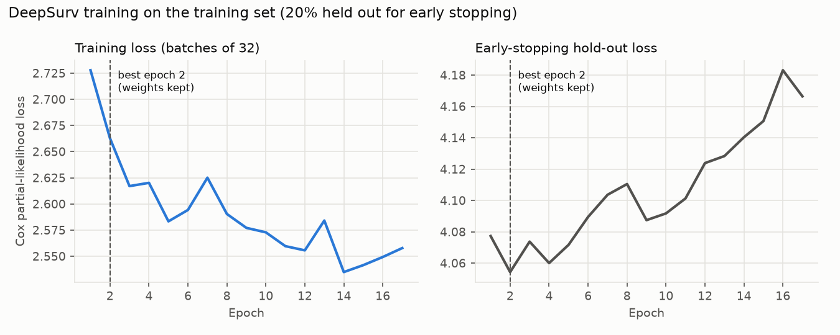
Figure J.1: DeepSurv training loss and early-stopping hold-out loss by epoch (training set)
Tuning configurations. Table J.3 lists every setting tried for each candidate model, each fitted on the training set and scored on the validation set (python -m core.tuning_results), so the chosen settings in Table 4.4 can be checked against the alternatives. Re-running the search reproduced every setting chosen in the main analysis. Validation C varied little between settings: by 0.001 for Cox PH, 0.029 for Elastic Net Cox and 0.111 for DeepSurv, so the comparison of models does not depend on a fortunate choice of setting.
Table J.3: Every tuning configuration and its validation Uno's C (each fitted on the training set; AFT distribution chosen by AIC)
Model | Setting | Validation Uno's C | Chosen
Cox PH | penalizer 0.5 | 0.667 | yes
Cox PH | penalizer 0.1 | 0.667
Cox PH | penalizer 0.0 | 0.667
Cox PH | penalizer 0.01 | 0.666
Elastic Net Cox | alpha 0.005, l1_ratio 0.1 | 0.665 | yes
Elastic Net Cox | alpha 0.02, l1_ratio 0.1 | 0.662
Elastic Net Cox | alpha 0.1, l1_ratio 0.1 | 0.662
Elastic Net Cox | alpha 0.005, l1_ratio 0.5 | 0.661
Elastic Net Cox | alpha 0.05, l1_ratio 0.1 | 0.660
Elastic Net Cox | alpha 0.005, l1_ratio 0.9 | 0.658
Elastic Net Cox | alpha 0.02, l1_ratio 0.5 | 0.658
Elastic Net Cox | alpha 0.2, l1_ratio 0.1 | 0.655
Elastic Net Cox | alpha 0.02, l1_ratio 0.9 | 0.655
Elastic Net Cox | alpha 0.05, l1_ratio 0.5 | 0.652
Elastic Net Cox | alpha 0.05, l1_ratio 0.9 | 0.650
Elastic Net Cox | alpha 0.1, l1_ratio 0.5 | 0.649
Elastic Net Cox | alpha 0.2, l1_ratio 0.5 | 0.639
Elastic Net Cox | alpha 0.1, l1_ratio 0.9 | 0.639
Elastic Net Cox | alpha 0.2, l1_ratio 0.9 | 0.637
DeepSurv | width 32, layers 1, dropout 0.3, lr 0.01 | 0.679 | yes
DeepSurv | width 32, layers 1, dropout 0.1, lr 0.01 | 0.676
DeepSurv | width 16, layers 2, dropout 0.3, lr 0.01 | 0.675
DeepSurv | width 16, layers 1, dropout 0.3, lr 0.001 | 0.674
DeepSurv | width 16, layers 2, dropout 0.1, lr 0.01 | 0.674
DeepSurv | width 32, layers 2, dropout 0.3, lr 0.01 | 0.671
DeepSurv | width 32, layers 1, dropout 0.3, lr 0.001 | 0.669
DeepSurv | width 8, layers 1, dropout 0.1, lr 0.01 | 0.665
DeepSurv | width 32, layers 2, dropout 0.1, lr 0.01 | 0.665
DeepSurv | width 32, layers 1, dropout 0.1, lr 0.001 | 0.662
DeepSurv | width 8, layers 1, dropout 0.3, lr 0.001 | 0.661
DeepSurv | width 8, layers 1, dropout 0.1, lr 0.001 | 0.659
DeepSurv | width 16, layers 1, dropout 0.1, lr 0.001 | 0.658
DeepSurv | width 8, layers 1, dropout 0.3, lr 0.01 | 0.655
DeepSurv | width 8, layers 2, dropout 0.3, lr 0.01 | 0.652
DeepSurv | width 16, layers 2, dropout 0.3, lr 0.001 | 0.651
DeepSurv | width 16, layers 1, dropout 0.3, lr 0.01 | 0.649
DeepSurv | width 16, layers 2, dropout 0.1, lr 0.001 | 0.644
DeepSurv | width 16, layers 1, dropout 0.1, lr 0.01 | 0.643
DeepSurv | width 32, layers 2, dropout 0.3, lr 0.001 | 0.621
DeepSurv | width 32, layers 2, dropout 0.1, lr 0.001 | 0.620
DeepSurv | width 8, layers 2, dropout 0.1, lr 0.001 | 0.610
DeepSurv | width 8, layers 2, dropout 0.1, lr 0.01 | 0.603
DeepSurv | width 8, layers 2, dropout 0.3, lr 0.001 | 0.568
AFT | distribution lognormal (AIC 2,724.8) | 0.693 | yes
AFT | distribution loglogistic (AIC 2,729.8) | 0.687
AFT | distribution weibull (AIC 2,766.7) | 0.655

Learning curve. Figure J.2 shows the selected model refitted on 25%, 50%, 75% and 100% of the training set, each smaller size averaged over 20 random subsets and scored on the validation set (python -m core.learning_curve). Validation C rose from 0.641 to 0.670, 0.682 and 0.693; the gains shrank from 0.029 to 0.012 and 0.010, and the spread between subsets narrowed, so more respondents answering the same questions would be expected to add little.
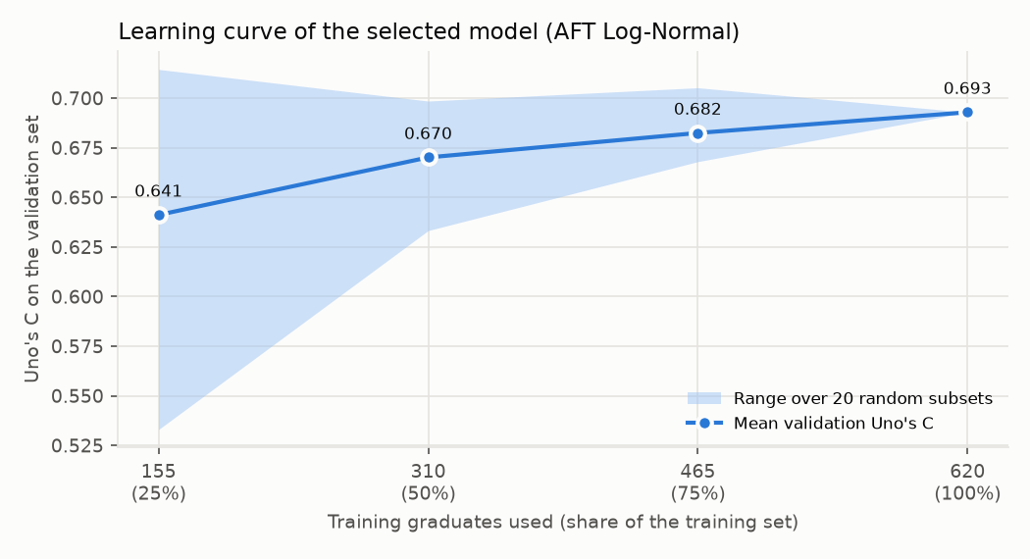
Figure J.2: Learning curve of the selected model (validation Uno's C by size of the training set)
Time-dependent AUC and Brier score. As supplementary measures that were not used to choose the model, Table J.4 reports the cumulative/dynamic AUC at 3, 6 and 12 months for every candidate on the validation set (python -m core.time_dependent_metrics). It is the survival-analysis counterpart of the ROC-AUC: of graduates employed by a given month and graduates still searching at that month, how often the employed one had the higher predicted chance. The selected AFT Log-Normal model had the highest AUC at every horizon (0.756, 0.795 and 0.808). Figure J.3 shows its Brier score month by month against the Kaplan-Meier baseline: on the validation set it was lower at 13 of 13 months, with the largest gap at month 4. This advantage did not carry over to the test set, where the integrated Brier score was 0.167 against 0.164 for the baseline (Chapter 5). The validation set is the one the model was chosen on, so its figures are optimistic, and the test result remains the one reported.
Table J.4: Time-dependent AUC, Uno's C and integrated Brier score of the candidate models (validation set)
Model | AUC at 3 months | AUC at 6 months | AUC at 12 months | Mean AUC | Uno's C | IBS
Cox PH | 0.723 | 0.749 | 0.794 | 0.743 | 0.667 | 0.179
Elastic Net Cox | 0.730 | 0.754 | 0.768 | 0.743 | 0.665 | 0.175
AFT Log-Normal | 0.756 | 0.795 | 0.808 | 0.775 | 0.693 | 0.171
DeepSurv | 0.708 | 0.782 | 0.787 | 0.741 | 0.679 | 0.175
Kaplan-Meier baseline | 0.500 | 0.500 | 0.500 | 0.500 | 0.500 | 0.202

AUC and Uno's C: 0.5 = chance, 1 = perfect; the Kaplan-Meier baseline predicts the same curve for everyone and so cannot rank graduates. IBS: lower is better.
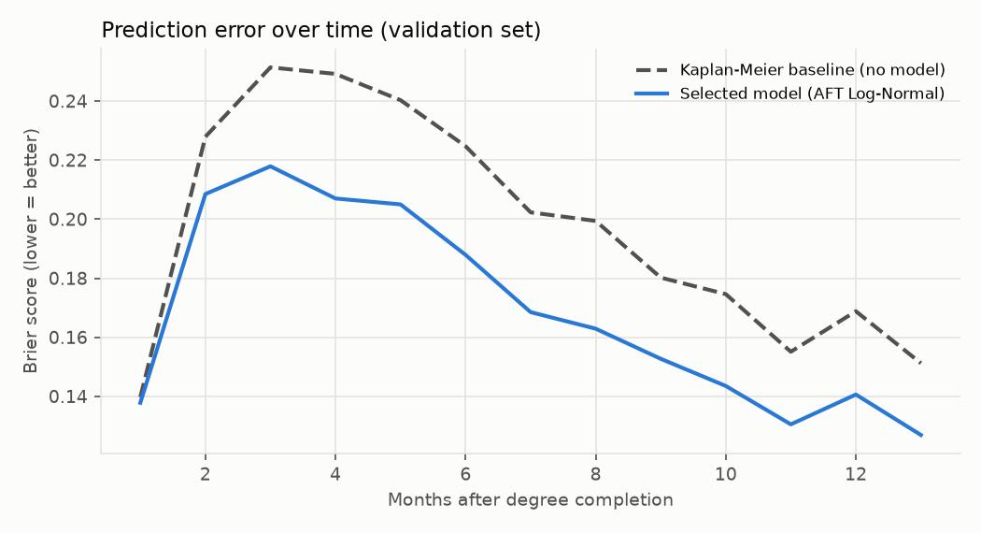
Figure J.3: Brier score over time of the selected model and the Kaplan-Meier baseline (validation set)
Baselines. Table J.5 compares the selected model with simpler versions of itself - the same AFT log-normal model with fewer inputs - each fitted on the training set and scored on the validation set (python -m core.baselines). GPA alone reached 0.637, clearly below the selected model (difference -0.056, 95% CI -0.095 to -0.021). Adding internship months raised it to 0.675 and the eight core inputs gave 0.683; neither differed clearly from the selected model (0.693). Most of the ranking therefore comes from GPA and internship experience, the two inputs clearly associated with the outcome (Table 5.3).
Table J.5: The selected model against simpler baselines (AFT log-normal, validation set)
Model | Validation Uno's C (95% CI) | Difference from selected (95% CI) | Selected better in
Kaplan-Meier (no model) | 0.500 | -0.193 | -
GPA only | 0.637 (0.574-0.696) | -0.056 (-0.095 to -0.021) | 100%
GPA + internship months | 0.675 (0.621-0.730) | -0.018 (-0.050 to +0.012) | 88%
Core inputs (8) | 0.683 (0.630-0.739) | -0.010 (-0.028 to +0.007) | 85%
Selected model (extended inputs) | 0.693 (0.636-0.750) | - | -
Differences come from 1,000 paired bootstrap resamples of the validation graduates; an interval that includes 0 means the two models cannot be distinguished on this set.

Appendix K: Additional Evaluation Figures
This appendix gives the figures behind evaluation results reported in Chapter 5 and in the secondary analyses (python -m core.evaluation_figures). Figures K.1 and K.2 describe the outcome, Figures K.3 and K.4 check the models' assumptions on the training set, and Figures K.5 and K.6 draw results that were already reported: the fairness check on the locked test set and the robustness checks on the validation set. No model was refitted on, or chosen with, the test set for these figures.
Time to the first IT job. Figure K.1 shows the Kaplan-Meier curve for all 885 modelling graduates. Half had found an IT job by 4 months, and 43.6%, 67.0%, 80.9% and 89.8% had found one by 3, 6, 12 and 24 months. The row beneath the curve gives the number still being followed at each time - 562 at 3 months, 281 at 6, 107 at 12 and 20 at 24 - so the curve after about 18 months rests on few graduates and its confidence interval widens.
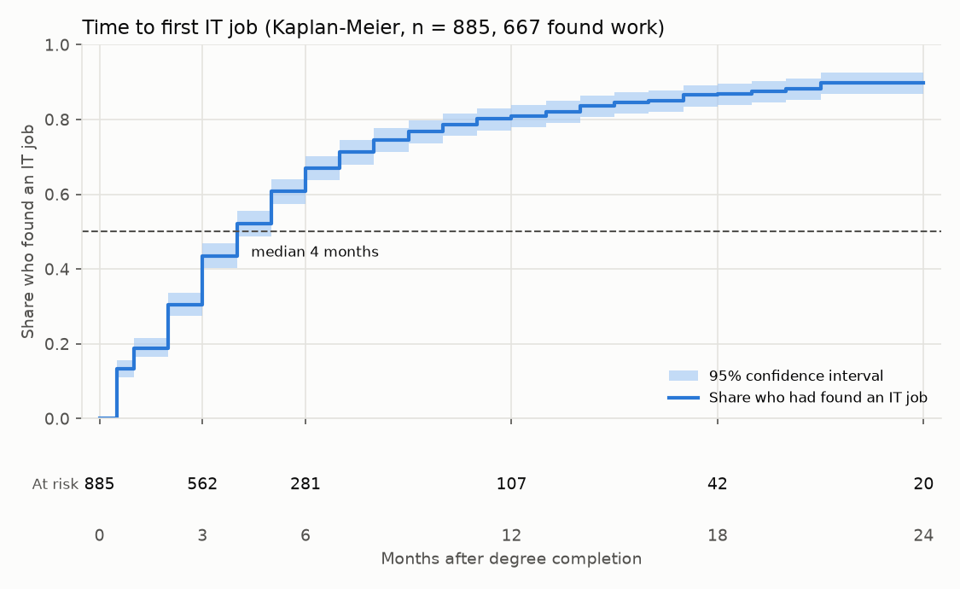
Figure K.1: Time to the first IT job with the number at risk (Kaplan-Meier, all modelling graduates, n = 885)
Competing paths. Figure K.2 separates a first IT role from another path - a non-IT job, self-employment or further studies - for the 635 graduates in the competing-risks analysis (python -m core.competing). By 12 months 77.8% had found an IT role first and 6.5% had taken another path first. Treating the other path as censoring (1 - Kaplan-Meier, dashed) would put the IT share at 81.9%, so the competing paths change the estimates only slightly.
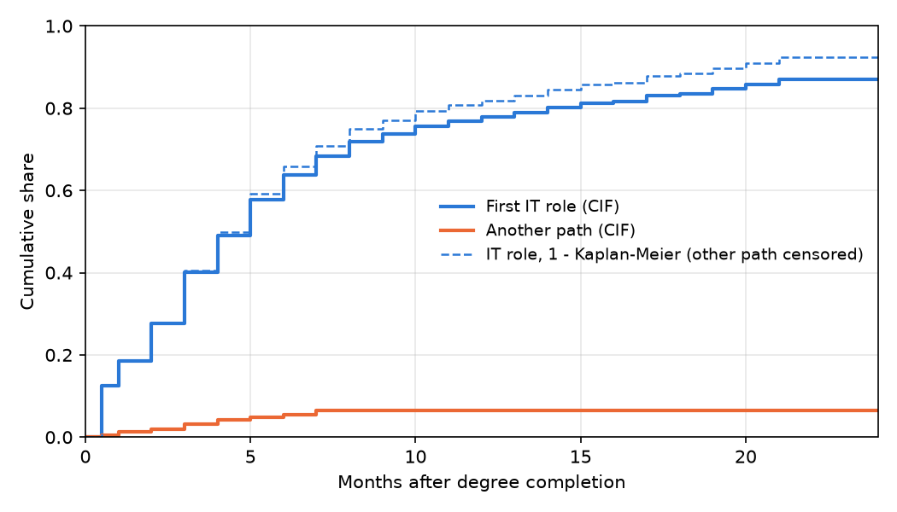
Figure K.2: Cumulative incidence of a first IT role and of another path (competing risks)
Fit of the AFT distributions. Figure K.3 compares the mean predicted share employed under each AFT distribution with the observed Kaplan-Meier curve on the training set. The log-normal and log-logistic curves almost coincide and both stay within 2.0 percentage points of the observed share on average; the Weibull curve fits less well (3.6 points on average) and rises too slowly over the first year. The log-normal distribution had the lowest AIC (2,724.8, against 2,729.8 and 2,766.7) and was chosen by that pre-set rule; the figure shows the choice is also visually reasonable.
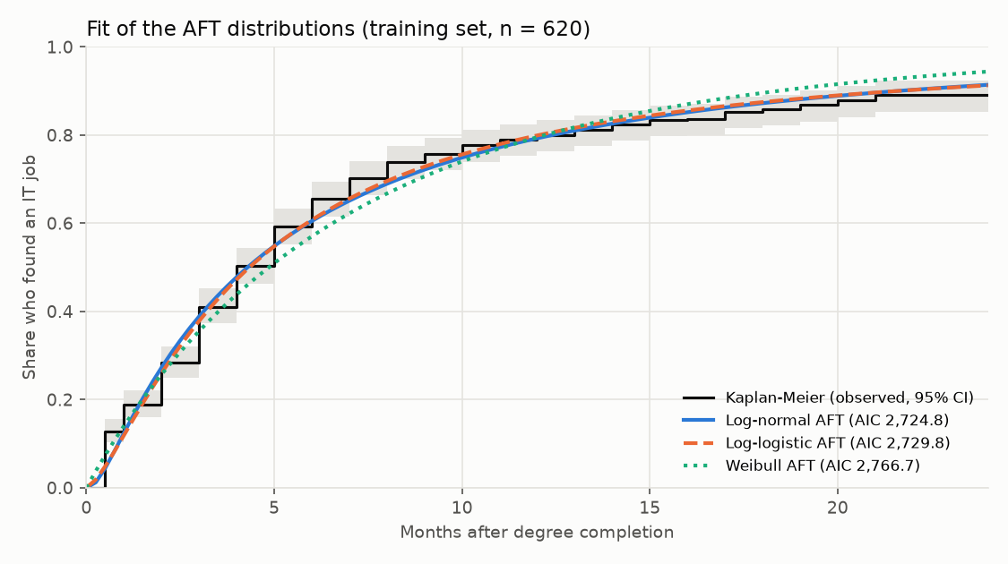
Figure K.3: Mean predicted share employed under each AFT distribution against the Kaplan-Meier curve (training set)
Proportional-hazards check. Figure K.4 shows the scaled Schoenfeld residuals of the Cox model on the training set, the check summarised in Chapter 5. A smoothed line that stays flat around zero means the effect of that factor does not change over time. No line shows a clear trend and every test has p > 0.10 (the smallest is 0.110, for certifications), so the proportional-hazards assumption of the Cox models is supported. The selected AFT model does not rely on this assumption; its fit is shown in Figure K.3.
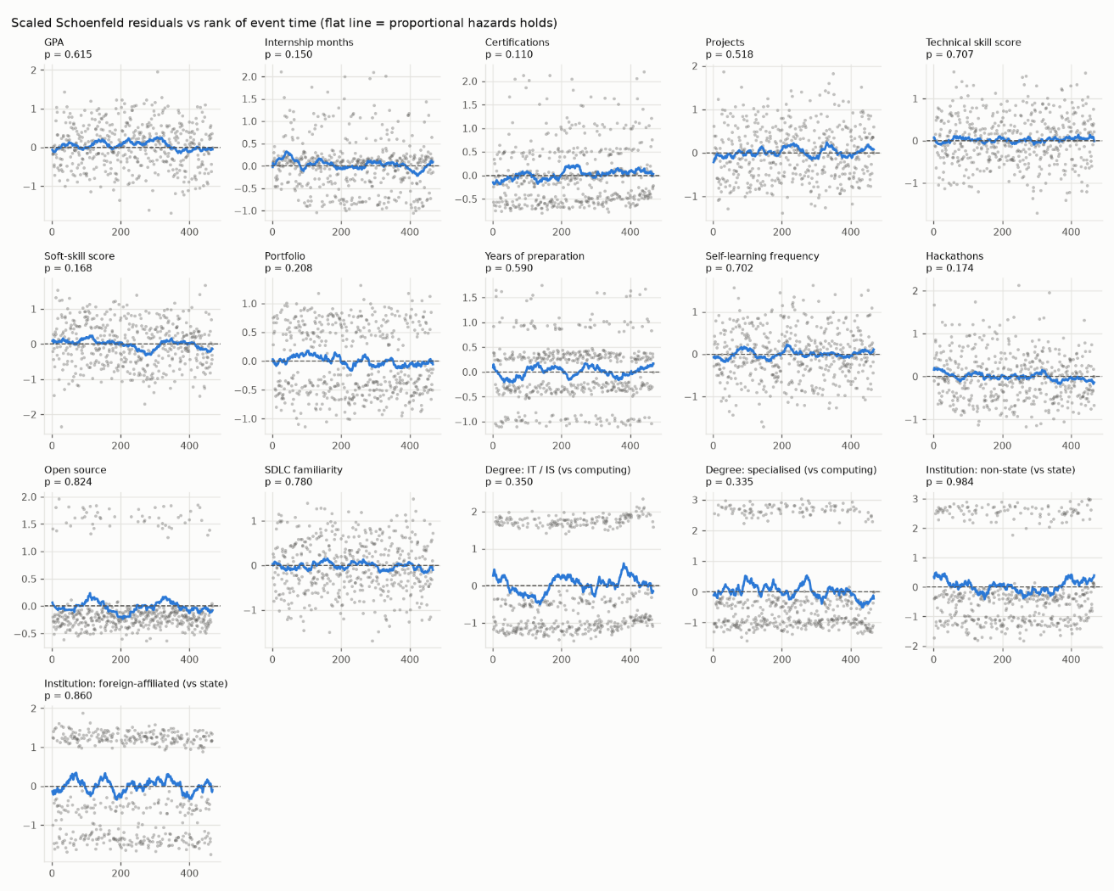
Figure K.4: Scaled Schoenfeld residuals of the Cox model against the rank of event time (training set)
Fairness. Figure K.5 draws the fairness results already reported for the locked test set (artifacts/fairness_report.md; not recomputed). The point estimates of Uno's C were above chance in every group, but the intervals were wide and three of them - men, foreign-affiliated and state institutions - included 0.5. The difference between women (0.724) and men (0.574) lies within overlapping intervals. Employment by six months was under-predicted in most groups, most for foreign-affiliated (by 0.24) and state institutions (by 0.21), consistent with the overall under-prediction in Chapter 5; non-state institutions were the exception, slightly over-predicted (by 0.02).
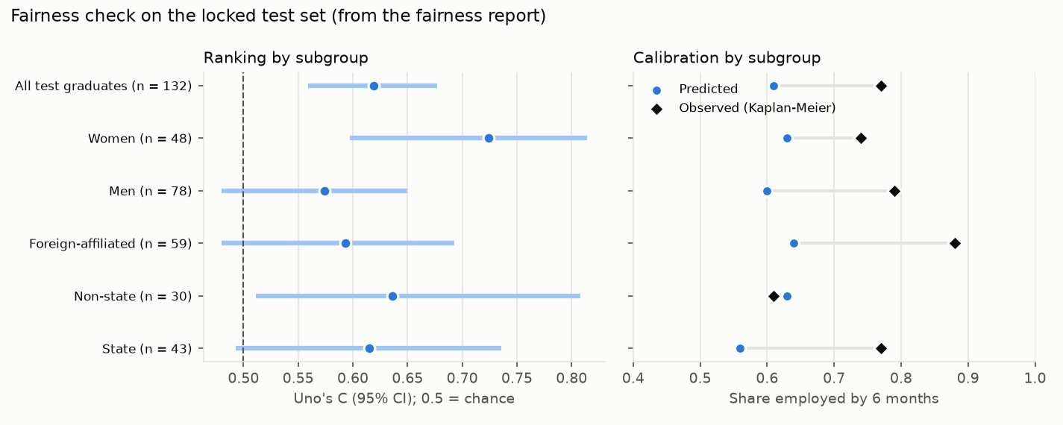
Figure K.5: Uno's C and calibration at six months by gender and institution type (locked test set)
Robustness. Figure K.6 collects the robustness checks of the selected model. Its validation Uno's C stayed between 0.659 and 0.707 under alternative data decisions, reached 0.721 on later cohorts when trained on earlier ones, and ranged from 0.658 to 0.702 when each institution type was held out of training. Every check lies well above chance and within 0.035 of the main result (0.693), so the model's ranking does not depend on one data decision, cohort or institution type.
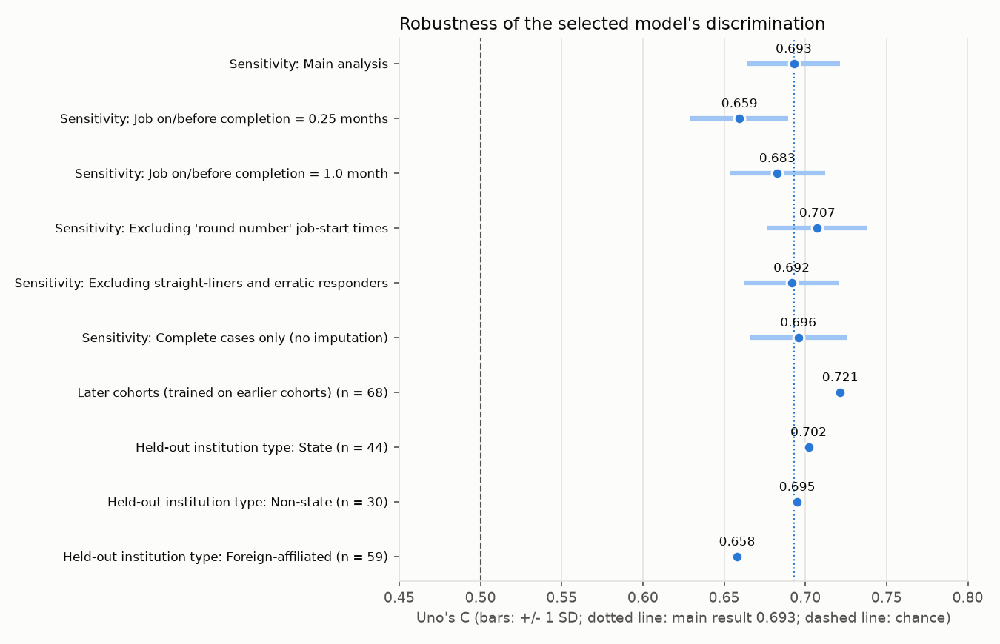
Figure K.6: Uno's C of the selected model across the sensitivity, temporal and institution-transfer checks (validation set)

